

**Table 1*****Student and teacher responses*** Percentage responses for each question item are shown. Statistical significance was compared using the Fisher Exact test.

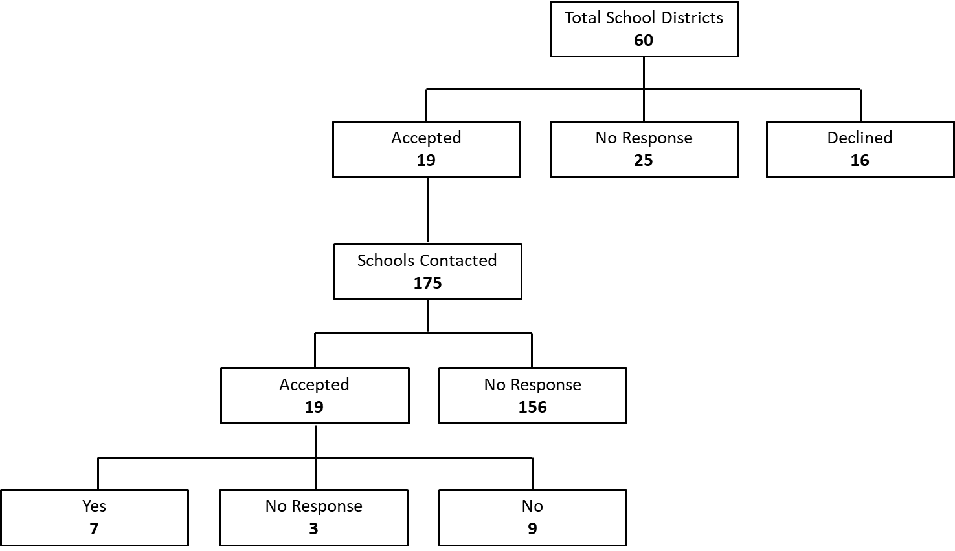

**Figure 1 *British Columbia (BC) district and school participation.*** There are 60 school districts in BC; 19 were willing to have their schools participate in our survey. We contacted all 175 schools within these 19 school districts. Nineteen schools responded to our request for participation and seven schools completed the survey (63 teachers and 597 students).



**Figure 2 *Academic background of the teachers surveyed.*** Only 38% of teachers (red) had an undergraduate education in a related discipline (physical education, kinesiology or human kinetics). The remainder completed their undergraduate training in disciplines related to arts, science or education.