Table 1

Cetacean elements identified to species by site, Barkley Sound

|  |  |  |  |  |  |
| --- | --- | --- | --- | --- | --- |
| *site* | *no.* | *humpback* | *grey* | *other species* | *source* |
| T’ukwaa* | 43 | 86.0% | 11.6% | 2.4% | Monks, McMillan, and St. Claire 2001 |
| Ch’uumat’a* | 42 | 78.6% | 14.3% | 7.1% | Monks, McMillan, and St. Claire 2001 |
| Ts’ishaa | 138 | 76.1% | 13% | 10.9% | Arndt 2011 |
| Hiikwis | 26 | 57.7% | 34.6% | 7.7% | Rodrigues and Yang 2014 |
| Huu7ii | 84 | 83.3% | 13.1% | 3.6% | Arndt 2011, Arndt and Yang 2012 |

*Identifications for T’ukw’aa and Ch’uumat’a were by visual comparisons with reference collections. All others were through aDNA analysis.

Table 2

Minor cetacean species identified (not humpback or grey)

|  |  |  |
| --- | --- | --- |
| *Species* | *No.* | *Sites* |
| Fin (*Balaeonoptera physalus*) | 11 | Ts’ishaa (9)  Huu7ii (2) |
| Right (*Eubalaena japonica*) | 7 | Ts’ishaa (3)  Huu7ii (1)  T’ukw’aa (1)  Ch’uumat’a (2) |
| Blue (*Balaenoptera musculus*) | 2 | Ts’ishaa |
| Sperm (*Physeter catodon*) | 2 | Hiikwis |
| Minke (*Balaenoptera acutorostrata*) | 1 | Ch’uumat’a |
| Orca or “killer whale” (*Orcinus orca*)* | 1 | Ts’ishaa |

*Although it is actually the largest member of the dolphin family, the orca or “killer whale” is commonly classed with the whales.

Table 3

Whale species identified by time period (aDNA identifications only)* **

|  |  |  |  |  |
| --- | --- | --- | --- | --- |
| *time period* | *humpback*  *no. / %* | *grey*  *no. / %* | *other*  *no. / %* | *total* |
| 0 to 1000 BP | 123 / 84.2 | 14 / 9.6 | 9 / 6.2 | 146 |
| 1000 to 2000 BP | 38 / 65.5 | 11 / 19.0 | 9 / 15.5 | 58 |
| 2000 to 3500 BP | 8 / 61.5 | 5 / 38.5 | - | 13 |
| 3500 to 5000 BP | 18 / 69.2 | 8 / 30.8 | - | 26 |

* 0 to 1000 BP from Ts’ishaa main village, Hiikwis, and Huu7ii (House 1 deposits); 1000 to 2000 BP from Ts’ishaa main village, Hiikwis, and Huu7ii (sub-floor midden); 2000 to 3500 BP from elevated landforms behind Ts’ishaa and Hiikwis villages (Huu7ii back terrace materials not analyzed); 3500 to 5000 BP from Ts’ishaa back terrace only.

** Five identified elements (3 humpback, 2 fin) from the Ts’ishaa main village could only be placed within the last 2,000 years. They have been omitted from this table.

Table 4

Analyzed whalebone: counts and percentage of total marine mammal bone

|  |  |  |  |
| --- | --- | --- | --- |
| *site* | *NISP* | *%NISP* | *reference* |
| T’ukw’aa | 3115* | 28.4 | Monks 2011 |
| Ma’acoah | 126 | 23.6 | Monks 2011 |
| Ts’ishaa | 254 | 29.1 | Frederick and Crockford 2005 |
| Huu7ii | 505 | 29.8 | Frederick 2012 |

*This number is incorrectly given as 315 in Table 9.5, Monks 2011



Figure 1. Map of Barkley Sound, showing locations of the excavated village sites discussed in this paper.



Figure 2. Whale species distributions at Barkley Sound sites compared to Ozette.



Figure 3. Graph showing change over time in whale species hunted based on excavated sites in Barkley Sound.

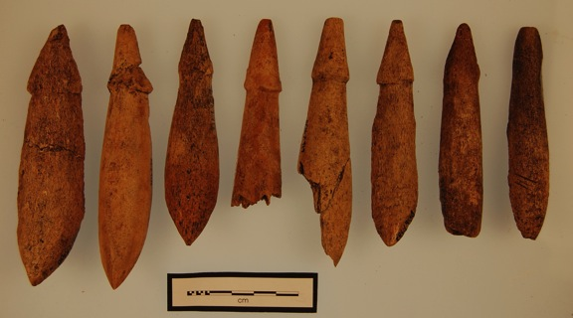

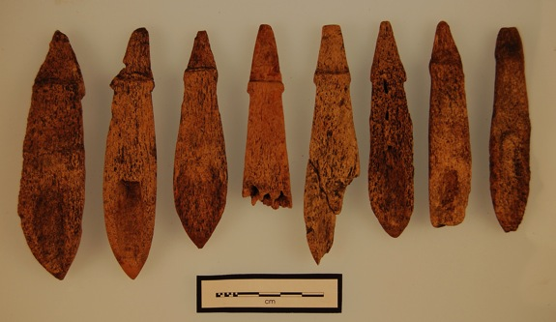

Figure 4. Large slotted harpoon valves, of the type used ethnographically to take marine mammals, from the house floor at Huu7ii (top, dorsal surfaces; bottom, ventral surfaces).

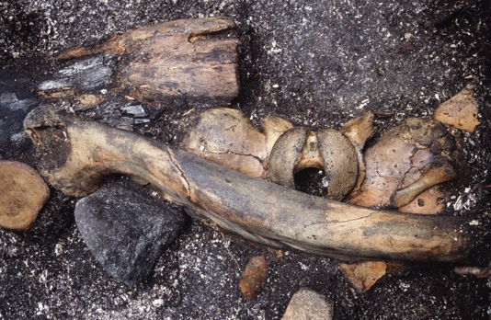

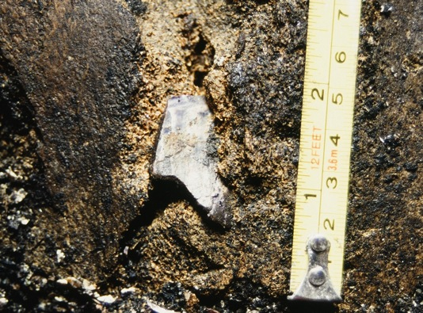

Figure 5. Part of a whalebone concentration at Ts’ishaa (top, a grey whale mandible lies across a humpback skull, with the partial mandible of a larger humpback above; bottom, the base of the humpback skull with much of a mussel-shell harpoon blade embedded in the bone).

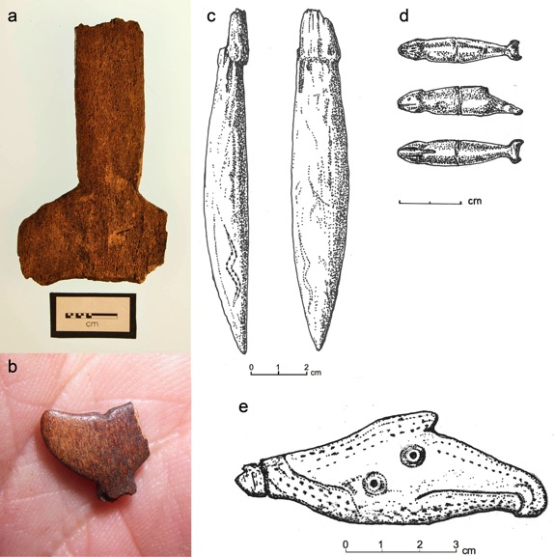

Figure 6. Whaling imagery on archaeological objects from Barkley Sound (a, bone “whale’s-tail” figure from T’ukw’aa; b, small bone “whale’s tail” image from Huu7ii; c, whalebone harpoon valve with incised design representing the lightning serpent from a surface cache; d, small stone sculpture of a whale from T’ukw’aa; e, bone pendant with whale and thunderbird imagery from Huu7ii. The thunderbird’s head with its downturned beak extends to the right. The whale’s snout, with an incised mouth line, is to the left, while its dorsal fin doubles as the crest on the thunderbird’s head).