Figures
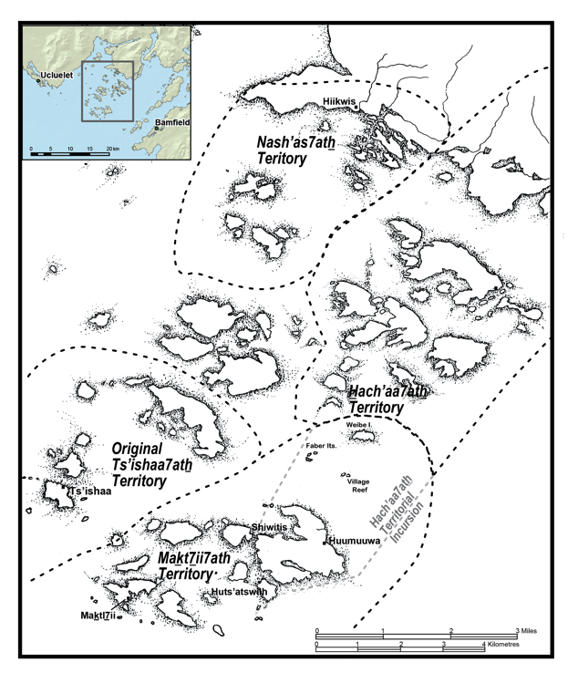
Figure 1. Territorially bounded local group areas in the Broken Group Islands during the eighteenth century as described in oral historical accounts synthesized by St. Claire (1991) and McMillan and St. Claire (2005). Map modified from St. Claire (1991).

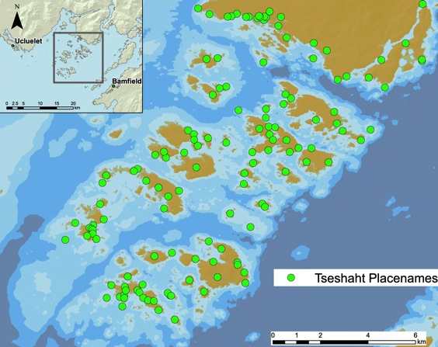
Figure 2. Tseshaht place names as detailed in oral historical accounts shared by community knowledge holders transcribed and translated by Sapir, Thomas, and Williams and later synthesized by St. Claire (1991) who affirmed each translation through interviews with Tseshaht elders in the 1970s and 1980s.

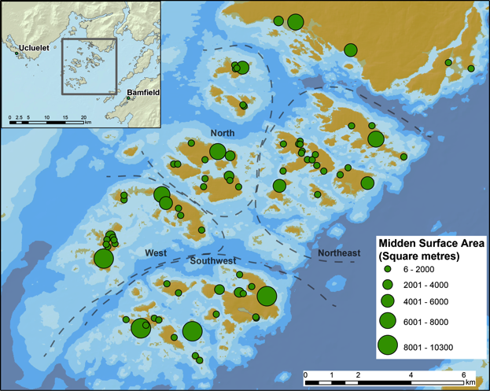
Figure 3 Recorded archaeological sites in the Broken Group Islands and Sechart Channel. The size of each circle represents the horizontal surface area of shell middens as determined by geo-rectifying original site maps in ARCGIS.
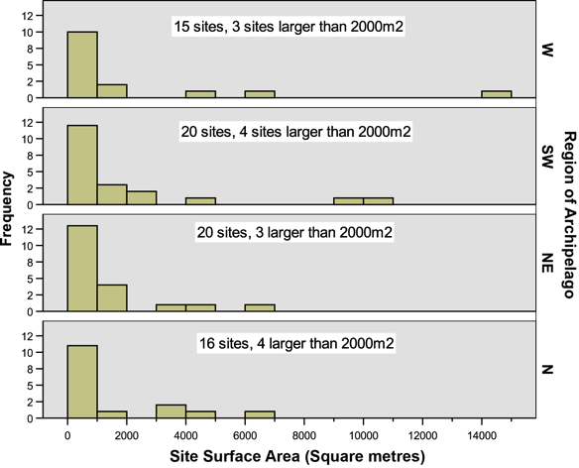
Figure 4. The size and number of shell midden sites in different quadrants of the Broken Group Islands. Data compiled from scaling and georectifying original site maps in ARCGIS 10 and tracing shell midden site boundaries.
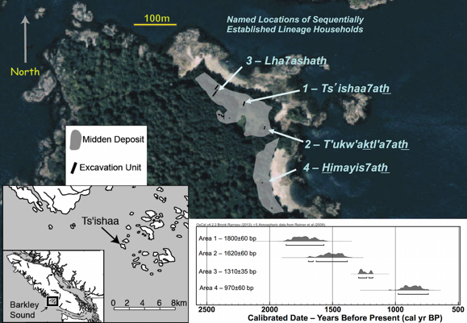
Figure 5. Site map of the village of Ts'ishaa (DfSi-16 and 17) showing oral historically named locations of household lineages (ushtakimilh) and their numbered sequence of occupation. Horizontal extent of midden deposits and the Tseshaht Archaeological Project excavation areas are shown, following McMillan and St. Claire (2005). Inset on the lower right depicts the calibrated ages of the four oldest radiocarbon dates obtained from separate site areas indicating the sequential occupation that accords with oral historical accounts. Dates are presented in McKechnie (2007:215).
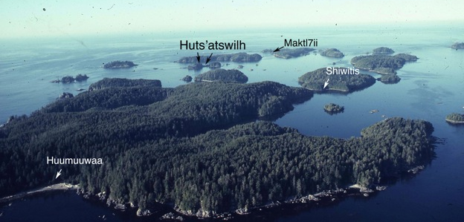
_ _
Figure 6. Overview of the Maktl7ii7ath study area with individual study sites (view looking west). Photo courtesy of the Royal BC Museum (West Coast Archaeological Project Files).
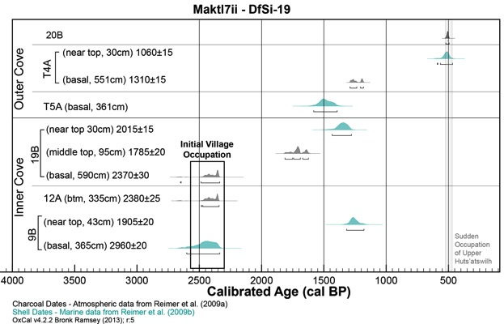
Figure 7. Calibrated Radiocarbon dates from Maktl7ii (DfSi-19) at Wouwer Island showing the calibrated age range and probability for individual dates. Dates on marine shell shown in turquoise and dates on charcoal are in grey calibrated on the atmospheric curve.

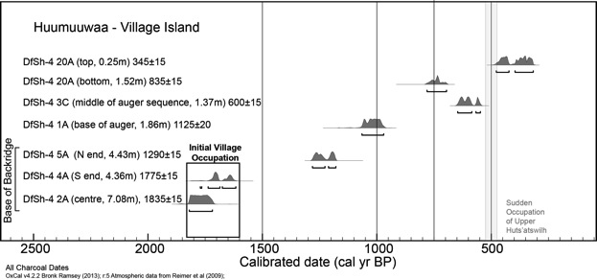
Figure 8. Calibrated radiocarbon dates from Huumuuwaa on Effingham Island (DfSh-4) showing the calibrated age range and probability for individual dates. All dates calibrated on the atmospheric curve.
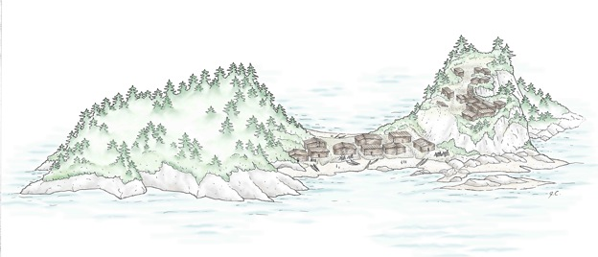
Figure 9. Illustration of Huts’atswilh showing the lower village in between two elevated bluffs (DfSh-31) and the upper defensive site (DfSh-79) on the sheer-sided elevated area to the right (view facing east). House locations and orientation is based on the archaeological evidence for house depressions and platforms and a high resolution topographic map as well as oral historical accounts provided in St. Claire (1991). Artwork by Jenny Cohen.
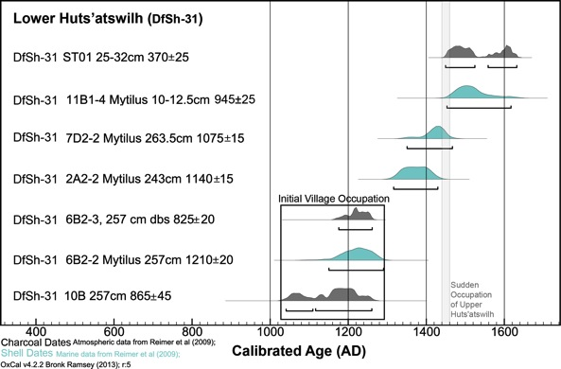
Figure 10. Dates from lower Huts’atswilh showing calibrated ages from basal percussion core samples. Note the progressive south to north trend in calibrated age reflecting horizontal growth of the site. Note the date from on lower right (83T11C) is a terminal date from the top of the cultural sediment rather than the other dates which are from basal layers. Dates on marine shell shown in turquoise and calibrated with a Delta-R of 150±21. Dates in grey are charcoal and calibrated on the atmospheric curve. Both sets calibrated using the program OxCal.
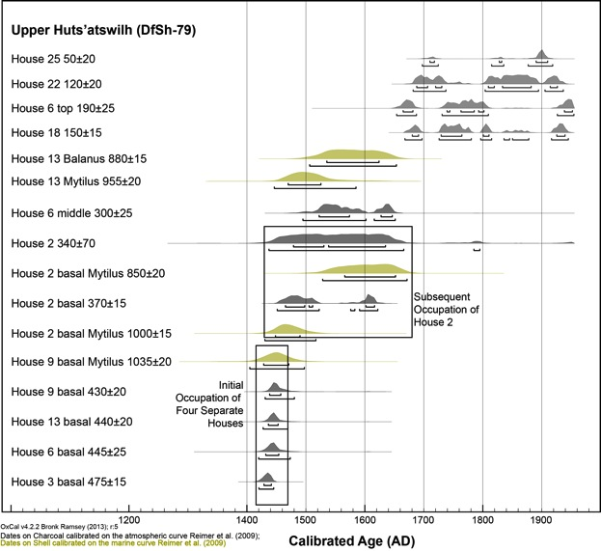
Figure 11. Dates on cultural deposits on upper Dicebox indicating the rapid construction of houses within the AD 1440-1460 interval and subsequent occupation up until the early twentieth century.

Tables
Table 1. The 15 largest shell midden sites in the Broken Group Islands and their associated place names. Bolded sites have been subject to fieldwork as part of this research or.
No. | Place name  Location | Site  Parks # & Borden # | Midden  Areaª  (m²) | House  Platform | House  Depression | Back-ridge | Radiocarbon data | Zooarch  data
1 | Ts’ishaa,  Benson Island | 204T&205T  DfSi16&17 | 14,450 | X | X | X | X | X
2 | Maktl7ii  Wouwer Island | 206T&215T  DfSi19& 30 | 10,040 | 5 |  | X | X | X
3 | Huumuuwaa  Village Island | 304T  DfSh-4 | 9,110 | 15 | X | X | X | X
X | N. Turret Island  No place name | 198T  DfSi-10 | 6,660 | X | X | X
4 | Tl'ihuuw'a  Nettle Island | 305T  DfSh-5 | 6,630 | X | X | X | X | X
5 | Aalhachmakis  Dodd Island | 72T  DfSh-19 | 6,150 | X | X | X | X | X
6 | Muk'waa7a  Turret Island | 195T  DfSi-7 | 4,690 | X | X | X
7 | Huts'atswilh  Dicebox Is. | 83T &129T  DfSh31&79 | 4,520 | 32 | X | X | X | X
8 | Kakmakimilh  Keith Island | 306T  DfSh-17 | 4,840 | X | X | X | X | X
9 | Aasimilh  Hand Island | 187T  DfSh-101 | 4,030 | X | ? | ? | X
10 | T’um’aktli  Gibraltar Island | 80T  DfSh-47 | 3,560 | X | X | X
11 | Tlakiyamilh  Chalk Island | 73T  DfSh-20 | 3,490 | X | X | X
12 | Hats'aat'iml  Turtle Island | 156T  DfSh-111 | 3,300 | X | ? | X
13 | Shiwitis  Gilbert Island | 82T  DfSh-29 | 2,470 | X | ? | ? | X | X
14 | Tl'atl'inkuuwis  Effingham Bay | DfSh-28 | 2,060 | NA | NA | NA
a – Shell Midden surface area calculated using the polygon outline of a geo-rectified original site map in ARCGIS 10.

Table 2. Lineage household names (ushtakimilh) names at the village of Maktl7ii on Wouwer Island (DfSi-19 & 30) presented in St. Claire (1991:38-41, 142-143).
Place name | Translation
Maktl7ii7ath | 'higher than others' also the name for the entire village
Ts’ap’is7ath, later becoming the  Nach’imuuwas7ath | NA  “people who have whale fins all around” (St. Claire 1991:38)
Ust’is7ath | 'down below (not high up on the beach)'
T’imik’ak’is7ath | 'people of gooseberry bushes on beach'

