Figure 1: Region map indicating the location of the Dundas Islands group and other areas mention in the text.

Figure 2: The Dundas Islands group and identified archaeological sites. Sites mentioned in the text are labelled. Base map and data provided by Kisha Supernant.

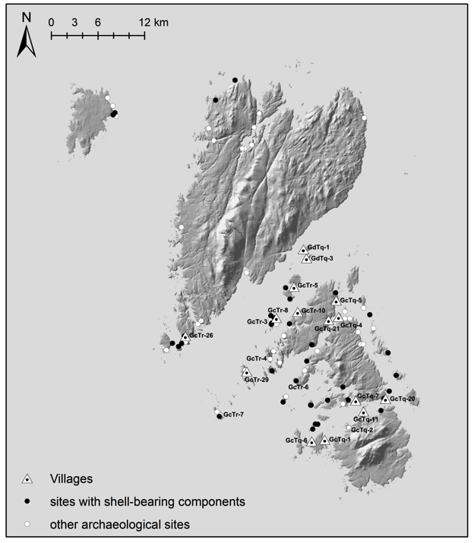

Figure 3: Relative sea-level curve for the Dundas Islands group (modified from McLaren 2008 and McLaren et al. 2011).

Figure 4: Sequentially arranged plot of Dundas Islands group shell-bearing sites by size showing a multi-modal distribution of site areas. Major clusters of site sizes indicated in boxes with solid lines; dashed lines indicate small potential clusters.

