SUPPLEMENTAL MATERIAL

Table S1. Pairwise Kruskal-Wallis between interior Douglas-fir (BC) samples in different Long-term Soil Productivity treatments. OM1 = branches and stumps were left on site. OM2 = branches, but not stumps, were removed, REF = unlogged reference plots. Pairwise Kruskal-Wallis q > 0.05.

Diversity metric | Groups | H statistic | q-value
Faith’s PD | REF vs OM1  REF vs OM2  OM1 vs OM2 | 0.884  0.640  3.206 | 0.424  0.424  0.220
Pielou’s  Evenness | REF vs OM1  REF vs OM2  OM1 vs OM2 | 0.871  1.964  0.472 | 0.492  0.483  0.492

Table S2. Pairwise PERMANOVA comparisons between interior Douglas-fir (BC) samples in different Long-term Soil Productivity treatments. OM1 = branches and stumps were left on site. OM2 = branches, but not stumps, were removed, REF = unlogged reference plots. PERMANOVA q > 0.05.

Diversity metric | Groups | Sample size | F model | q-value
Bray-Curtis | REF vs OM1  REF vs OM2  OM1 vs OM2 | 24  21  33 | 1.300  0.880  1.011 | 0.126  0.730  0.638
Jaccard | REF vs OM1  REF vs OM2  OM1 vs OM2 | 24  21  33 | 1.052  0.987  1.005 | 0.069  0.618  0.582
Unweighted UniFrac | REF vs OM1  REF vs OM2  OM1 vs OM2 | 24  21  33 | 1.020  1.119  1.077 | 0.330  0.153  0.189
Weighted  UniFrac | REF vs OM1  REF vs OM2  OM1 vs OM2 | 24  21  33 | 1.750  1.789  1.623 | 0.083  0.083  0.083

Table S3. Pairwise Kruskal-Wallis between interior Douglas-fir (BC) samples in different C:N ratio categories. q > 0.05.

Diversity metric | Groups | H statistic | q-value
Faith’s PD | Low vs Mid  Low vs High  Mid vs High | 0.402  3.203  0.952 | 0.526  0.220  0.494
Pielou’s  Evenness | Low vs Mid  Low vs High  Mid vs High | 0.021  0.030  0.193 | 0.884  0.884  0.884

Figure S1. Microbial communities are distinct between sub-boreal spruce (BC) sites but not interior Douglas-fir sites. Principal coordinate analysis showing weighted UniFrac beta diversity between sites in the organic layer of the (A) sub-boreal spruce (BC) (weighted UniFrac PERMANOVA: F19,61 = 7.953, q = 0.001) and (B) interior Douglas-fir (BC) (weighted UniFrac PERMANOVA: F17,38 = 0.989, q = 0.385) ecozones.

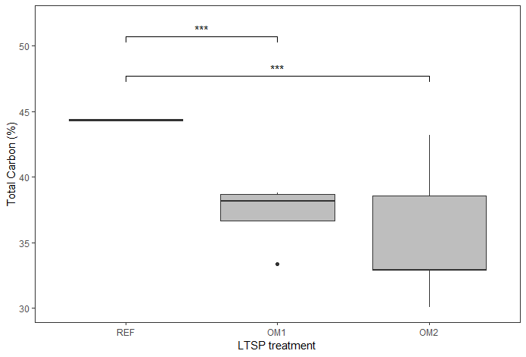
Figure S2. Total % C significantly decreases with severity of Long-term Soil Productivity treatment. One-way ANOVA: F_{2, 36} = 15.2, p < 0.001. Pairwise t-tests: REF vs OM1 p < 0.001, REF vs OM2 p < 0.001, OM1 vs OM2 p = 0.136.

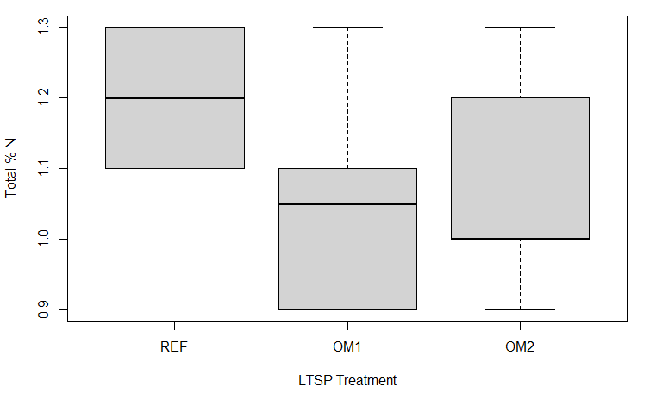

Figure S3. Total % N does not significantly change with severity of Long-term Soil Productivity treatment. One-way ANOVA: F_{2,36} = 2.513, p = 0.0952.

