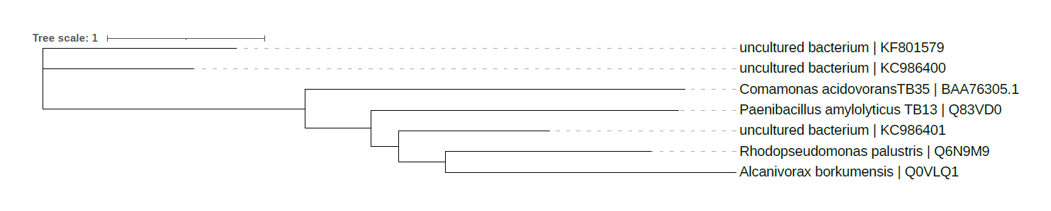
Supplementary Figure 1. Phylogenetic tree of the seed PLAase reference package viewed in iTOL. Phylogeny of phyla containing PLAase genes discovered and documented in PAZy under EC number 3.1.1.1. Sequence names at the tree’s leaf tips show the organism name and unique GenBank/UniProt accession identifier.

