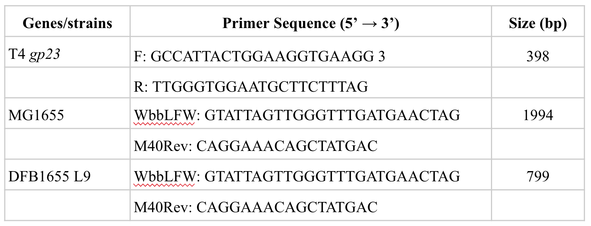
Table S1. Primer sequences for PCR primers. The same forward and reverse primers were used to amplify the wbbL gene in MG1655 and DFB1655 L9. MG1655 contains an insert in wbbL producing an expected larger fragment.

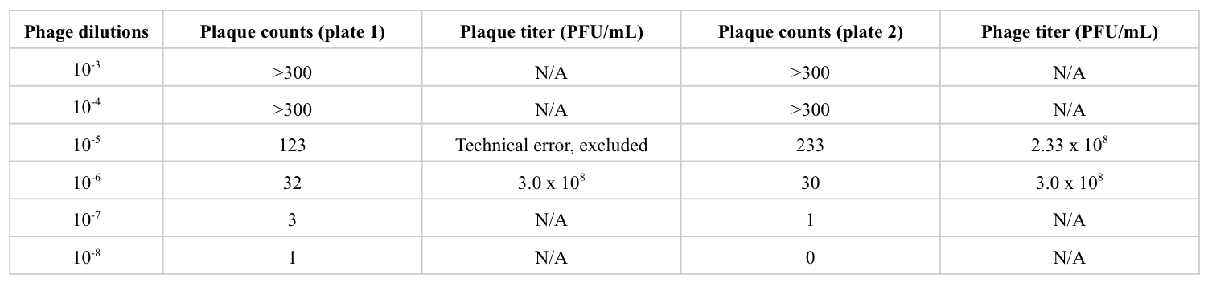
Table S2. T4 bacteriophage stock titer. Serial dilutions of T4 bacteriophage were mixed with MG1655 and overlay agar, plated, and incubated overnight at 37°C. The plaque counts falling between 30 and 300 were included for phage titer calculation. The phage titer was calculated using the number of plaques * 10 * reciprocal of the dilution factor, and the final concentration of T4 bacteriophage is determined using the average concentration based on all plates included.
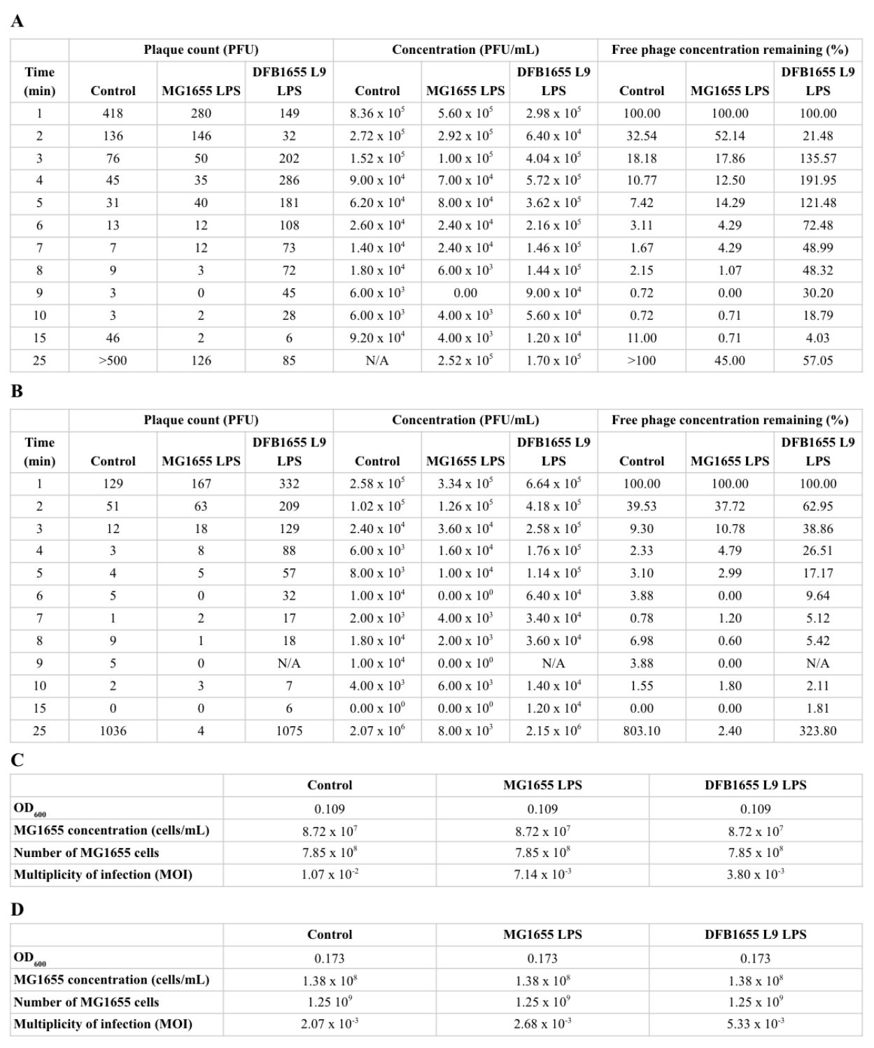
Table S3. T4 bacteriophage concentrations, MG1655 concentrations, and MOI during adsorption assay. Plaque counts, concentrations, and percentage of free T4 bacteriophage in chloroform-treated supernatant in control, LPS with no O¹⁶-antigen group (MG1655 LPS), and O¹⁶-antigen containing LPS group (MG1655 L9 LPS) during (A) replicate 1 and (B) replicate 2. Concentration of MG1655 used for adsorption assay, and MOI calculated following the equation: # of initial T4 bacteriophage/# of MG1655 cells for (C) replicate 1 and (D) replicate 2. N/A stands for not available due to technical issues.
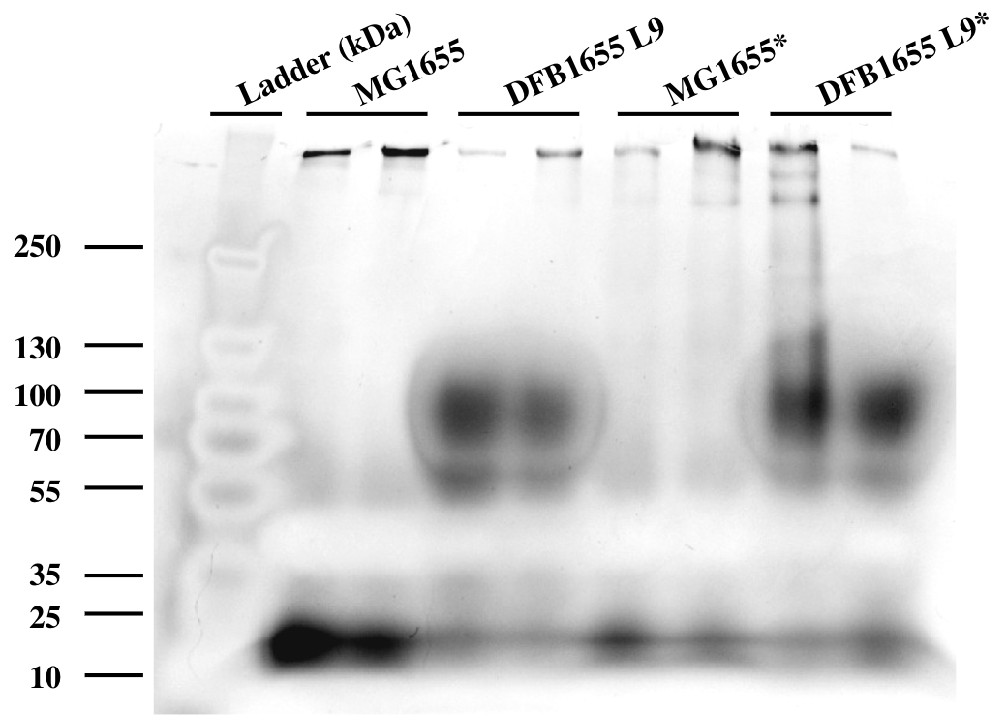
FIG. S1 O¹⁶-antigen LPS is only present in L9 extracted LPS. LPS was extracted from MG1655 and DFB1655 L9, then subjected to SDS-PAGE and silver staining. Marker sizes (kDa) were superimposed from the PageRulerTM PreStained Protein Ladder. * indicates the addition of beta-mercaptoethanol (BME) during sample preparation.

