SUPPLEMENTAL FIGURES
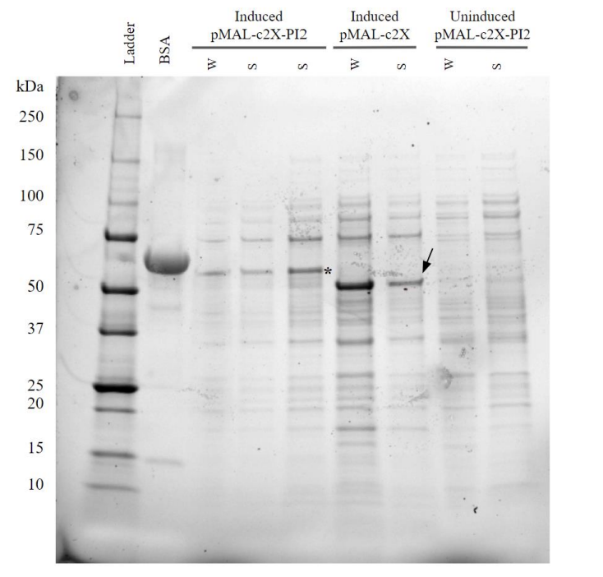
FIG. S1 Protein expression in SHuffle cells induced under optimal conditions was visualized with SDS-PAGE. SHuffle cells transformed with either pMAL-c2X-PI2 or pMAL-c2X were cultured overnight and induced with 1.0 mM IPTG at room temperature (RT). Uninduced pMAL-c2X-PI2-expressing cells and induced pMAL-c2X-expressing cells served as negative controls. Whole cell lysates (W) and soluble cell fractions (S) were extracted from the cultures and analyzed using SDS-PAGE. A reference ladder and 2 mg/L bovine serum albumin (BSA) (66.5 kDa) were used as molecular weight standards. MBP-PI2 (66.5 kDa) were observed in all samples from induced pMAL-c2X-PI2-containing cells as indicated by the asterisk, except for the negative controls. In the induced pMAL-c2X condition, bands at 50.5 kDa represent the presence of MBP-ß-gal-α, as indicated by the arrow.
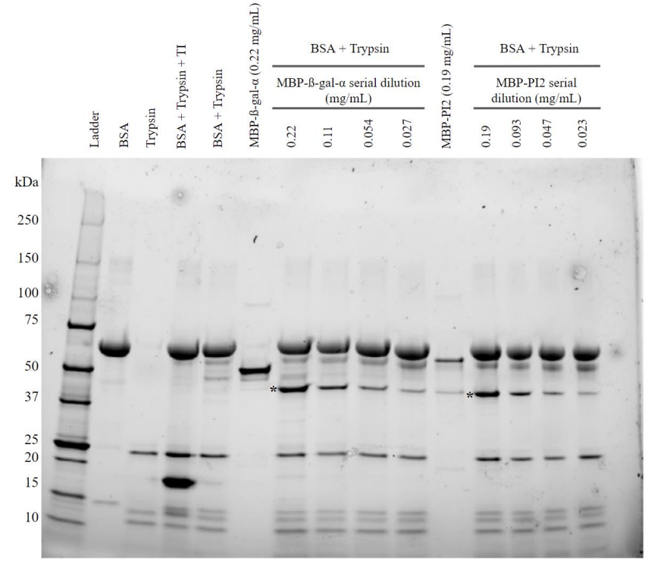
FIG. S2 The trypsin inhibition activity of MBP-PI2 may be facilitated by PI2. The full SDS-PAGE gel image corresponding to Fig. 6A is presented. To determine if the trypsin inhibitory activity of MBP-PI2 previously observed is due to the activity of PI2 and not MBP, a 2-fold serial dilution of either MBP-PI2 (starting from 0.19 mg/mL) or MBP-ß-gal-α (starting from 0.22 mg/mL) was incubated with trypsin (0.16 mg/mL) and bovine serum albumin (BSA) (1.36 mg/mL) at 37°C for 15 minutes. BSA (1.36 mg/mL) and trypsin (0.16 mg/mL), which featured BSA fragmentation, served as a negative control. BSA (1.36 mg/mL), trypsin inhibitor (TI) (0.47 mg/mL), and trypsin (0.16 mg/mL), which did not feature BSA fragmentation, served as a positive control. A reference ladder and 1.36 mg/mL BSA (66.5 kDa) were used as molecular weight standards. MBP-ß-gal-α (50.5 kDa) and MBP-PI2 (66.5 kDa) only samples served as molecular weight references. Asterisks indicate the presence of MBP (42.5 kDa).
SUPPLEMENTAL TABLES

Table S1. SDS-PAGE densitometry analysis of soluble MBP-PI2 bands to compare soluble protein expression levels under different induction conditions. Refer to Fig. 2 for the corresponding SDS-PAGE gel.
Induction condition | MBP-PI2 relative band intensity* | Average relative band intensity
20°C – 0.1 mM IPTG | 1.06 | 1.17
 | 1.28
30°C – 0.1 mM IPTG | 1.19 | 1.29
 | 1.39
20°C – 1 mM IPTG | 1.75 | 1.80
 | 1.86
30°C – 1 mM IPTG | 1.56 | 1.72
 | 1.88
*Two technical replicates completed per condition.

Table S2. SDS-PAGE densitometry analysis of bovine serum albumin (BSA) and trypsin bands to assess MBP-PI2 functionality. Refer to Fig. 5 for the corresponding SDS-PAGE gel and graph.
Sample | BSA band intensity | Trypsin band intensity
BSA only (1.36 mg/mL) * | 5621 | -
Trypsin (0.16 mg/mL) * + BSA | 2947 | 748
Trypsin + BSA + trypsin inhibitor (0.47 mg/mL) | 4242 | 1750
MBP-PI2 EF #3 (0.37 mg/mL) | 4401 | 1661
MBP-PI2 EF #3 (0.19 mg/mL) | 4296 | 1544
MBP-PI2 EF #3 (0.093 mg/mL) | 4488 | 1443
MBP-PI2 EF #4 (0.53 mg/mL) | 5015 | 1548
MBP-PI2 EF #4 (0.27 mg/mL) | 4662 | 1635
MBP-PI2 EF #4 (0.13 mg/mL) | 5120 | 1663
*Same concentrations of BSA and trypsin were used in all subsequent reactions.

Table S3. SDS-PAGE densitometry analysis of bovine serum albumin (BSA) and trypsin bands to assess functionality of MBP-ß-gal-α compared to MBP-PI2. Refer to Fig. 6 for the corresponding SDS-PAGE gel and graph.
Sample | BSA band intensity | Trypsin band intensity
BSA only (1.36 mg/mL) * | 10920 | -
Trypsin (0.16 mg/mL) * + BSA | 7354 | 4097
Trypsin + BSA + trypsin inhibitor (0.47 mg/mL) | 6346 | 2264
MBP-ß-gal-α (0.22 mg/mL) | 5718 | 1853
MBP-ß-gal-α (0.11 mg/mL) | 5160 | 1587
MBP-ß-gal-α (0.054 mg/mL) | 5856 | 1761
MBP-ß-gal-α (0.027 mg/mL) | 5782 | 1994
MBP-PI2 (0.19 mg/mL) | 6205 | 2495
MBP-PI2 (0.093 mg/mL) | 6737 | 2144
MBP-PI2 (0.047 mg/mL) | 6430 | 1881
MBP-PI2 (0.023 mg/mL) | 6206 | 2773
*Same concentrations of BSA and trypsin were used in all subsequent reactions.

