SUPPLEMENTAL MATERIALS
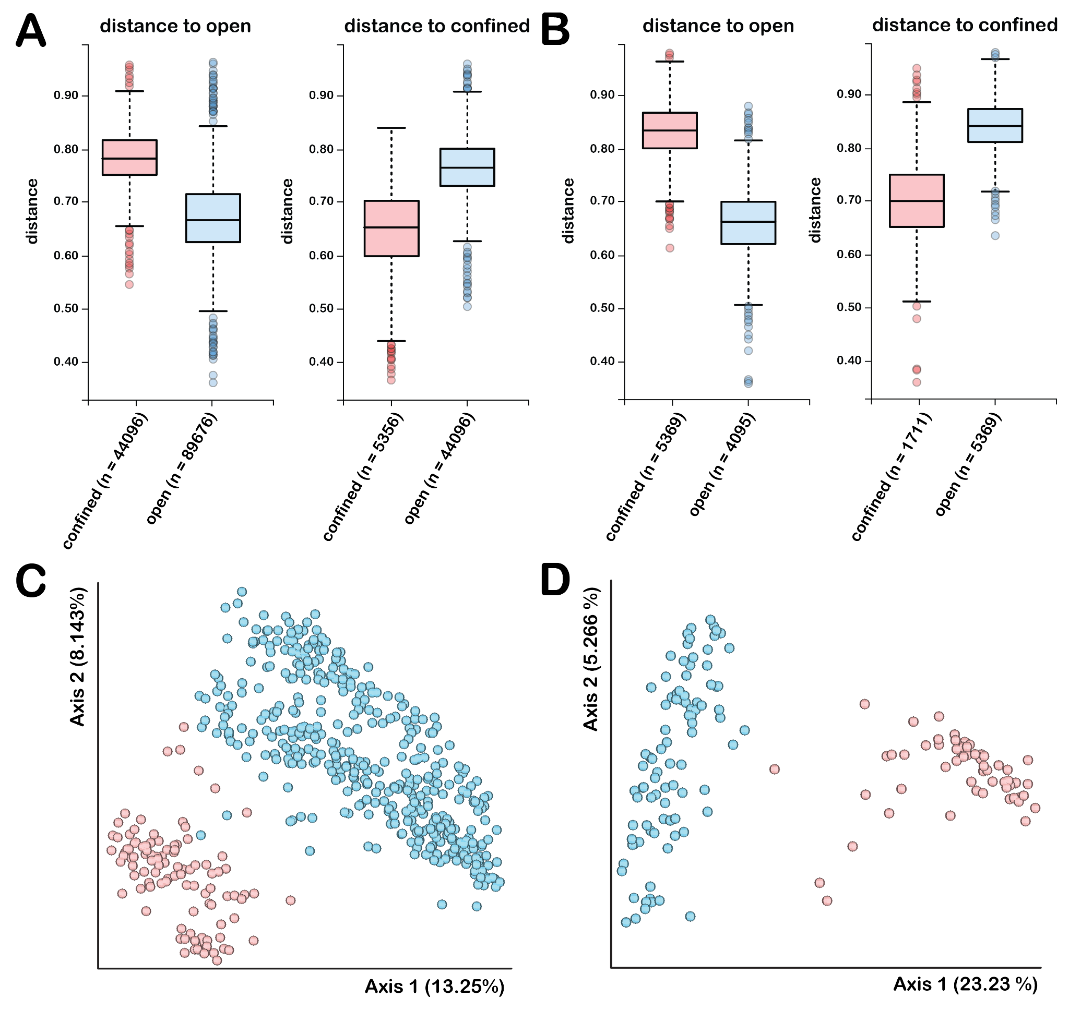 Supplemental Figure 1. Open and confined environments have different microbiome diversity. Unweighted UniFrac analysis of (A) abiotic (p = 0.001, q = 0.001) and (B) biotic (p = 0.001, q = 0.001) surfaces in the confined (red) and open (blue) environments were conducted. Box plots and error bars represent mean ± SEM. Statistical analysis was performed via the permutational multivariate analysis of variance (PERMANOVA). Principal coordinates analysis (PCoA) plot of beta diversity (Unweighted Unifrac) distances across the hiseas and dorms datasets for (C) abiotic and (D) biotic surfaces.
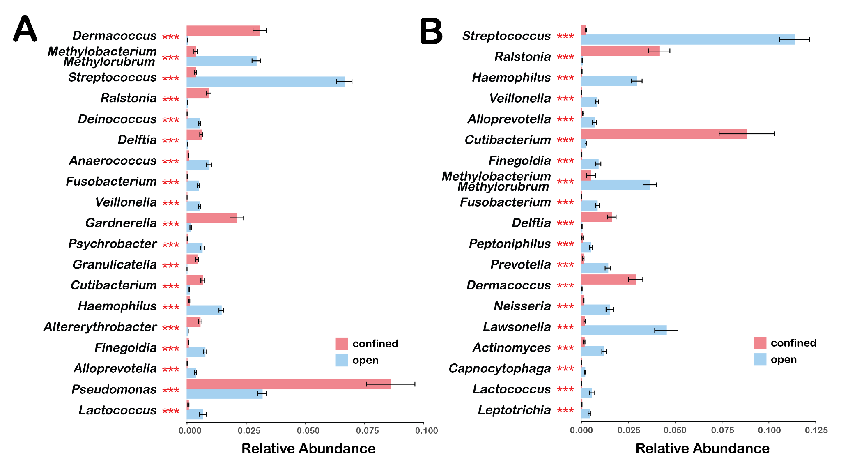
Supplemental Figure 2. Pseudomonas sp. and Cutibacterium sp. are more abundant in confined environments relative to open environments, while Streptococcus sp. are more abundant in open environments relative to confined environments. Relative abundance analysis was conducted using the RandomForest/Microeco pipeline for both (A) abiotic and (B) biotic surfaces in the confined (red) and open (blue) environment. Statistical analysis via the Wald Chi-Squared Test. *** p < 0.005.

