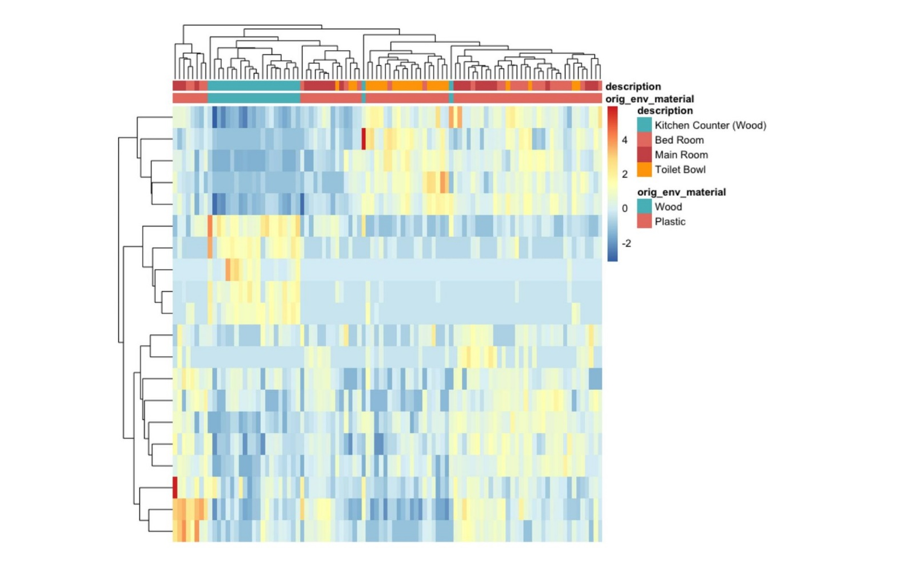
SUPPLEMENTAL FIGURES
Figure S1. Heatmap of samples showed grouping based on surface material and location. The dendrogram shows clustering of samples of the same material (plastic or wood) and clustering of samples according to location (Kitchen Counter, Bed Room, Main Room, Toilet Bowl). Cells within the heatmap are colored according to read counts. Rows represent ASVs while columns represent samples.

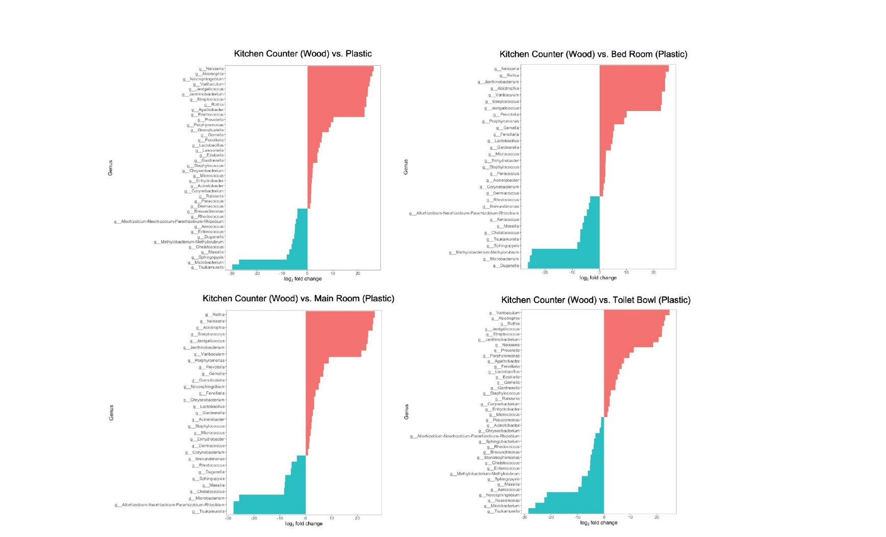
Figure S2. Plastic surfaces had more differentially abundant taxa compared to wood surfaces with the exception of the toilet bowl. Differential abundance analysis at the genus level for wood vs plastic and each plastic location (Bed Room, Main Room, Toilet Bowl). More differentially abundant taxa on plastic are represented in red while more differentially abundant taxa on wood are represented in blue. There were 29 more relatively abundant taxa on plastic and 12 more relatively abundant taxa on wood.

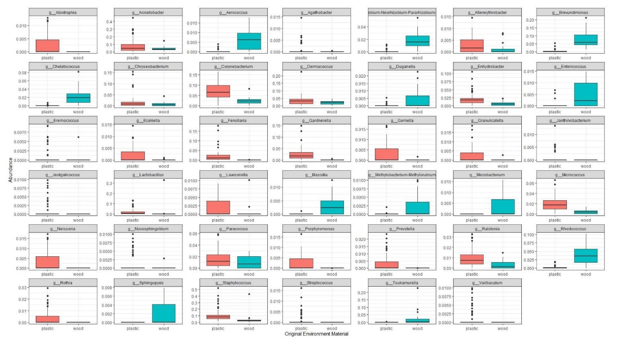
Figure S3. There are 29 more differentially abundant taxa on plastic and 12 more differentially abundant taxa on wood. Relative abundance plots of the 41 differentially abundant taxa between wood and plastic surfaces. Some relatively abundant taxa were present to comparable levels on both surface types (n=9). Some strains identified were present at very low levels on both surfaces (n=7).

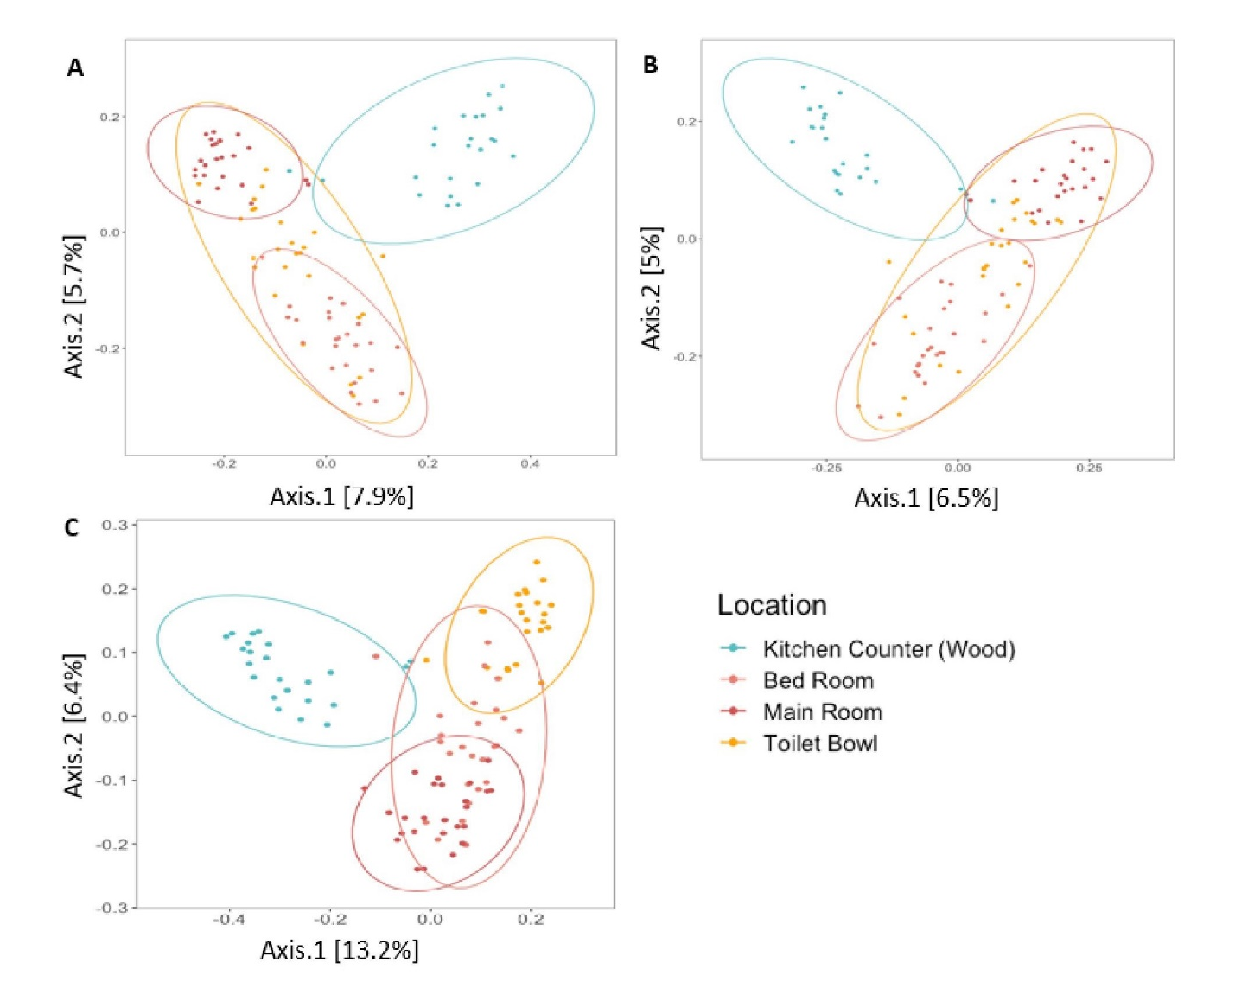
Figure S4. Distinct clustering by location is observed across beta diversity metrics. The PCoA plots were generated using Jaccard (A), Bray-Curtis (B), and Unweighted Unifrac (C) beta diversity metrics. The ellipses represent the estimated 95% confidence intervals of the samples, and are added to better visualize the clustering between surface locations.

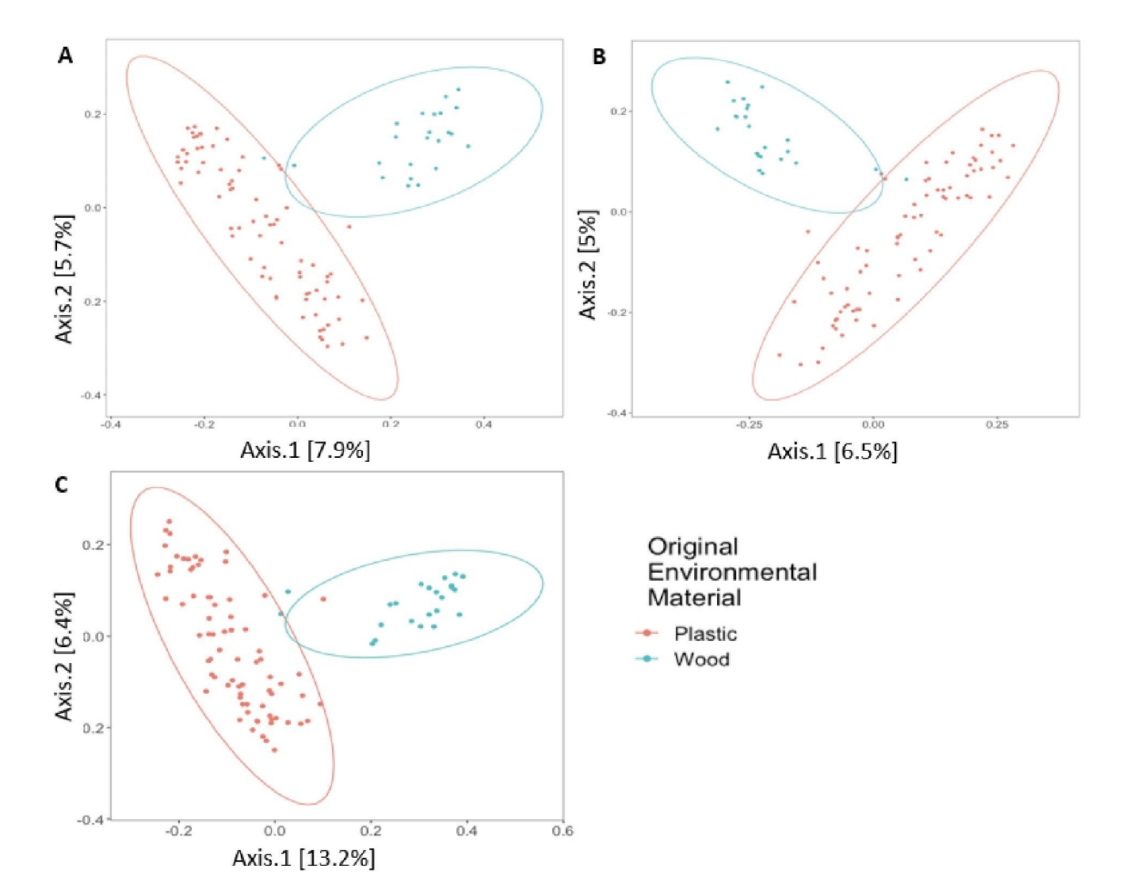
Figure S5. Distinct clustering by surface material is observed across beta diversity metrics. The PCoA plots were generated using Jaccard (A), Bray-Curtis (B), and Unweighted Unifrac (C) beta diversity metrics. The ellipses represent the estimated 95% confidence intervals of the samples, and are added to better visualize the clustering between surface locations.

Figure S6. Strains in higher differential abundance on plastic surfaces compared to wood are more often shared across the three plastic locations. The numbers indicate the amount of shared strains. A greater number of strains (17) were found to be shared across the three plastic locations (main room, bed room and toilet bowl), as compared to the number of unique strains found in each location.

