Supplementary material

R and qiime scripts:

Script | Format | Filename
Working script for QIIME2 pipeline | .txt | Soil_QIIME2_script.txt
Exploratory analysis of metadata | .Rmd | exploratory_analysis.Rmd
PCoA plots in R | .Rmd | PCoA_plots.Rmd
Logistic regression analysis of alpha diversity metrics | .Rmd | logistic_regression_analysis.Rmd
Indicator taxa analysis paired with logistic regression | .Rmd | indicator_taxa.Rmd
Taxonomic bar plot | .Rmd | taxonomic_bar_plot.Rmd
In-house function to calculate relative abundance of taxonomy ASV counts | .R | RelativeTaxa.R
*note: Rmd is an “R markdown” script. It is more readable to the user
Supplementary figures
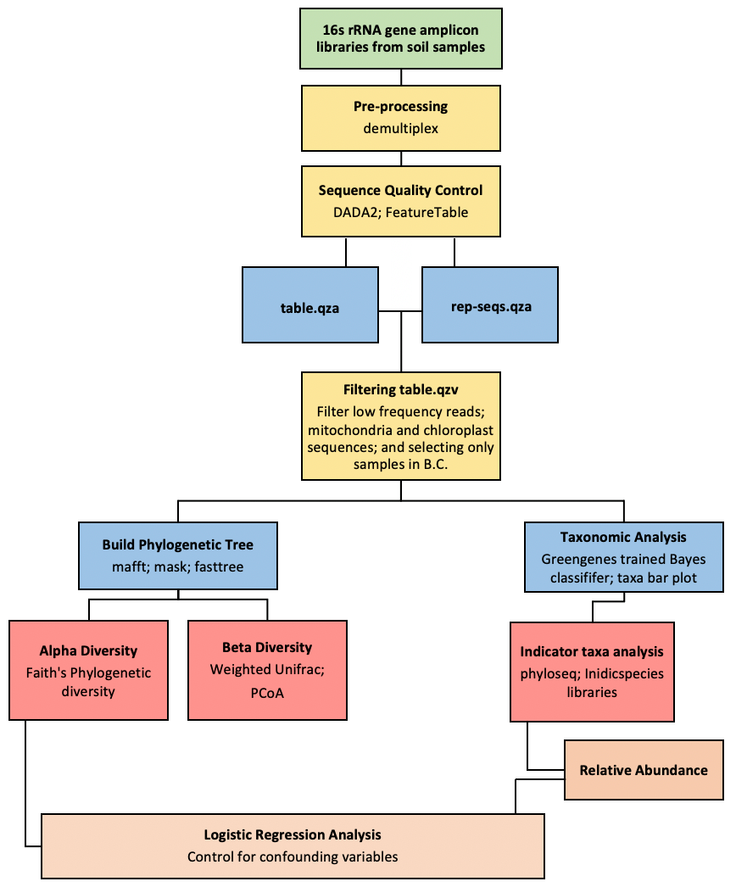
Supplementary Figure S0: Summary of processing and analysis pipeline conducted. For a more detailed explanation, please refer to the scripts and the methods section.

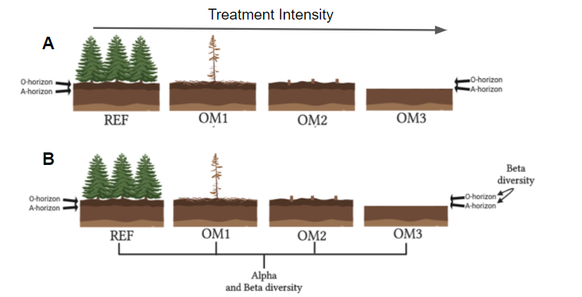
Supplementary Figure S1: Characteristics of different organic matter (OM) removal treatments in harvesting practices and how their relation to soil microbiome was studied. (A) OM removal treatments refer to the harvesting practices done in managed forests. These treatments are characterized either by the debranching of trees in-situ (OM1), removal of branches and trunks (OM2), or removal of branches, trunks and top soil layer (OM3) of forests. Reference (REF) samples had no organic matter removal. (B) To investigate the effects of OM removal intensity in microbial diversity and composition, Alpha- and Beta-diversity analyses between the different OM removal treaded forest plots were conducted. Furthermore, Soil heterogeneity was investigated within each OM treatment plot by comparing Beta-diversity composition between soil horizons (O and A). Image done with Biorender (https://biorender.com/)

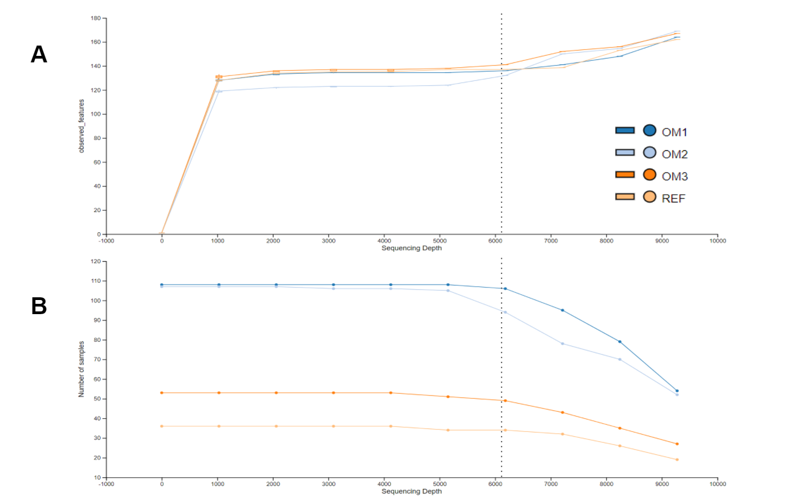
Supplementary Figure S2: Sample rarefaction grouped by OM removal treatment. Rarefaction was done to select an adequate sequencing depth to be used in downstream alpha and beta diversity analyses. At the selected sampling depth of 6041 all diversity metrics plateau while most samples are still retained (only 20 samples were dropped). (A) Comparison between sequencing depth and observed features diversity metric based on OM removal treatment categories and the number of samples retained at each depth (B).
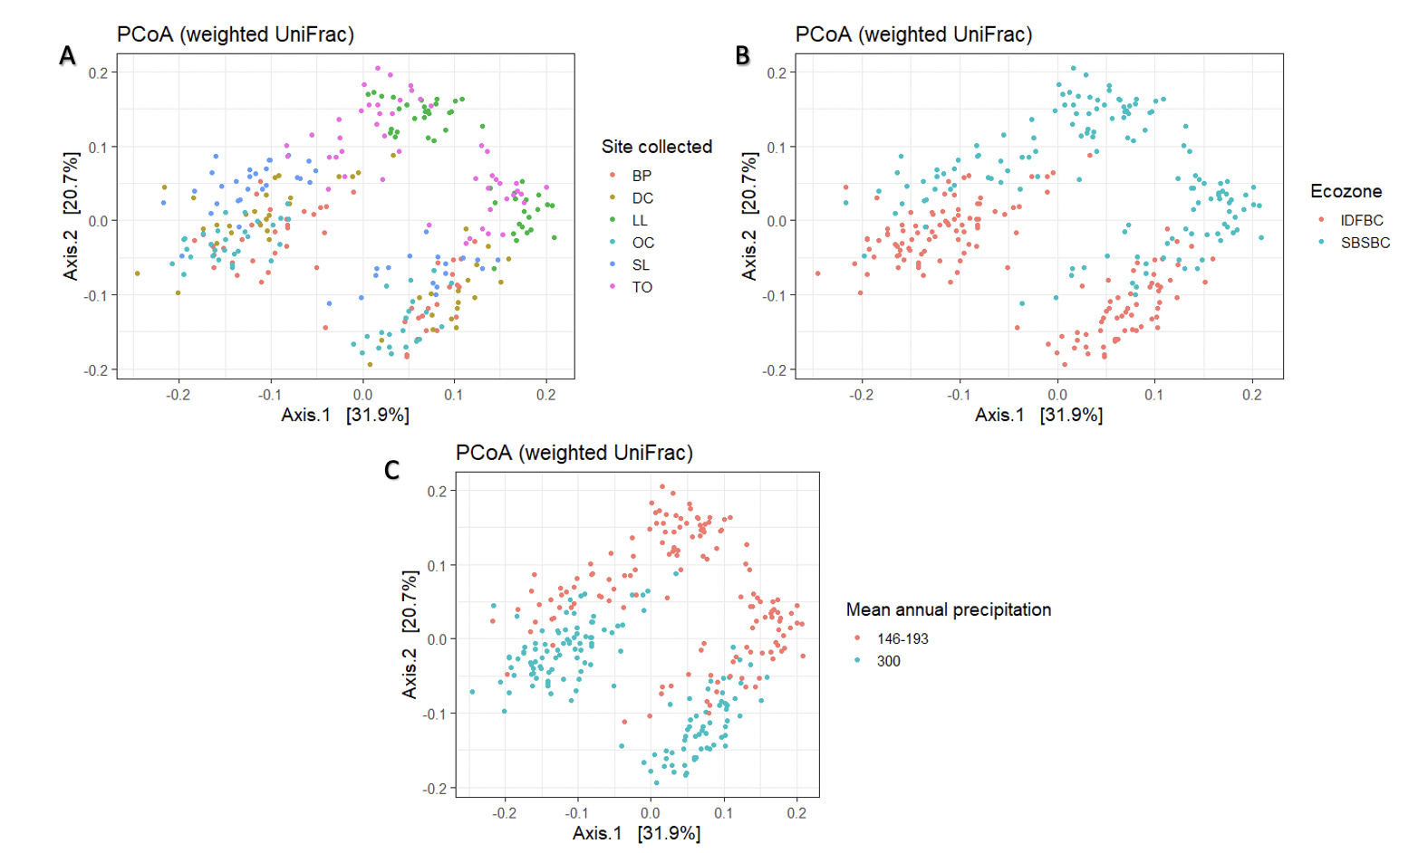
Supplementary Figure S3: Clustering of soil microbial communities based on various abiotic factors suggests confounding variables. Weighted UniFrac PCoA ordinations of samples based on microbial diversity depending on various abiotic factors besides OM treatment. (A) Analysis based on the site where each soil sample was collected. Clustering is visible based on similarities on the location the samples were collected. (B) Analysis based on the specific ecozone where each soil sample was collected. Clustering is visible based on the two different ecozones utilized in the metadata. (C) Analysis based on the mean annual precipitation observed at the collection site. Clear clustering visible based on the two different groups highlighted. Variance identified by each PCoA axis is given in parentheses for each plot. Data for other variables with clustering patterns is not shown.

Supplementary Table S1. Estimates and significance of considered explanatory variables for logistic regression models. Test statistic used was t value
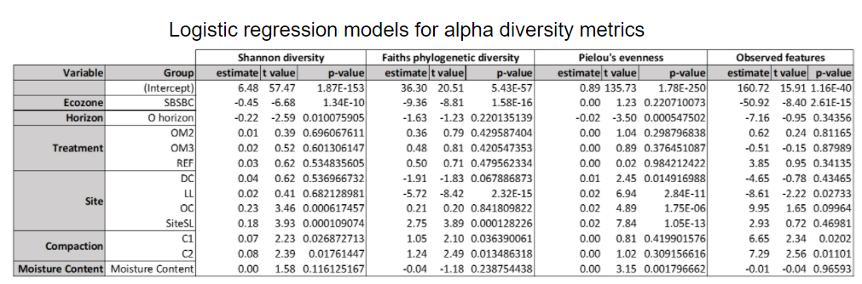

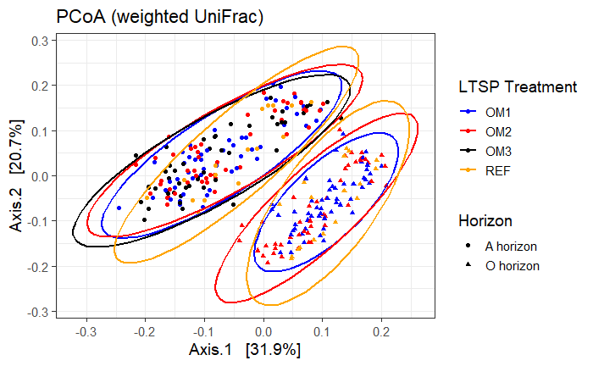

Supplementary Figure S4: Clustering of different OM treatments separated by soil horizon. Weighted UniFrac PCoA ordinations of all three OM treatments and the reference plot (REF). There is no observable distinct clustering pattern between any of the different OM treatments. OM3 (black) was not present in the O horizon. Variance identified by each PCoA axis is given in parentheses.

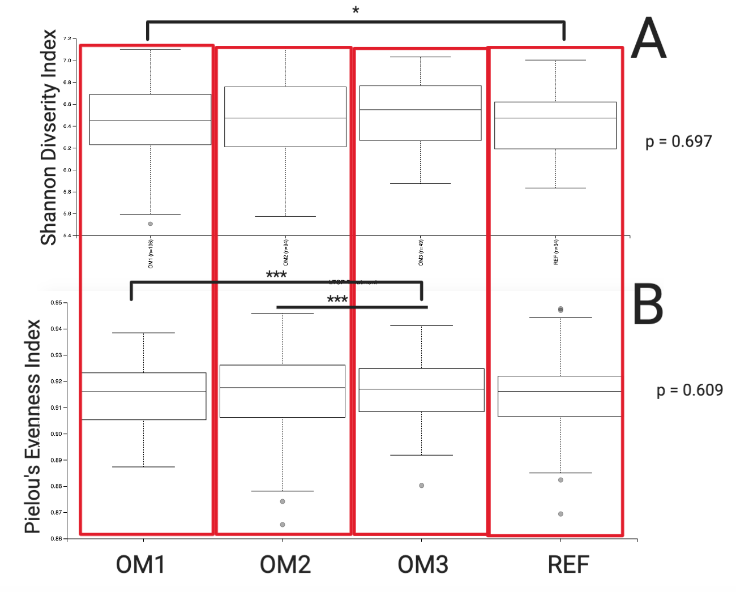
Supplementary Figure S5. No differences in microbial diversity between OM treatments. Box plot visualization of Shannon Diversity (A) and Pielou’s Evenness (B) metrics done on forest sites in BC separated by OM treatment. Upper and lower box boundaries represent the interquartile range (25%-75%); the middle line represents the median; upper and lower range of whiskers represent maximum and minimum values, respectively. The Kruskal-Wallis (all groups) p value is indicated. * indicates statistical significance (p<0.05). *** indicates p<0.001

Supplementary Table S2. Differentially abundant bacterial classes in OM removal treatment were determined using Indicator Taxa analysis.
Abbreviations: OM, Organic Matter; OM1, tree stem removal; OM2, whole tree removal; OM3, whole tree and top soil layer removal; REF, reference plot.
Test statistic used was the Indicator value.
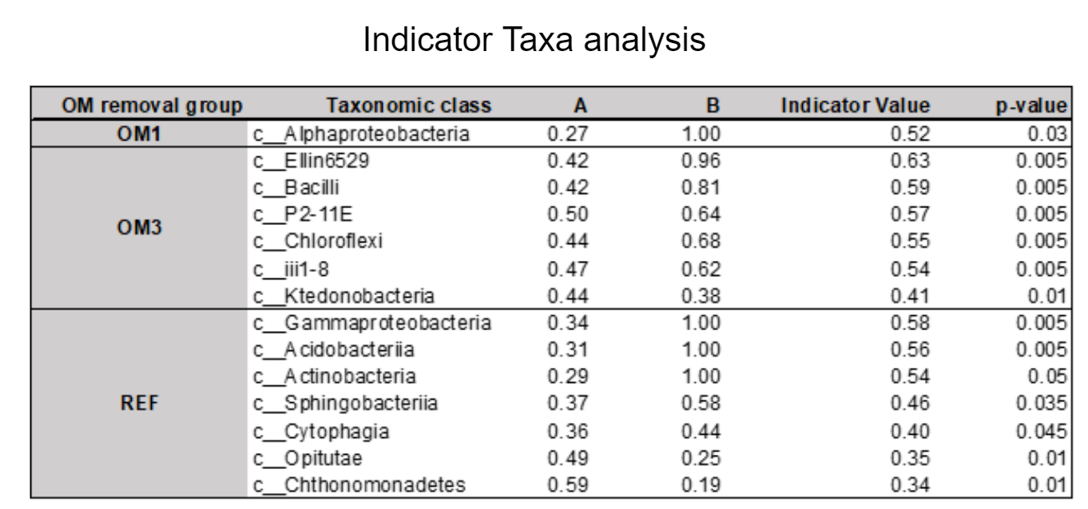

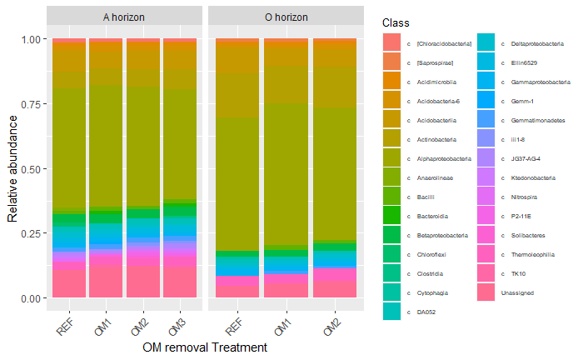
Supplementary figure S6: Composition of bacterial classes relative to OM removal treatments and soil horizon. Composition bar plot shows representative microbial classes with relative abundance over 1%. OM, Organic Matter; OM1, tree stem removal; OM2, whole tree removal; OM3, whole tree and top soil layer removal; REF, reference plot. Each color represents an independent taxonomic class
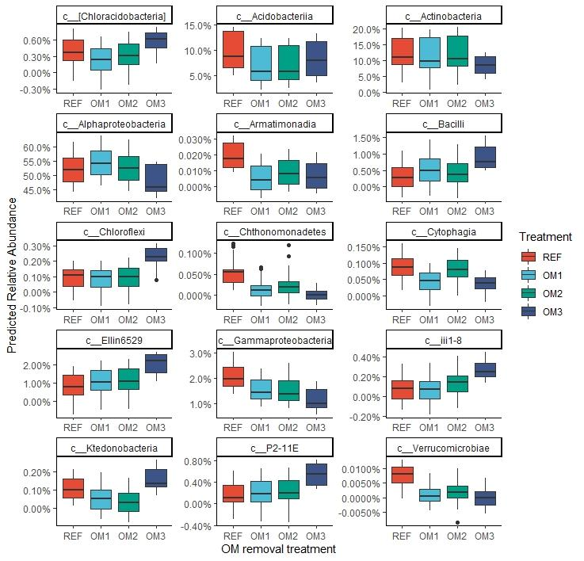

Supplementary Figure S7. Indicator Taxa analysis reveals significant abundance differences of bacterial classes based on OM removal treatment. Significant bacterial classes from the Indicator Taxa analysis were run through a logistic regression model to control for confounding variables. The model-predicted relative abundance of the representative classes was plotted based on OM treatment. Upper and lower box boundaries represent the interquartile range (25%-75%); the middle line represents the median; upper and lower range of whiskers represent maximum and minimum values, respectively. Indicator value significance was calculated based on the Permutation.

