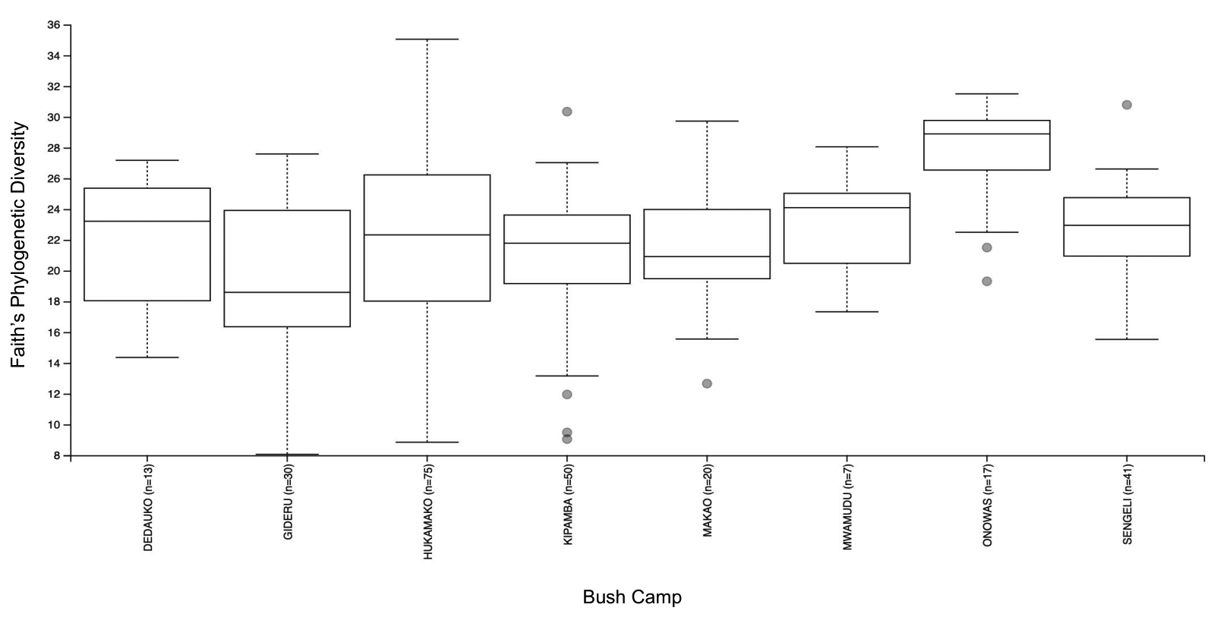SUPPLEMENTARY FIG. 1.
Alpha-diversity comparisons of gut microbial composition between the 8 bush camps of interest. Assessments of phylogenetic richness using Faith’s Phylogenetic Diversity reveal no significant differences between bush camps, with the exception of the Onowas bush camp (p-adjusted=0.003; Kruskal-Wallis pairwise). Whiskers represent minimum and maximum values of alpha-diversity values. Outliers are denoted as dots.

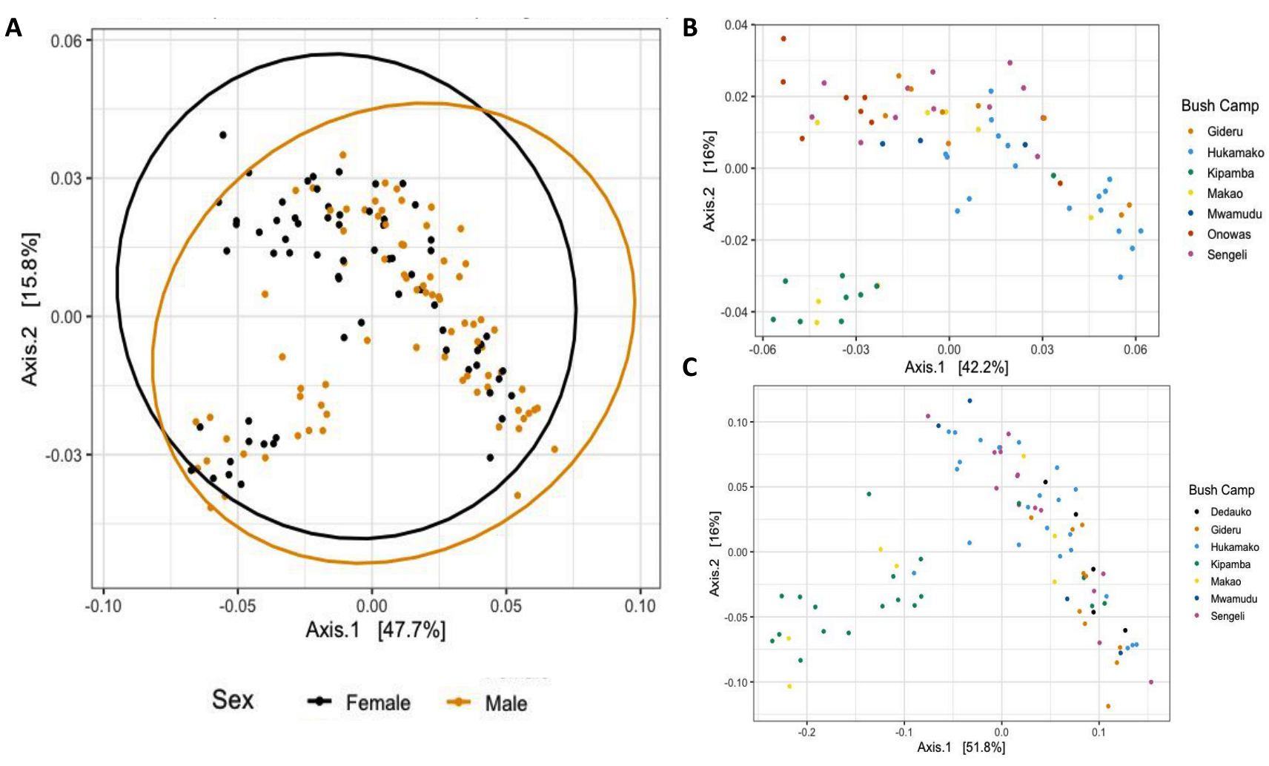

SUPPLEMENTARY FIG. 2.
Sex differences in gut microbiome composition. (A) Weighted UniFrac PCoA of fecal microbiota from males and females post-puberty reveal no clear patterns of separation by sex. (B) Weighted UniFrac PCoA applied to gut microbial composition by bush camp in females post-puberty and (C) males post-puberty.

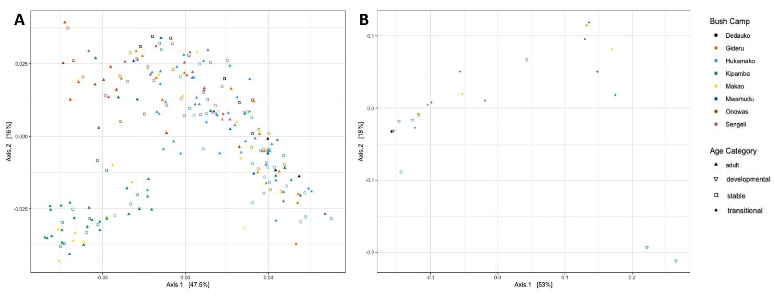
SUPPLEMENTARY FIG. 3.
Age differences in gut microbiome composition. (A) Weighted UniFrac PCoA of fecal microbiota from individuals in the adult (>46 years) and stable (31-46 months) age category of microbiome development. (B) Weighted UniFrac PCoA of fecal microbiota from individuals in the developmental (3-14 months) and transitional (15-30 months) age categories of microbiome development.

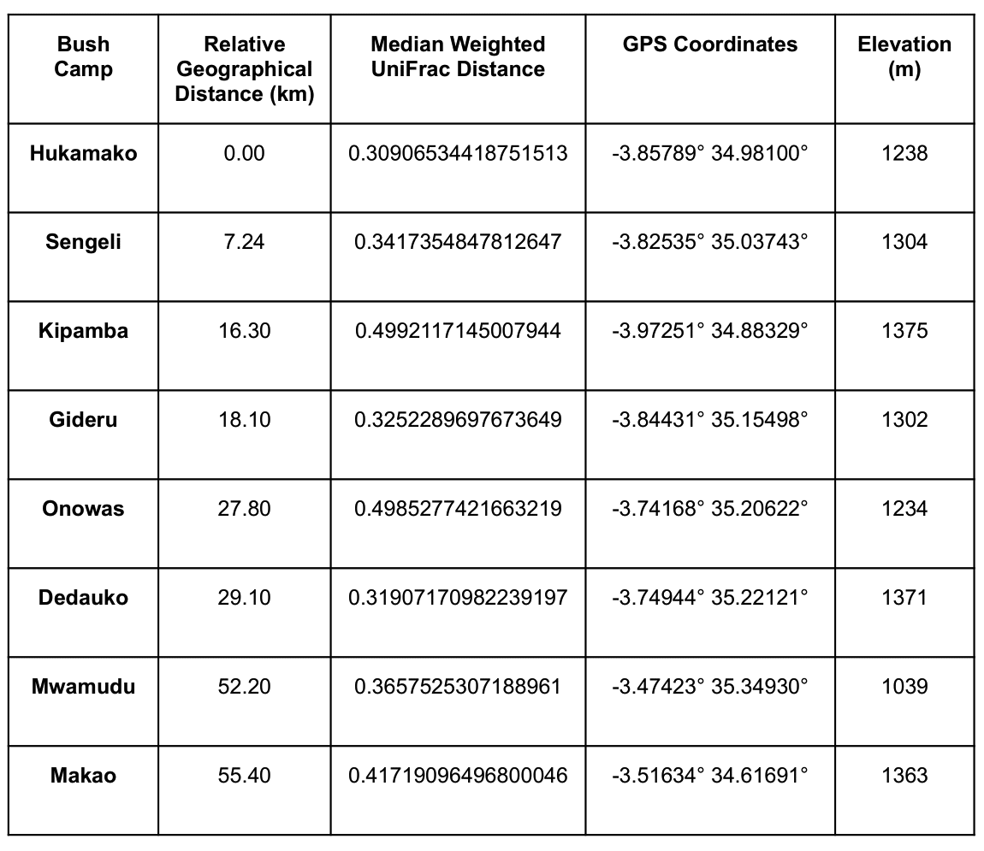
SUPPLEMENTARY TABLE 1.
The 8 Hadza Bush Camps of Interest. A summary of the obtained geographical coordinates and settlement elevations for each Hadza bush camp included in the study. Median Weighted UniFrac distance and relative geographical distance were measured against Hukamako as the reference bush camp.

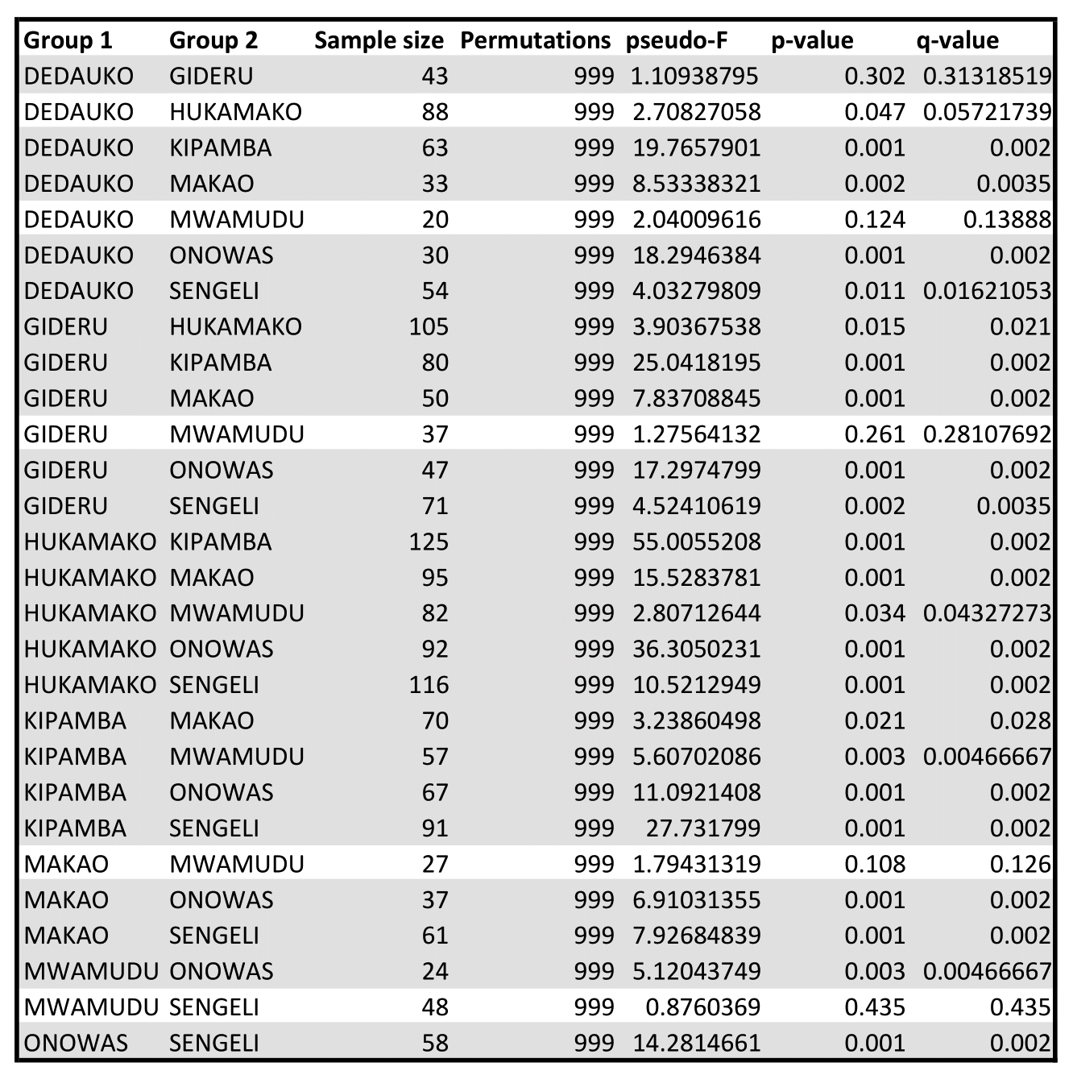
SUPPLEMENTARY TABLE 2.
Summary of pairwise PERMANOVA results for weighted UniFrac distances between the 8 bush camps of interest. Hsighlighted rows indicate significance (p-adjusted > 0.05).

