Supplementary Material
Effects of Dietary Fiber Intake on Gut Microbial Diversity and the Abundance of short-chain fatty acid Producing and Proteolytic Bacteria in Parkinson’s Disease Patients
Authors: Parsa Afrasiabi, Nicholas deGoutiere, Barinder Kaila, and Arshbir Aulakh
Affiliation: Department of Microbiology and Immunology, University of British Columbia, Vancouver, British Columbia, Canada

FIGURE CAPTIONS
Figure S1: Relative abundance of SCFA-producing bacteria in (A) control and (B) PD patients in high and low fiber conditions. No significant differences were observed among these bacteria. However a slightly higher median is observed in Coprococcus and Lachnospira in high fiber groups.

Figure S2: Relative abundance of proteolytic bacteria in (A) control and (B) PD patients in high and low fiber conditions. No significant difference observed in abundance between high and low fiber groups, and a low relative abundance overall for these bacteria.

Figure S3: Correlation analysis of Bristol stool scores (1-6) vs. fiber consumption in (A) control and (B) PD patients. No linear correlation is observed between these two variables (R <0.1 and p <0.05).

CONTROL
A
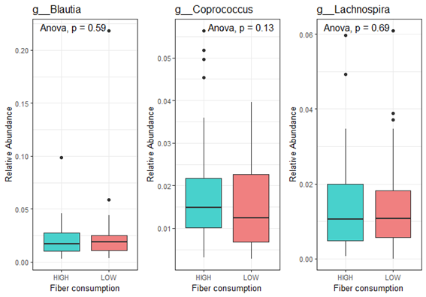
PD
B
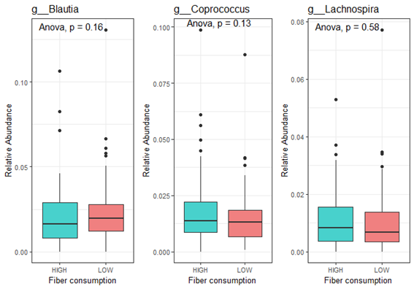
Figure S1: Relative abundance of SCFA-producing bacteria in (A) control and(B) PD patients in high and low fiber conditions. No significant differences were observed among these bacteria. However a slightly higher median is observed in Coprococcus and Lachnospira in high fiber groups.

CONTROL
A
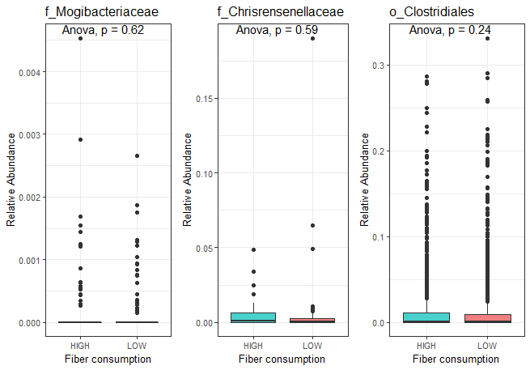

PD
B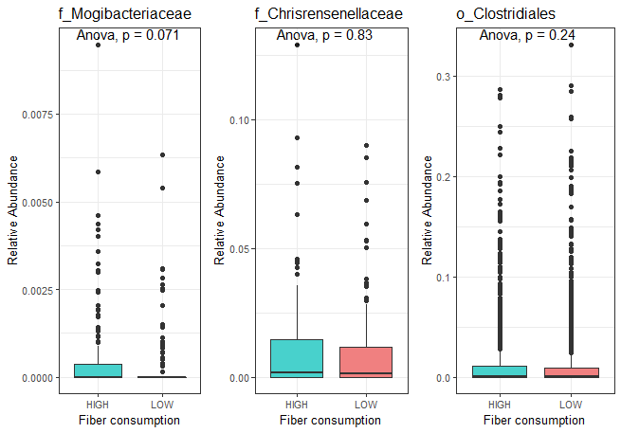
Figure S2: Relative abundance of proteolytic bacteria in (A) control and (B) PD patients in high and low fiber conditions. No significant difference observed in abundance between high and low fiber groups, and a low relative abundance overall for these bacteria.

CONTROL
A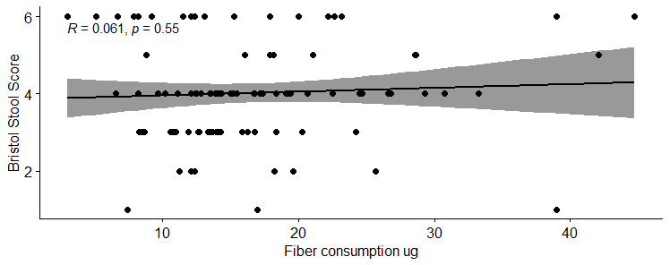

PD
B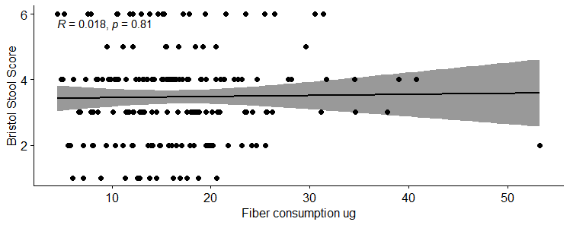

Figure S3: Correlation analysis of Bristol stool scores (1-6) vs. fiber consumption in (A) control and (B) PD patients. No linear correlation is observed between these two variables (R <0.1 and p <0.05).

