Supplemental Material
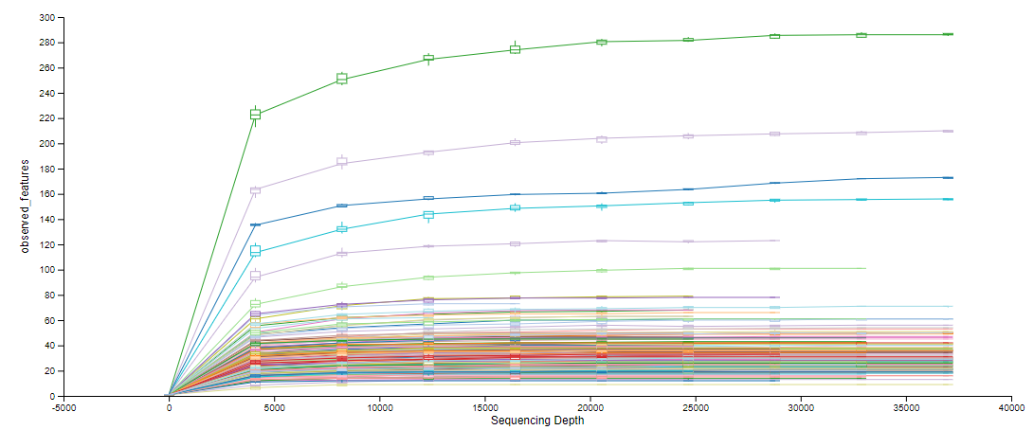
Figure S1. Sampling depth was selected to be 4250 for phylogenetic analysis. The alpha-rarefaction plot was generated using QIIME. The sequencing depth is the number of sequenced bases per sample, while the observed features represent ASV. Curves represent different wlz values.

Table S1. Maternal weight classification based on BMI. The BMI definitions used to subset data for the maternal BMI determinant.
Body Mass Index (BMI) | Classification
Less than 18.5 | Underweight
Between 18.5 and 24.9 | Normal
Between 24.9 and 29.9 | Overweight
Above 30 | Obese
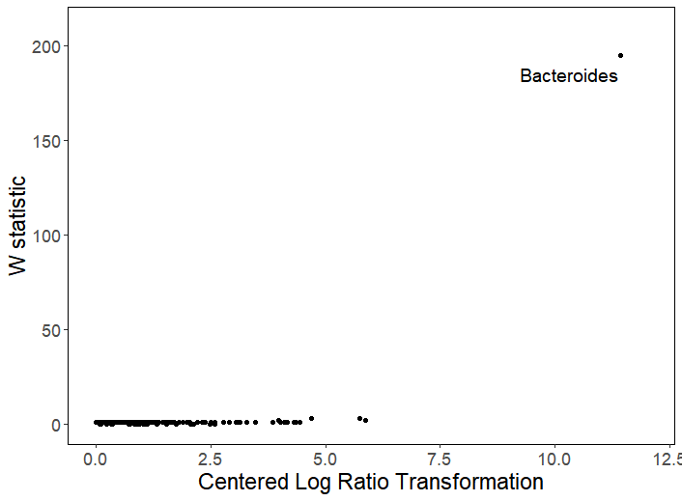
Figure S2. Only the Bacteroides genus was differentially abundant between modes of delivery. Analysis of composition of microbiomes (ANCOM) was done at the genus level between c-section and vaginally delivered infants in QIIME. W statistic measures significance of differences while Centered Log Ratio Transformation represents the magnitude of differences. For Bacteroides (labelled), W=195. Data was visualized in R.

