A B
C
Figure S1. Principal coordinate analysis in taxonomic groups do not have a clear pattern with location. PCoA plots using the Bray-Curtis dissimilarity index show diversity across various locations. (A) family Rhinocerotidae and (B) genus Equus exhibit a pattern in regards to location. (C) Gorilla gorilla do not exhibit any clustering in regards to location. PERMANOVA testing did not exhibit statistical significance.
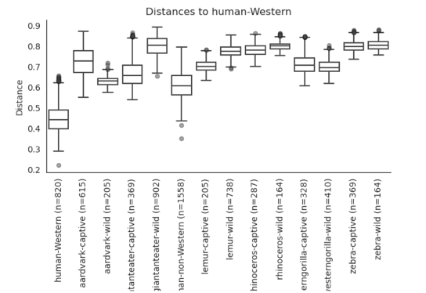
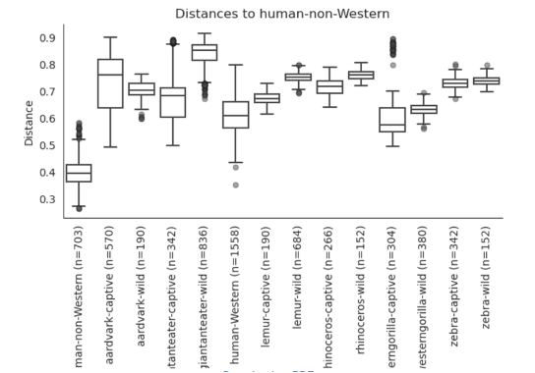
Figure S2. Unweighted UniFrac distance metric comparing distances of captive and wild animals to Western and non-Western humans. Captive animals are more similar to humans than wild animals are, and to non-Western humans than to Western humans.

A
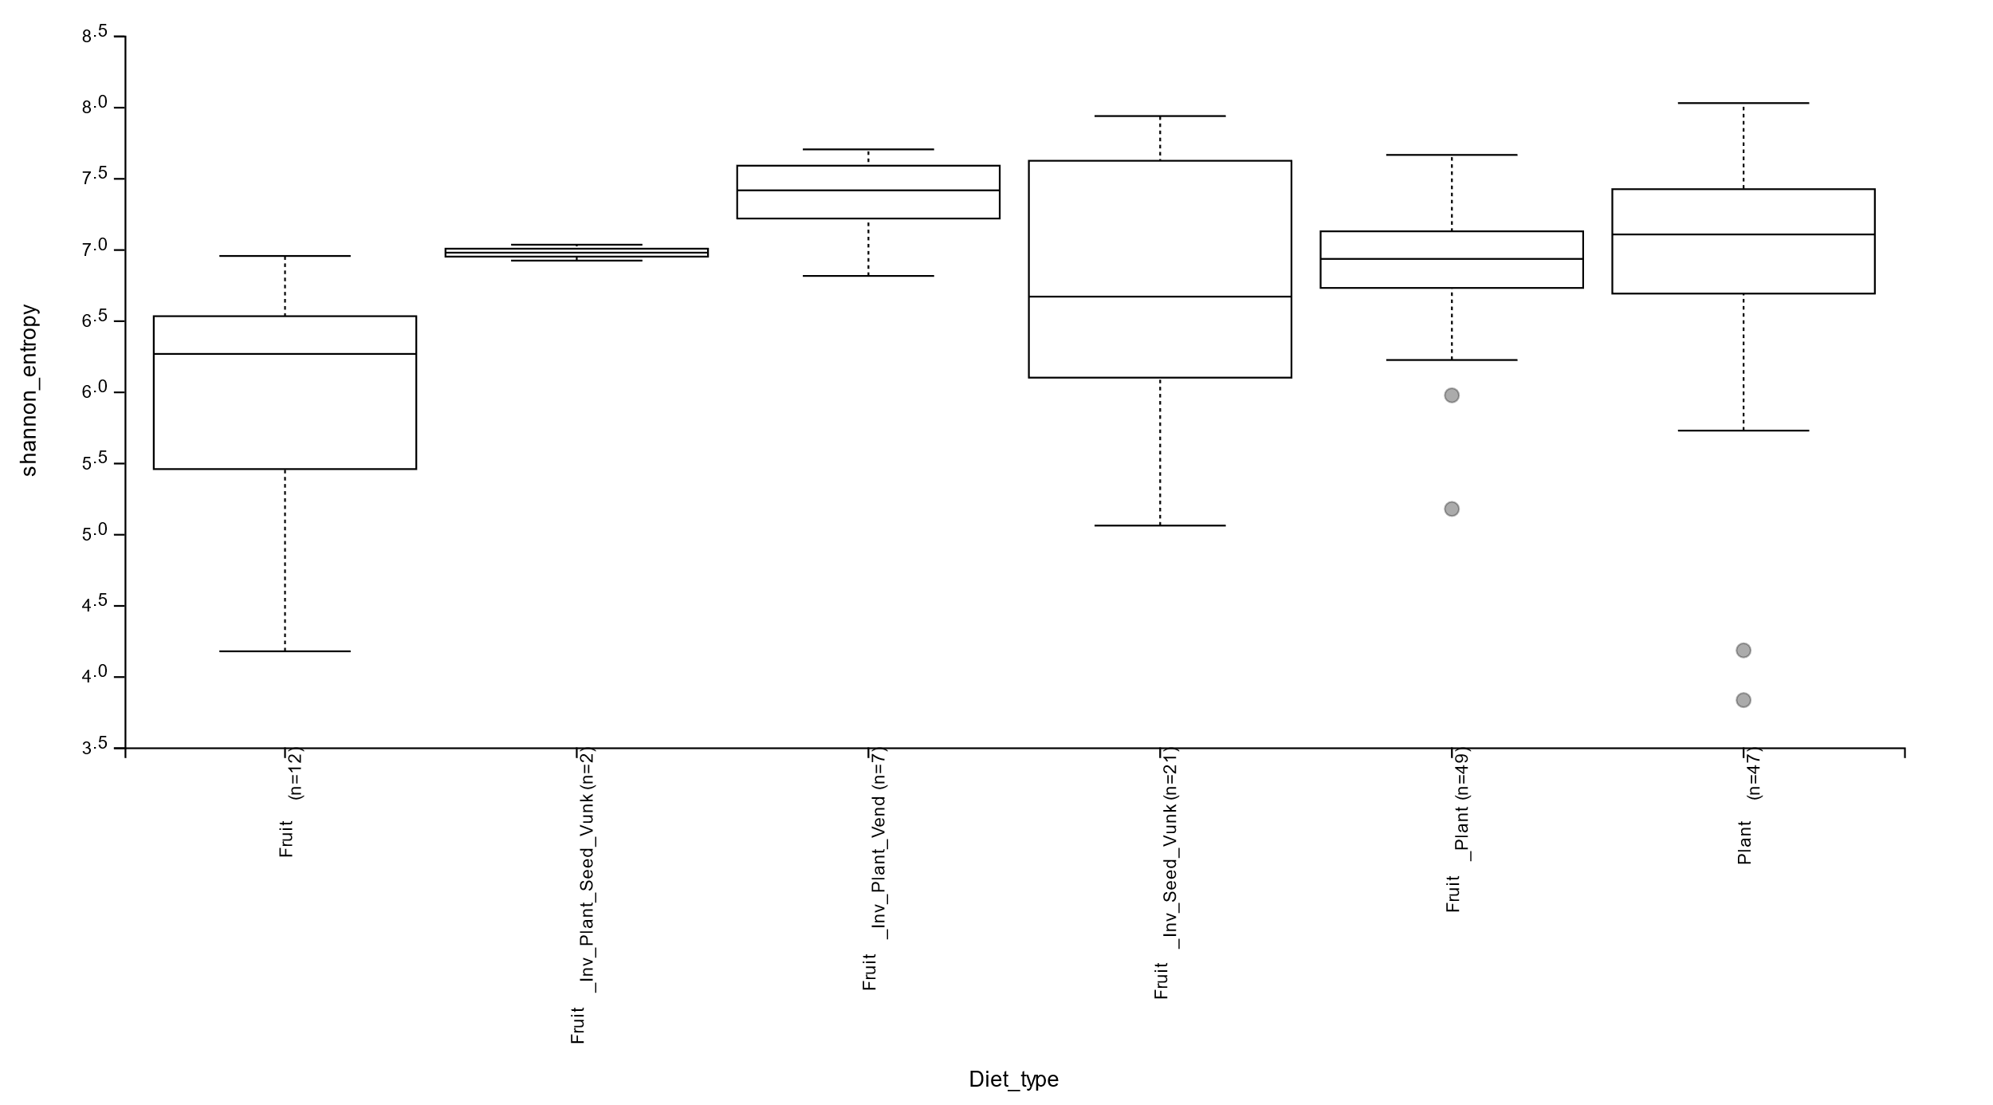
B
Diet composition |  | p-value
Fruit (n=12) | Fruit_Inv_Plant_Seed_Vunk (n=2) | 0.067889
 | Fruit_Inv_Plant_Vend (n=7) | 0.000723
 | Fruit_Inv_Seed_Vunk (n=21) | 0.02474
 | Fruit_Plant (n=49) | 7.65E-05
 | Plant (n=47) | 0.000223
Fruit_Inv_Plant_Seed_Vunk (n=2) | Fruit_Inv_Plant_Vend (n=7) | 0.143235
 | Fruit_Inv_Seed_Vunk (n=21) | 0.827259
 | Fruit_Plant (n=49) | 0.734095
 | Plant (n=47) | 0.686041
Fruit_Inv_Plant_Vend (n=7) | Fruit_Inv_Seed_Vunk (n=21) | 0.144556
 | Fruit_Plant (n=49) | 0.004925
 | Plant (n=47) | 0.125462
Fruit_Inv_Seed_Vunk (n=21) | Fruit_Plant (n=49) | 0.594819
 | Plant (n=47) | 0.377381
Fruit_Plant (n=49) | Plant (n=47) | 0.109281

Figure S3. Shannon diversity demonstrate a significant decrease in bacterial abundance compared to other composition. Alpha diversity of each diet composition is computed using QIIME2 and plotted in (A) boxplot visualized with QIIME2 view tested for statistical significance, (B) statistical significance in p-value of each composition to one another.
Table S1. Indicator family of giant anteaters (Myrmecophaga tridactyla)
Taxonomic Classification | Indicator Statistic | p-value
National Zoo (number of indicator families = 2)  Bacteria Tenericutes Mollicutes Anaeroplasmatales Anaeroplasmataceae  Bacteria Verrucomicrobia Verrucomicrobiae Verrucomicrobiales Verrucomicrobiaceae | 1.0000  0.993 | 0.005  0.010
Zurich Zoo (number of indicator families = 8)  Bacteria Actinobacteria Actinobacteria Actinomycetales NA  Bacteria Proteobacteria NA NA NA  Bacteria Firmicutes Bacilli Lactobacillales Leuconostocaceae  Bacteria Firmicutes Bacilli Turicibacterales Turicibacteraceae  Bacteria Firmicutes Erysipelotrichi Erysipelotrichales Erysipelotrichaceae  Bacteria Firmicutes Bacilli Lactobacillales Streptococcaceae  Bacteria Firmicutes Clostridia Clostridiales NA  Bacteria Firmicutes Clostridia Clostridiales Peptococcaceae | 1.000  0.995  0.970  0.967  0.924  0.899  0.877  0.875 | 0.015  0.020  0.010  0.015  0.010  0.010  0.020  0.030

Table S2. Indicator family of aardvarks (Orycteropus afer)

Taxonomic Classification | Indicator Statistic | p-value
Cincinnati Zoo (number of indicator families = 3)  Bacteria Proteobacteria Gammaproteobacteria Aeromonadales Succinivibrionaceae  Bacteria Bacteroidetes Bacteroidia Bacteroidales Prevotellaceae  Bacteria Firmicutes Clostridia Clostridiales Ruminococcaceae | 0.991  0.964  0.836 | 0.005  0.010  0.020
Colchester Zoo (number of indicator families = 5)  Bacteria Bacteroidetes Flavobacteriia Flavobacteriales Flavobacteriaceae  Bacteria Actinobacteria Actinobacteria Actinomycetales Micrococcaceae  Bacteria Proteobacteria Gammaproteobacteria Pseudomonadales Moraxellaceae  Bacteria Firmicutes Clostridia Clostridiales [Tissierellaceae]  Bacteria Proteobacteria Alphaproteobacteria Rhodobacterales Rhodobacteraceae | 0.934  0.911  0.902  0.871  0.862 | 0.010  0.005  0.010  0.015  0.005
London Zoo (number of indicator families = 8)  Bacteria Bacteroidetes Bacteroidia Bacteroidales RF16  Bacteria TM7 TM7-3 CW040 F16  Bacteria Firmicutes Bacilli Bacillales Alicyclobacillaceae  Bacteria Tenericutes Mollicutes RF39 NA  Bacteria Bacteroidetes Bacteroidia Bacteroidales NA  Bacteria Firmicutes Clostridia Clostridiales [Mogibacteriaceae]  Bacteria Firmicutes Erysipelotrichi Erysipelotrichales Erysipelotrichaceae  Bacteria Firmicutes Clostridia Clostridiales Clostridiaceae | 0.988  0.942  0.920  0.892  0.870  0.837  0.831  0.807 | 0.010  0.015  0.005  0.030  0.040  0.020  0.045  0.035
TdR Nature Reserve (number of indicator families = 32)  Bacteria Actinobacteria Actinobacteria Actinomycetales Geodermatophilaceae  Bacteria Actinobacteria Actinobacteria Actinomycetales Thermomonosporaceae  Bacteria Planctomycetes Planctomycetia Gemmatales Isosphaeraceae  Bacteria Bacteroidetes NA NA NA  Bacteria Proteobacteria Gammaproteobacteria NA NA  Bacteria Proteobacteria Gammaproteobacteria Alteromonadales Alteromonadaceae Bacteria Firmicutes Bacilli Bacillales Bacillaceae  Bacteria Firmicutes Bacilli Bacillales Paenibacillaceae  Bacteria Bacteroidetes Bacteroidia Bacteroidales Bacteroidaceae  Bacteria Proteobacteria Gammaproteobacteria Pseudomonadales Pseudomonadaceae  Bacteria Actinobacteria Actinobacteria Actinomycetales NA  Bacteria Firmicutes Bacilli Lactobacillales Aerococcaceae  Bacteria Proteobacteria Alphaproteobacteria Rhizobiales Brucellaceae  Bacteria Proteobacteria Gammaproteobacteria Xanthomonadales Xanthomonadaceae  Bacteria Firmicutes Bacilli Bacillales NA  Bacteria Actinobacteria Actinobacteria Actinomycetales Promicromonosporaceae  Bacteria Proteobacteria Betaproteobacteria Burkholderiales Alcaligenaceae  Bacteria NA NA NA NA  Bacteria Actinobacteria Actinobacteria Actinomycetales Actinomycetaceae  Bacteria Actinobacteria Actinobacteria Actinomycetales Bogoriellaceae  Bacteria Actinobacteria Actinobacteria Actinomycetales Mycobacteriaceae  Bacteria Actinobacteria Actinobacteria Actinomycetales Streptosporangiaceae  Bacteria Gemmatimonadetes Gemm-3 NA NA  Bacteria Proteobacteria Alphaproteobacteria Rhizobiales Beijerinckiaceae  Bacteria Proteobacteria Alphaproteobacteria Rhizobiales Methylobacteriaceae  Bacteria Proteobacteria Gammaproteobacteria  Bacteria Proteobacteria Gammaproteobacteria Chromatiales Ectothiorhodospiraceae  Bacteria Proteobacteria NA NA NA  Bacteria Tenericutes Mollicutes RsaHF231 NA  Bacteria TM7 TM7-3 I025 NA  Bacteria Fusobacteria Fusobacteriia Fusobacteriales Fusobacteriaceae  Bacteria Actinobacteria Actinobacteria Actinomycetales Yaniellaceae | 1.000  1.000  1.000  1.000  1.000  0.998  0.997  0.997  0.985  0.984  0.984  0.983  0.982  0.979  0.975  0.974  0.973  0.959  0.866  0.866  0.866  0.866  0.866  0.866  0.866  0.866  0.866  0.866  0.866  0.866  0.855  0.852 | 0.005  0.005  0.005  0.005  0.005  0.005  0.005  0.005  0.030  0.005  0.005  0.005  0.005  0.005  0.005  0.005  0.005  0.005  0.015  0.015  0.015  0.015  0.030  0.020  0.015  0.020  0.010  0.030  0.015  0.015  0.040  0.035
Table S3. Indicator taxa at the genus level. Indicator taxa analysis showing bacterial taxa present in humans and captive animals that are absent in wild animals. Most notable genera include Blautia, Streptococcus, Coprococcus, Ruminococcus, Oscillospira, Faecalibacterium, Lachnospira, Roseburia and Clostridium. A represents the specificity of each taxon to the group (human-captive animals), B the fidelity and stat the indicator value (A*B). Asterisks represent different p-values (‘***’ - 0, ‘**’ - 0.001, ‘*’ - 0.01, ‘.’ - 0.05, ‘ ’ - 0.1).
Giant anteater
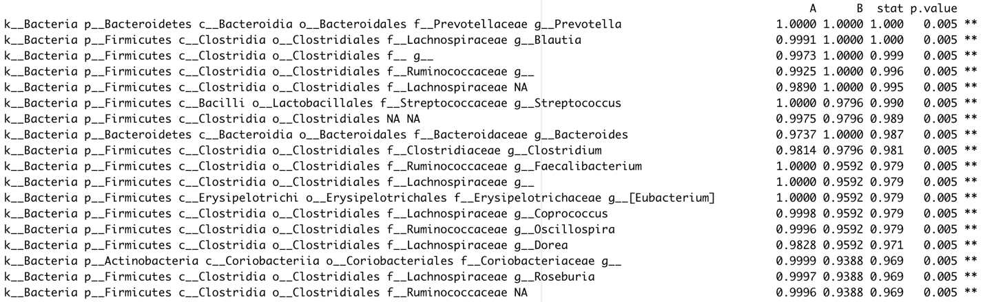
Rhinoceros
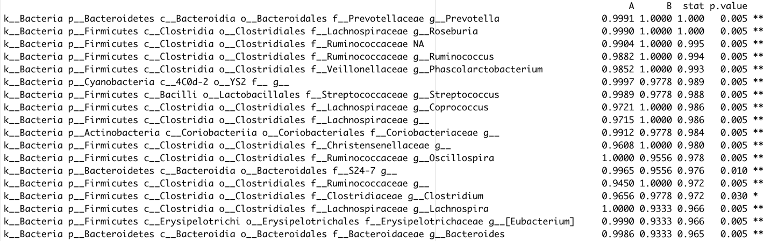
Lemur
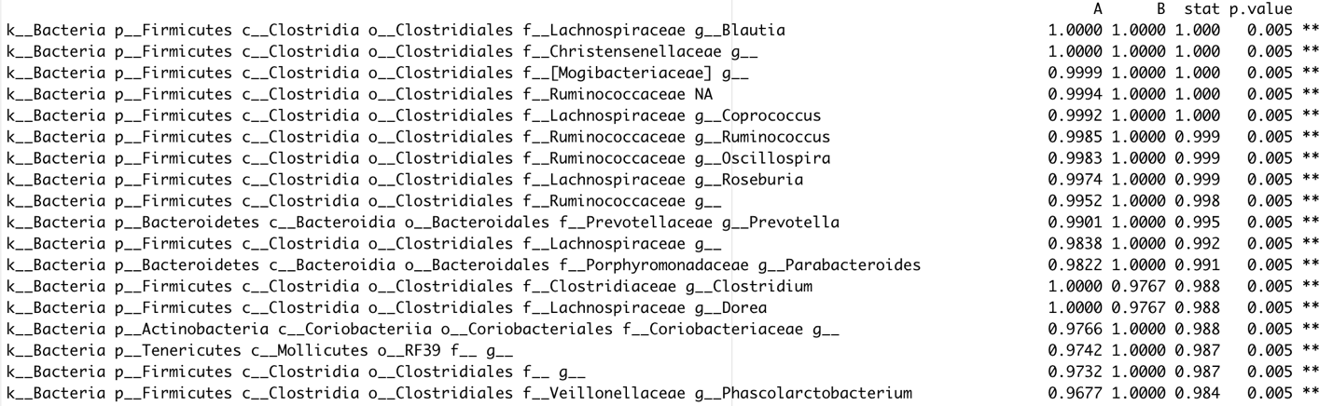

Western gorilla
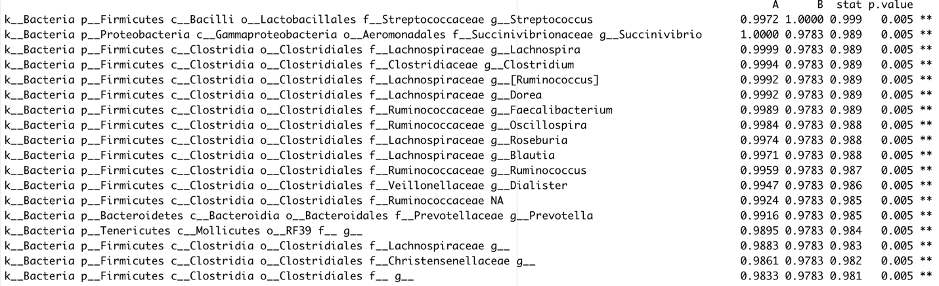

Table S4. Differentially abundant classes based on diet composition. Differential abundance was computed in R using the phyloseq package at class level based on the diet composition. The significance is reported with adjusted p-value.

Class | Adjusted p-value
Opitutae | 0.017170242
Epsilonproteobacteria | 0.00609561
Gammaproteobacteria | 0.002797558
Planctomycetia | 0.006412206
Erysipelotrichi | 2.20E-05
Anaerolineae | 6.27E-27
Clostridia | 0.000469216

