SUPPLEMENTAL MATERIAL

The effects of alcohol consumption and increased body mass on the gut microbiota of Parkinson’s Disease patients

Jared Dutra, Madeline Fung, Michelle Ling, Rui Lin Zhi

SUPPLEMENTAL TABLE CAPTIONS
Table S1. Alcohol consumption categories. Criteria for each category was based on Canadian Centre on Substance Use and Addiction guidelines for daily alcohol consumption in adult men and women (56).
Table S2. BMI categories for PD patients and healthy controls. Criteria for overweight status was based on BMI score groupings (15).
Table S3. Pairwise PERMANOVA results based on Weighted UniFrac beta diversity analysis between alcohol consumption groups. Group 1 and 2 denote the two groups being compared. p-value <0.05 = significant. q-value <0.05 = significant.
Table S4. Pairwise PERMANOVA results based on Bray-Curtis beta diversity analysis between alcohol consumption groups. Group 1 and 2 denote the two groups being compared. p-value <0.05 = significant. q-value <0.05 = significant.
Table S5. Pairwise PERMANOVA results based on Unweighted UniFrac beta diversity analysis between alcohol consumption groups. Group 1 and 2 denote the two groups being compared. p-value <0.05 = significant. q-value <0.05 = significant.
Table S6. Pairwise PERMANOVA results based on Jaccard beta diversity analysis between alcohol consumption groups. Group 1 and 2 denote the two groups being compared. p-value <0.05 = significant. q-value <0.05 = significant.
Table S7. Coprococcus differential abundance results in subjects sorted by alcohol consumption categories. Columns n1 and n2 denote sample sizes corresponding to the alcohol consumption groups being compared, Group 1 and Group 2, respectively. Adjusted p-values <0.05 = significant. ns = not significant.
Table S8. Blautia differential abundance results in subjects sorted by alcohol consumption categories. Columns n1 and n2 denote sample sizes corresponding to the alcohol consumption groups being compared, Group 1 and Group 2, respectively. Adjusted p-values <0.05 = significant. ns = not significant.
Table S9. Roseburia differential abundance results in subjects sorted by alcohol consumption categories. Columns n1 and n2 denote sample sizes corresponding to the alcohol consumption groups being compared, Group 1 and Group 2, respectively. Adjusted p-values <0.05 = significant. ns = not significant.
Table S10. Lachnospira differential abundance results in subjects sorted by alcohol consumption categories. Columns n1 and n2 denote sample sizes corresponding to the alcohol consumption groups being compared, Group 1 and Group 2, respectively. Adjusted p-values <0.05 = significant. ns = not significant.
Table S11. Faecalibacterium differential abundance results in subjects sorted by alcohol consumption categories. Columns n1 and n2 denote sample sizes corresponding to the alcohol consumption groups being compared, Group 1 and Group 2, respectively. Adjusted p-values <0.05 = significant. ns = not significant.
Table S12. Pairwise PERMANOVA results based on the Weighted UniFrac beta diversity distances for comparing BMI and PD disease status. Group 1 and 2 denote the two groups being compared. p-value <0.05 = significant. q-value <0.05 = significant.
Table S13. Two indicator families are associated with overweight PD individuals. A indicates specificity (RA of a given taxa for each group) and B indicates fidelity (taxa present across the majority of samples from that specific group). Indicator value “stat” is calculated by multiplying A and B. p-values <0.05 = significant.

SUPPLEMENTAL FIGURE CAPTIONS
Figure S1. Alcohol consumption categories do not have an effect on microbial community composition. The gut microbiome composition of subjects was analyzed with (A) Jaccard, (B) Bray-Curtis, and (C) Unweighted UniFrac beta diversity metrics in QIIME2. Corresponding pairwise PERMANOVA statistics can be found in Tables S4-S6.
Figure S2. No differences in the composition of gut microbiomes of different alcohol consumption groups were observed across any beta diversity metric. Beta diversity of gut microbiotas across subjects in the three categories of alcohol consumption based on (A) Jaccard, (B) Bray-Curtis, and (C) Unweighted UniFrac. Corresponding pairwise PERMANOVA statistics can be found in Tables S4-S6.
Figure S3. No correlation was found between average alcohol consumption (g/day) and UPDRS 1, 2, 3, and 4 scores. (A) UPDRS 1 and (B) 2 scores are based on non-motor and motor challenges faced by subjects in their day-to-day lives, respectively. (C) UPDRS 3 scores represent the results of a movement analysis examination. (D) UPDRS 4 scores represent motor complications experienced by patients. Higher scores indicate more severe symptoms. Subjects with no alcohol consumption data were excluded from the analysis. Number of patients (n) = 195.
Figure S4. Five families are differential abundant between overweight and normal PD patients. The families Veillonellaceae, Lachnospiraceae, Desulfovibrionaceae, and Alcaligenaceae exhibited a positive fold change, indicating a higher abundance in overweight PD patients. The family Victivallaceae exhibited a negative fold change, indicating a higher abundance in normal PD patients.
SUPPLEMENTAL TABLES
Table S1. Alcohol consumption categories. Criteria for each category was based on Canadian Centre on Substance Use and Addiction guidelines for daily alcohol consumption in adult men and women (56).
Women |  |  | Men
Alcohol consumption | Range (g/day) | n | Alcohol consumption | Range (g/day) | n
None | 0 | 23 | None | 0 | 38
Low | 0.1 - 13.6 | 90 | Low | 0.1 - 27.2 | 107
Moderate | 13.7 - 27.1 | 5 | Moderate | 27.3 - 40.7 | 10
High | >27.2 | 9 | High | >40.8 | 3

Table S2. BMI categories for PD patients and healthy controls. Criteria for overweight status was based on BMI score groupings (15).
Disease status | BMI categories  (normal = 18.5-25; overweight = 25-30) | Number of subjects (n)
Control | Normal | 41
 | Overweight | 38
PD | Normal | 71
 | Overweight | 82

Table S3. Pairwise PERMANOVA results based on Weighted UniFrac beta diversity analysis between alcohol consumption groups. Group 1 and 2 denote the two groups being compared. p-value <0.05 = significant. q-value <0.05 = significant.
Group 1 | Group 2 | Sample size | Permutation | pseudo-F | p-value | q-value
High | Low | 165 | 999 | 1.102104 | 0.306 | 0.787
High | Moderate | 21 | 999 | 0.717307 | 0.633 | 0.787
High | None | 54 | 999 | 1.120412 | 0.33 | 0.787
Low | Moderate | 166 | 999 | 0.561177 | 0.746 | 0.787
Low | None | 199 | 999 | 0.51953 | 0.787 | 0.787
Moderate | None | 55 | 999 | 0.558168 | 0.668 | 0.787

Table S4. Pairwise PERMANOVA results based on Bray-Curtis beta diversity analysis between alcohol consumption groups. Group 1 and 2 denote the two groups being compared. p-value <0.05 = significant. q-value <0.05 = significant.
Group 1 | Group 2 | Sample size | Permutation | pseudo-F | p-value | q-value
High | Low | 165 | 999 | 1.767261 | 0.907 | 0.907
High | Moderate | 21 | 999 | 2.773597 | 0.643 | 0.8304
High | None | 54 | 999 | 1.925926 | 0.524 | 0.8304
Low | Moderate | 166 | 999 | 1.574987 | 0.692 | 0.8304
Low | None | 199 | 999 | 0.824537 | 0.512 | 0.8304
Moderate | None | 55 | 999 | 0.717412 | 0.483 | 0.8304

Table S5. Pairwise PERMANOVA results based on Unweighted UniFrac beta diversity analysis between alcohol consumption groups. Group 1 and 2 denote the two groups being compared. p-value <0.05 = significant. q-value <0.05 = significant.
Group 1 | Group 2 | Sample size | Permutation | pseudo-F | p-value | q-value
High | Low | 165 | 999 | 0.913513 | 0.6 | 0.9585
High | Moderate | 21 | 999 | 0.91976 | 0.639 | 0.9585
High | None | 54 | 999 | 1.200759 | 0.172 | 0.909
Low | Moderate | 166 | 999 | 0.614935 | 0.995 | 0.995
Low | None | 199 | 999 | 1.062708 | 0.303 | 0.909
Moderate | None | 55 | 999 | 0.742394 | 0.909 | 0.995

Table S6. Pairwise PERMANOVA results based on Jaccard beta diversity analysis between alcohol consumption groups. Group 1 and 2 denote the two groups being compared. p-value <0.05 = significant. q-value <0.05 = significant.
Group 1 | Group 2 | Sample size | Permutation | pseudo-F | p-value | q-value
High | Low | 165 | 999 | 0.944019 | 0.68 | 0.971
High | Moderate | 21 | 999 | 0.938257 | 0.736 | 0.971
High | None | 54 | 999 | 1.024249 | 0.336 | 0.971
Low | Moderate | 166 | 999 | 0.846103 | 0.971 | 0.971
Low | None | 199 | 999 | 0.998596 | 0.453 | 0.971
Moderate | None | 55 | 999 | 0.878127 | 0.924 | 0.971

Table S7. Coprococcus differential abundance results in subjects sorted by alcohol consumption categories. Columns n1 and n2 denote sample sizes corresponding to the alcohol consumption groups being compared, Group 1 and Group 2, respectively. Adjusted p-values <0.05 = significant. ns = not significant.
Disease | Variable | Group 1 | Group 2 | n1 | n2 | p | p.adj | p.adj.signif
Control | Abundance | High | Low | 7 | 71 | 0.01 | 0.12 | ns
Control | Abundance | High | Moderate | 7 | 4 | 0.066 | 0.792 | ns
Control | Abundance | High | None | 7 | 19 | 0.02 | 0.24 | ns
Control | Abundance | Low | Moderate | 71 | 4 | 0.96 | 1 | ns
Control | Abundance | Low | None | 71 | 19 | 0.663 | 1 | ns
Control | Abundance | Moderate | None | 4 | 19 | 0.858 | 1 | ns
PD | Abundance | High | Low | 13 | 112 | 0.139 | 1 | ns
PD | Abundance | High | Moderate | 13 | 16 | 0.526 | 1 | ns
PD | Abundance | High | None | 13 | 43 | 0.414 | 1 | ns
PD | Abundance | Low | Moderate | 112 | 16 | 0.519 | 1 | ns
PD | Abundance | Low | None | 112 | 43 | 0.622 | 1 | ns
PD | Abundance | Moderate | None | 16 | 43 | 0.88 | 1 | ns

Table S8. Blautia differential abundance results in subjects sorted by alcohol consumption categories. Columns n1 and n2 denote sample sizes corresponding to the alcohol consumption groups being compared, Group 1 and Group 2, respectively. Adjusted p-values <0.05 = significant. ns = not significant.
Disease | Variable | Group 1 | Group 2 | n1 | n2 | p | p.adj | p.adj.signif
Control | Abundance | High | Low | 7 | 71 | 0.374 | 1 | ns
Control | Abundance | High | Moderate | 7 | 4 | 0.565 | 1 | ns
Control | Abundance | High | None | 7 | 19 | 0.336 | 1 | ns
Control | Abundance | Low | Moderate | 71 | 4 | 0.238 | 1 | ns
Control | Abundance | Low | None | 71 | 19 | 0.413 | 1 | ns
Control | Abundance | Moderate | None | 4 | 19 | 0.159 | 1 | ns
PD | Abundance | High | Low | 13 | 112 | 0.366 | 1 | ns
PD | Abundance | High | Moderate | 13 | 16 | 0.701 | 1 | ns
PD | Abundance | High | None | 13 | 43 | 0.262 | 1 | ns
PD | Abundance | Low | Moderate | 112 | 16 | 0.48 | 1 | ns
PD | Abundance | Low | None | 112 | 43 | 0.578 | 1 | ns
PD | Abundance | Moderate | None | 16 | 43 | 0.326 | 1 | ns

Table S9. Roseburia differential abundance results in subjects sorted by alcohol consumption categories. Columns n1 and n2 denote sample sizes corresponding to the alcohol consumption groups being compared, Group 1 and Group 2, respectively. Adjusted p-values <0.05 = significant. ns = not significant.
Disease | Variable | Group 1 | Group 2 | n1 | n2 | p | p.adj | p.adj.signif
Control | Abundance | High | Low | 7 | 71 | 0.712 | 1 | ns
Control | Abundance | High | Moderate | 7 | 4 | 0.786 | 1 | ns
Control | Abundance | High | None | 7 | 19 | 0.345 | 1 | ns
Control | Abundance | Low | Moderate | 71 | 4 | 0.916 | 1 | ns
Control | Abundance | Low | None | 71 | 19 | 0.356 | 1 | ns
Control | Abundance | Moderate | None | 4 | 19 | 0.802 | 1 | ns
PD | Abundance | High | Low | 13 | 112 | 0.162 | 1 | ns
PD | Abundance | High | Moderate | 13 | 16 | 0.151 | 1 | ns
PD | Abundance | High | None | 13 | 43 | 0.219 | 1 | ns
PD | Abundance | Low | Moderate | 112 | 16 | 0.648 | 1 | ns
PD | Abundance | Low | None | 112 | 43 | 0.863 | 1 | ns
PD | Abundance | Moderate | None | 16 | 43 | 0.604 | 1 | ns

Table S10. Lachnospira differential abundance results in subjects sorted by alcohol consumption categories. Columns n1 and n2 denote sample sizes corresponding to the alcohol consumption groups being compared, Group 1 and Group 2, respectively. Adjusted p-values <0.05 = significant. ns = not significant.
Disease | Variable | Group 1 | Group 2 | n1 | n2 | p | p.adj | p.adj.signif
Control | Abundance | High | Low | 7 | 71 | 0.51 | 1 | ns
Control | Abundance | High | Moderate | 7 | 4 | 0.319 | 1 | ns
Control | Abundance | High | None | 7 | 19 | 0.23 | 1 | ns
Control | Abundance | Low | Moderate | 71 | 4 | 0.493 | 1 | ns
Control | Abundance | Low | None | 71 | 19 | 0.345 | 1 | ns
Control | Abundance | Moderate | None | 4 | 19 | 0.825 | 1 | ns
PD | Abundance | High | Low | 13 | 112 | 0.759 | 1 | ns
PD | Abundance | High | Moderate | 13 | 16 | 0.67 | 1 | ns
PD | Abundance | High | None | 13 | 43 | 0.857 | 1 | ns
PD | Abundance | Low | Moderate | 112 | 16 | 0.265 | 1 | ns
PD | Abundance | Low | None | 112 | 43 | 0.366 | 1 | ns
PD | Abundance | Moderate | None | 16 | 43 | 0.684 | 1 | ns

Table S11. Faecalibacterium differential abundance results in subjects sorted by alcohol consumption categories. Columns n1 and n2 denote sample sizes corresponding to the alcohol consumption groups being compared, Group 1 and Group 2, respectively. Adjusted p-values <0.05 = significant. ns = not significant.
Disease | Variable | Group 1 | Group 2 | n1 | n2 | p | p.adj | p.adj.signif
Control | Abundance | High | Low | 7 | 71 | 0.184 | 1 | ns
Control | Abundance | High | Moderate | 7 | 4 | 0.403 | 1 | ns
Control | Abundance | High | None | 7 | 19 | 0.529 | 1 | ns
Control | Abundance | Low | Moderate | 71 | 4 | 0.9 | 1 | ns
Control | Abundance | Low | None | 71 | 19 | 0.496 | 1 | ns
Control | Abundance | Moderate | None | 4 | 19 | 0.651 | 1 | ns
Control | Abundance | No data | None | 2 | 19 | 0.574 | 1 | ns
PD | Abundance | High | Low | 13 | 112 | 0.593 | 1 | ns
PD | Abundance | High | Moderate | 13 | 16 | 0.703 | 1 | ns
PD | Abundance | High | None | 13 | 43 | 0.341 | 1 | ns
PD | Abundance | Low | Moderate | 112 | 16 | 0.896 | 1 | ns
PD | Abundance | Low | None | 112 | 43 | 0.266 | 1 | ns
PD | Abundance | Moderate | None | 16 | 43 | 0.46 | 1 | ns

Table S12. Pairwise PERMANOVA results based on the Weighted UniFrac beta diversity distances for comparing BMI and PD disease status. Group 1 and 2 denote the two groups being compared. p-value <0.05 = significant. q-value <0.05 = significant.
Group 1 | Group 2 | Sample size | Permutation | pseudo-F | p-value | q-value
PD-normal | PD-overweight | 151 | 999 | 1.767261 | 0.110 | 0.220
PD-normal | Control-normal | 110 | 999 | 2.773597 | 0.037 | 0.220
PD-normal | Control-overweight | 108 | 999 | 1.925926 | 0.078 | 0.220
PD-overweight | Control-normal | 121 | 999 | 1.574987 | 0.178 | 0.267
PD-overweight | Control-overweight | 119 | 999 | 0.824537 | 0.436 | 0.482
Control-normal | Control-overweight | 78 | 999 | 0.717412 | 0.482 | 0.482

Table S13. Two indicator families are associated with overweight PD individuals. A indicates specificity (RA of a given taxa for each group) and B indicates fidelity (taxa present across the majority of samples from that specific group). Indicator value “stat” is calculated by multiplying A and B. p-values <0.05 = significant.
Indicator taxa (family level) | A | B | stat | p-value
k__Bacteria p__Firmicutes c__Clostridia o__Clostridiales f__Veillonellaceae | 0.3633 | 0.9878 | 0.599 | 0.020
k__Bacteria p__Firmicutes c__Clostridia o__Clostridiales f__Peptococcaceae | 0.5643 | 0.2683 | 0.389 | 0.035

SUPPLEMENTAL FIGURES
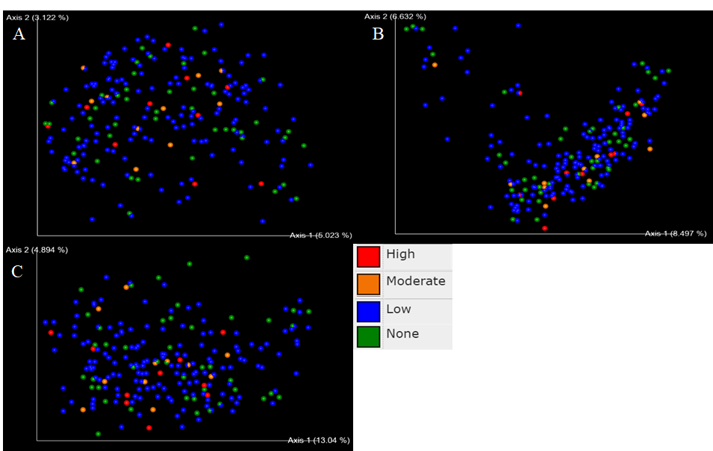
Figure S1. Alcohol consumption categories do not have an effect on microbial community composition. The gut microbiome composition of subjects was analyzed with (A) Jaccard, (B) Bray-Curtis, and (C) Unweighted UniFrac beta diversity metrics in QIIME2. Corresponding pairwise PERMANOVA statistics can be found in Tables S4-S6.
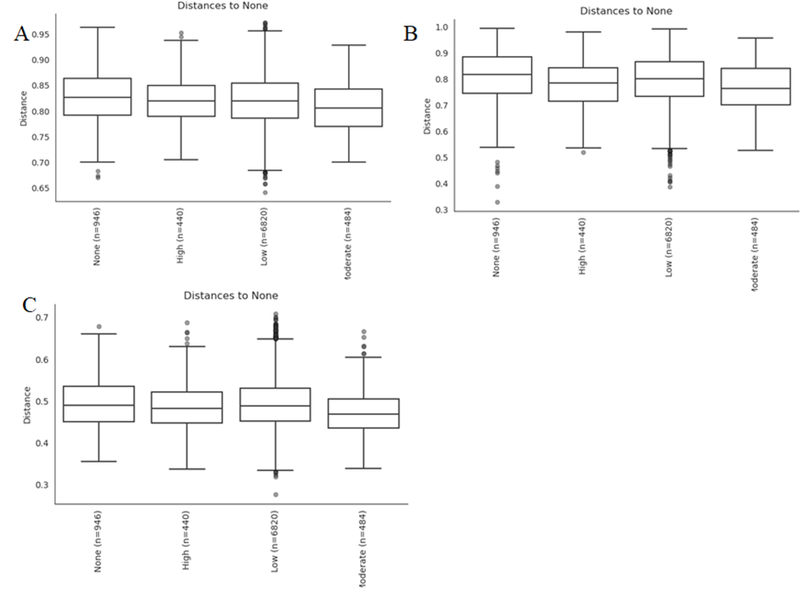Figure S2. No differences in the composition of gut microbiomes of different alcohol consumption groups were observed across any beta diversity metric. Beta diversity of gut microbiotas across subjects in the three categories of alcohol consumption based on (A) Jaccard, (B) Bray-Curtis, and (C) Unweighted UniFrac. Corresponding pairwise PERMANOVA statistics can be found in Tables S4-S6.
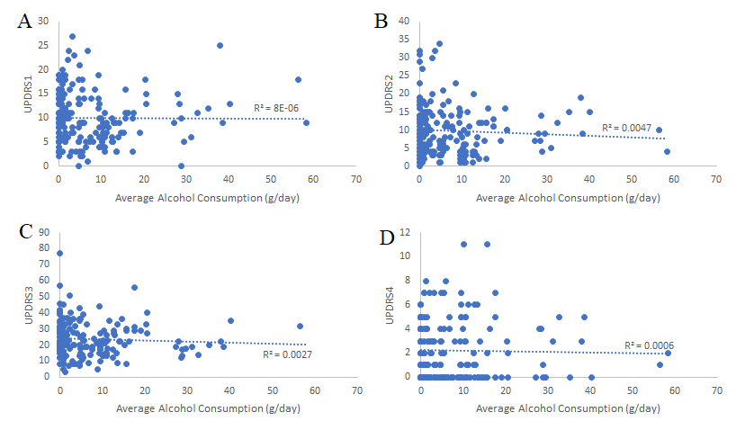
Figure S3. No correlation was found between average alcohol consumption (g/day) and UPDRS 1, 2, 3, and 4 scores. (A) UPDRS 1 and (B) 2 scores are based on non-motor and motor challenges faced by subjects in their day-to-day lives, respectively. (C) UPDRS 3 scores represent the results of a movement analysis examination. (D) UPDRS 4 scores represent motor complications experienced by patients. Higher scores indicate more severe symptoms. Subjects with no alcohol consumption data were excluded from the analysis. Number of patients (n) = 195.
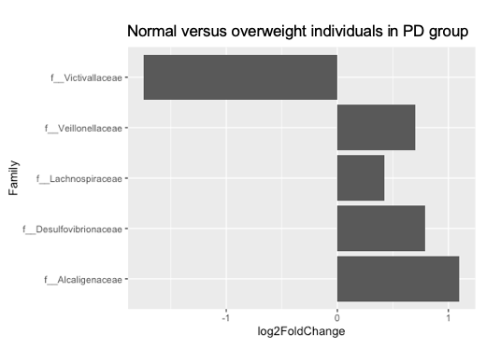
Figure S4. Five families are differential abundant between overweight and normal PD patients. The families Veillonellaceae, Lachnospiraceae, Desulfovibrionaceae, and Alcaligenaceae exhibited a positive fold change, indicating a higher abundance in overweight PD patients. The family Victivallaceae exhibited a negative fold change, indicating a higher abundance in normal PD patients.
Script S1. QIIME2 commands.
#PROCESSING RAW 16S rRNA SEQUENCES
#Importing data and visualizing demultiplexed sequence summary
qiime tools import \
--type 'SampleData[SequencesWithQuality]' \
--input-path /mnt/datasets/project_2/parkinsons/parkinsons_manifest.txt \
--output-path demux.qza \
--input-format SingleEndFastqManifestPhred33V2

qiime demux summarize \
--i-data demux.qza \
--o-visualization demux.qzv

#Sequence quality control and feature table construction using DADA2
qiime dada2 denoise-single \
--i-demultiplexed-seqs demux.qza \
--p-trim-left 0 \
--p-trunc-len 251 \
--o-representative-sequences rep-seqs-dada2.qza \
--o-table table-dada2.qza \
--o-denoising-stats stats-dada2.qza

#Generating FeatureTable and FeatureData summaries
qiime feature-table summarize \
--i-table table-dada2.qza \
--o-visualization table.qzv \
--m-sample-metadata-file /mnt/datasets/project_2/parkinsons/parkinsons_metadata.txt

qiime feature-table tabulate-seqs \
--i-data rep-seqs-dada2.qza \
--o-visualization rep-seqs.qzv

#Generating tree for phylogenetic diversity analyses
qiime phylogeny align-to-tree-mafft-fasttree \
--i-sequences rep-seqs-dada2.qza \
--o-alignment aligned-rep-seqs.qza \
--o-masked-alignment masked-aligned-rep-seqs.qza \
--o-tree unrooted-tree.qza \
--o-rooted-tree rooted-tree.qza

#ALCOHOL

#Filter metadata to remove subjects who have taken more than 5 doses of antibiotics in the last 5 years (ie. 1 per year average)
qiime feature-table filter-samples \
--i-table /data/table.qza \
--m-metadata-file /mnt/datasets/project_2/parkinsons/parkinsons_metadata.txt \
--p-where "'5'<[Abx_doses_last_5_years]<'25'" \
--o-filtered-table alcohol-abx-filtered-table.qza

qiime feature-table summarize \
--i-table alcohol-abx-filtered-table.qza \
--o-visualization alcohol-abx-filtered-table.qzv \
--m-sample-metadata-file /mnt/datasets/project_2/parkinsons/parkinsons_metadata.txt

#Calculate beta diversity metrics using filtered table
qiime diversity core-metrics-phylogenetic \
--i-phylogeny /data/rooted-tree.qza \
--i-table alcohol-abx-filtered-table.qza \
--p-sampling-depth 5105 \
--m-metadata-file /data/alcohol/parkinsons_metadata.txt \
--output-dir core-metrics-results

#Conduct analysis for all 4 beta diversity metrics (Jaccard, Bray-Curtis, unweighted and weighted Unifrac)
qiime diversity beta-group-significance \
--i-distance-matrix /data/alcohol/core-metrics-results/unweighted_unifrac_distance_matrix.qza \
--m-metadata-file /data/alcohol/parkinsons_metadata.txt \
--m-metadata-column Alcohol_Group \
--o-visualization /data/alcohol/core-metrics-results/unweighted-unifrac-significance.qzv \
--p-pairwise

qiime diversity beta-group-significance \
--i-distance-matrix /data/alcohol/core-metrics-results/weighted_unifrac_distance_matrix.qza \
--m-metadata-file /data/alcohol/parkinsons_metadata.txt \
--m-metadata-column Alcohol_Group \
--o-visualization /data/alcohol/core-metrics-results/weighted-unifrac-significance.qzv \
--p-pairwise

qiime diversity beta-group-significance \
--i-distance-matrix /data/alcohol/core-metrics-results/jaccard_distance_matrix.qza \
--m-metadata-file /data/alcohol/parkinsons_metadata.txt \
--m-metadata-column Alcohol_Group \
--o-visualization /data/alcohol/core-metrics-results/jaccard-significance.qzv \
--p-pairwise

qiime diversity beta-group-significance \
--i-distance-matrix /data/alcohol/core-metrics-results/bray_curtis_distance_matrix.qza \
--m-metadata-file /data/alcohol/parkinsons_metadata.txt \
--m-metadata-column Alcohol_Group\
--o-visualization /data/alcohol/core-metrics-results/bray_curtis-significance.qzv \
--p-pairwise

#ASV-based filtering in Qiime2
qiime feature-table filter-features \
--i-table /data/alcohol/alcohol-abx-filtered-table.qza \
--p-min-frequency 142 \
--o-filtered-table /data/alcohol/alcohol-abx-filtered-table-ASVfiltered.qza

qiime taxa filter-table \
--i-table /data/alcohol/alcohol-abx-filtered-table-ASVfiltered.qza \
--i-taxonomy /data/taxonomy.qza \
--p-exclude Archaea,chloroplast,mitochondria \
--o-filtered-table /data/alcohol/alcohol-abx-filtered-table-ASVtaxafiltered.qza

#Exporting files for analysis in R
qiime tools export \
--input-path table.qza \
--output-path exported
qiime tools export \
--input-path taxonomy.qza \
--output-path exported
qiime tools export \
--input-path rooted-tree.qza \
--output-path exported

nano exported/taxonomy.tsv
#Edited column names (`Feature ID` to `#OTUID`, `Taxon` to `taxonomy`, `Confidence` to `confidence`)

biom add-metadata \
-i exported/feature-table.biom \
-o exported/table-with-taxonomy.biom \
--observation-metadata-fp exported/taxonomy.tsv \
--sc-separated taxonomy

#BMI
#Filter metadata to keep only subjects of “control-normal”, “control-overweight”, “PD-normal”, “PD-overweight” Disease_BMI categories
qiime feature-table filter-samples \
--i-table /data/table.qza \
--m-metadata-file /data/BMI/parkinsons_metadata.txt \
--p-where "NOT [Disease_BMI]='null'" \
--o-filtered-table Disease_BMI-sorted.qza

qiime feature-table summarize \
--i-table Disease_BMI-sorted.qza \
--o-visualization Disease_BMI-sorted.qzv \
--m-sample-metadata-file /data/BMI/parkinsons_metadata.txt

#Calculate beta diversity metrics using filtered table
qiime diversity core-metrics-phylogenetic \
--i-phylogeny /data/rooted-tree.qza \
--i-table Disease_BMI-sorted.qza \
--p-sampling-depth 5105 \
--m-metadata-file /data/BMI/parkinsons_metadata.txt \
--output-dir core-metrics-results

#Conduct beta-diversity analysis with weighted Unifrac
qiime diversity beta-group-significance \
--i-distance-matrix /data/BMI/core-metrics-results/weighted_unifrac_distance_matrix.qza \
--m-metadata-file /data/BMI/parkinsons_metadata.txt \
--m-metadata-column Disease_BMI \
--o-visualization /data/BMI/core-metrics-results/qzv/weighted-unifrac-Disease_BMI-significance.qzv \
--p-pairwise

#ASV-based filtering in Qiime 2
qiime feature-table filter-features \
--i-table /data/BMI/Disease_BMI-sorted.qza \
--p-min-frequency 142 \
--o-filtered-table /data/BMI/Disease_BMI-sorted-ASVfiltered.qza

qiime taxa filter-table \
--i-table /data/BMI/Disease_BMI-sorted-ASVfiltered.qza \
--i-taxonomy /data/BMI/taxonomy.qza \
--p-exclude Archaea,chloroplast,mitochondria \
--o-filtered-table /data/BMI/Disease_BMI-sorted-ASVtaxafiltered.qza

#Exporting files for analysis in R
qiime tools export \
--input-path taxonomy.qza \
--output-path exported_files_to_R

qiime tools export \
--input-path rooted-tree.qza \
--output-path exported_files_to_R

qiime tools export \
--input-path Disease_BMI-sorted-ASVtaxafiltered.qza \
--output-path exported_files_to_R

nano exported_files_to_R/taxonomy.tsv
# Edit the column names and changes `Feature ID` to `#OTUID`, `Taxon` to `taxonomy`, `Confidence` to `confidence`

biom add-metadata \
-i exported_files_to_R/feature-table.biom \
-o exported_files_to_R/table-with-taxonomy.biom \
--observation-metadata-fp exported_files_to_R/taxonomy.tsv \
--sc-separated taxonomy
Script S2. R commands.
#ALCOHOL

# Load CRAN packages
library(tidyverse)
library(vegan)

# Load Bioconductor packages
library(phyloseq)
library(DESeq2)

# Setup helper functions
# Calculate relative abundance
calculate_RA <- function(x) x/sum(x)

# define this function below, which we'll use in a minute
gm_mean <- function(x, na.rm = TRUE) {
exp(sum(log(x[x > 0]), na.rm = na.rm) / length(x))
}

# Export biom file and tree from QIIME2 and provide original metadata file
biom_file <- import_biom("table-with-taxonomy.biom")
metadata <- import_qiime_sample_data("alcohol_categorized_metadata.tsv")
tree <- read_tree_greengenes("tree.nwk")

# Combine all information into a single phyloseq object
physeq <- merge_phyloseq(biom_file, metadata, tree)

# Convert taxonomic rank from numbers to proper names
colnames(tax_table(physeq)) <- c("Kingdom", "Phylum", "Class", "Order",
"Family", "Genus", "Species")

# Keep only abundant ASVs
# First determine counts of ASV across all samples
total_counts <- taxa_sums(physeq)

# Calculate relative abundance for each ASV
relative_abundance <- calculate_RA(total_counts)

# Determine which ASVs are more abundant than 0.1%
# Change this if you want a different cutoff (0.001 = 0.1%)
abundant <- relative_abundance > 0.001
abundant_taxa <- prune_taxa(abundant, physeq)
# Check the resulting new phyloseq object with much fewer taxa
abundant_taxa
Genus <- tax_glom(abundant_taxa, taxrank = "Genus", NArm = FALSE)
Genus
deseq_alcohol_feature
geo_means <- apply(counts(deseq_alcohol_feature), 1, gm_mean)
deseq_alcohol_feature <- estimateSizeFactors(deseq_alcohol_feature, geoMeans = geo_means)
deseq_alcohol_feature <- DESeq(deseq_alcohol_feature, fitType="local")
feature_diff_abund <- results(deseq_alcohol_feature)

# Define cutoff for the adjusted p-value
alpha <- 0.05

# Reformat information as data frame including feature as variable
significant_feature <- as_tibble(feature_diff_abund, rownames = "feature")

# Keep only significant results and sort by adjusted p-value
significant_feature <- filter(significant_feature, padj < alpha)
significant_feature <- arrange(significant_feature, padj)

# Get the taxonomic information as a data frame
taxa_df <- as_tibble(as.data.frame(tax_table(physeq)), rownames = "feature")

# Combine the significant features with taxonomic classification
significant_feature <- inner_join(significant_feature, taxa_df)
dim(significant_feature)

# Plot differential abundance
significant_feature %>%
ggplot(aes(x = log2FoldChange, y = Genus)) +
geom_col()

# Convert to relative abundance
physeq_RA <- transform_sample_counts(physeq, calculate_RA)
genus_RA <- tax_glom(physeq_RA, taxrank = "Genus", NArm = FALSE)

# Graph genera of interest and filter for that genus with subset_taxa.
faecalibacterium <- subset_taxa(genus_RA, Genus == "g__Faecalibacterium")

# The next step enables us to plot the data by changing the table from wide to long format.
blautia_melt <- psmelt(faecalibacterium)

#define comparisons
library(rstatix)
library(ggpubr)
library(dplyr)

pre_compare <- subset(blautia_melt, alcohol_categories != "No data")
my_comparison <- list(pre_compare, c("Control", "PD"))

#Do stat test to compare between groups
stat.test <- pre_compare %>%
group_by(Disease) %>%
t_test(Abundance ~ alcohol_categories) %>%
adjust_pvalue(method = "bonferroni") %>%
add_significance("p.adj")
stat.test

stat.test <- stat.test %>%
add_xy_position(x="Disease", dodge = 0.8)

# Plot with ggplot function
# Define what dataset to plot and what variable on x-axis and y-axis
my_font_size <- 5
asteriks_font <- 25
level_order <- c('None', 'Low', 'Moderate', 'High')
ggplot(filter(blautia_melt, alcohol_categories %in% c("High", "Moderate", "Low", "None")), aes(x = as.factor(Disease), y = Abundance)) +
# Visualize data as Boxplot
stat_compare_means(comparisons = my_comparison, label.y = 0.085, tip.length = 0, label = "p.signif")+
stat_pvalue_manual(
stat.test, label = "p.adj", tip.length = 0.02,hide.ns = TRUE, label.y = 0.3, size = asteriks_font)+
geom_boxplot(aes(fill = fct_relevel(alcohol_categories, levels =c("None", "Low", "Moderate", "High")))) +
# Label for x-axis
xlab("Category") +
# Label for y-axis
ylab("Relative Abundance") +
# Plot title
ggtitle("Faecalibacterium") +
theme(plot.title = element_text(hjust = 0.5))+
# colors for the different groups
scale_fill_manual(values=c("royalblue3", "darkgreen", "yellow2", "red4")) +
guides(fill = FALSE) +
# Set a standard theme for plot
theme_bw(base_size = 16)
#BMI
# Load packages
library(tidyverse)
library(vegan)
library(phyloseq)
library(DESeq2)
library(ggplot2)

# Load packages for stat test
library(ggpubr)
library(rstatix)

# Setup helper functions
# Calculate relative abundance
calculate_RA <- function(x) x/sum(x)
# Calculate geometric mean
gm_mean <- function(x, na.rm = TRUE){exp(sum(log(x[x > 0]), na.rm = na.rm) / length(x))}

# Importing all data files
biom_file <- import_biom("table-with-taxonomy.biom")
metadata <- import_qiime_sample_data("parkinsons_metadata_BMI.txt")
tree <- read_tree_greengenes("tree.nwk")

# Combine all objects into phyloseq object
physeq <- merge_phyloseq(biom_file, metadata, tree)

# Set set of random numbers, make sure your analysis is reproducible
set.seed(711)

# Rename column names for taxonomic ranks
colnames(tax_table(physeq)) <- c("Kingdom", "Phylum", "Class", "Order", "Family", "Genus", "Species")

# Define cutoff for the adjusted p-value
alpha <- 0.05

# Subset samples into PD and control
physeq_PD = subset_samples(physeq, Disease == "PD")
physeq_control = subset_samples(physeq, Disease == "Control")

# Get data table with taxonomic information of each feature
taxa_df_PD <- as_tibble(as.data.frame(tax_table(physeq_PD)), rownames = "feature")
taxa_df_ctl <- as_tibble(as.data.frame(tax_table(physeq_control)), rownames = "feature")

#Calculate differential abundance at family level for PD, and run DEseq2 analysis
# Group PD by family rank
family_PD <- tax_glom(physeq_PD, taxrank = "Family", NArm = FALSE)
deseq_family_PD <- phyloseq_to_deseq2(family_PD, ~Disease_BMI)
geo_means_family_PD <- apply(counts(deseq_family_PD), 1, gm_mean)
deseq_family_PD <- estimateSizeFactors(deseq_family_PD, geoMeans = geo_means_family_PD)
deseq_family_PD <- DESeq(deseq_family_PD, fitType = "local")
family_diff_abund_PD <- results(deseq_family_PD)
significant_family_PD <- as_tibble(family_diff_abund_PD, rownames = "feature")
significant_family_PD <- filter(significant_family_PD, padj < alpha)
significant_family_PD <- inner_join(significant_family_PD, taxa_df_PD)
write_csv(significant_family, "significant_family_PD.csv")
significant_family_PD %>%
ggplot(aes(x = log2FoldChange, y = Family)) +
geom_col()

#Calculate differential abundance at phylum level for PD and controls, and run DEseq2 analysis
# Group PD by phylum rank
phylum_PD <- tax_glom(physeq_PD, taxrank = "Phylum", NArm = FALSE)
deseq_phylum_PD <- phyloseq_to_deseq2(phylum_PD, ~Disease_BMI)
geo_means_phylum_PD <- apply(counts(deseq_phylum_PD), 1, gm_mean)
deseq_phylum_PD <- estimateSizeFactors(deseq_phylum, geoMeans = geo_means_phylum_PD)
deseq_phylum_PD<- DESeq(deseq_phylum_PD, fitType = "local")
phylum_diff_abund_PD <- results(deseq_phylum_PD)
significant_phylum_PD <- as_tibble(phylum_diff_abund_PD, rownames = "feature")
#Dont filter to view see p-values for Firm and Bact
#significant_phylum <- filter(significant_phylum, padj < alpha)
significant_phylum_PD <- inner_join(significant_phylum_PD, taxa_df_PD)

# Group controls by phylum rank
phylum_ctl <- tax_glom(physeq_control, taxrank = "Phylum", NArm = FALSE)
deseq_phylum_ctl <- phyloseq_to_deseq2(phylum_ctl, ~Disease_BMI)
geo_means_phylum_ctl <- apply(counts(deseq_phylum_ctl), 1, gm_mean)
deseq_phylum_ctl <- estimateSizeFactors(deseq_phylum_ctl, geoMeans = geo_means_phylum_ctl)
deseq_phylum_ctl<- DESeq(deseq_phylum_ctl, fitType = "local")
phylum_diff_abund_ctl <- results(deseq_phylum_ctl)
significant_phylum_ctl <- as_tibble(phylum_diff_abund_ctl, rownames = "feature")
#Dont filter to view p-values for Firm and Bact
#significant_phylum <- filter(significant_phylum, padj < alpha)
significant_phylum_ctl <- inner_join(significant_phylum_ctl, taxa_df_ctl)

# RA for Controls
# Calculate relative abundance
physeq_ctl_RA <- transform_sample_counts(physeq_control, calculate_RA)
phylum_ctl_RA <- tax_glom(physeq_ctl_RA, taxrank = "Phylum", NArm = FALSE)

# Graph Bacteroidetes and filter for that phylum with subset_taxa.
bacteroidetes_ctl <- subset_taxa(phylum_ctl_RA, Phylum == "p__Bacteroidetes")

# Plot the data by changing the table from wide to long format.
bacteroidetes_ctl_melt <- psmelt(bacteroidetes_ctl)

# Plot with ggplot function
# Manually add stat to the plot
ggplot(bacteroidetes_ctl_melt, aes(x = as.factor(Disease_BMI), y = Abundance)) +
geom_boxplot(aes(fill = as.factor(Disease_BMI))) +
xlab("Disease_BMI") +
ylab("Relative Abundance") +
ggtitle("Bacteroidetes") +
scale_fill_manual(values=c("seagreen3", "indianred1")) +
guides(fill = FALSE) +
theme_bw(base_size = 16)

# Graph Firmicutes and filter for that phylum with subset_taxa.
firmicutes_ctl <- subset_taxa(phylum_ctl_RA, Phylum == "p__Firmicutes")

# Plot the data by changing the table from wide to long format.
firmicutes_ctl_melt <- psmelt(firmicutes_ctl)

# Plot with ggplot function
# Manually add stat to the plot
ggplot(firmicutes_ctl_melt, aes(x = as.factor(Disease_BMI), y = Abundance)) +
geom_boxplot(aes(fill = as.factor(Disease_BMI))) +
xlab("Disease_BMI") +
ylab("Relative Abundance") +
ggtitle("Firmicutes") +
scale_fill_manual(values=c("seagreen3", "indianred1")) +
guides(fill = FALSE) +
theme_bw(base_size = 16) +
ylim(0,0.8)

#RA for PD
# Calculate relative abundance
physeq_PD_RA <- transform_sample_counts(physeq_PD, calculate_RA)
phylum_PD_RA <- tax_glom(physeq_PD_RA, taxrank = "Phylum", NArm = FALSE)

# Graph Bacteroidetes and filter for that phylum with subset_taxa.
bacteroidetes_PD <- subset_taxa(phylum_PD_RA, Phylum == "p__Bacteroidetes")

# Plot the data by changing the table from wide to long format.
bacteroidetes_PD_melt <- psmelt(bacteroidetes_PD)

# Plot with ggplot function
# Manually add stat to the plot
ggplot(bacteroidetes_PD_melt, aes(x = as.factor(Disease_BMI), y = Abundance)) +
geom_boxplot(aes(fill = as.factor(Disease_BMI))) +
xlab("Disease_BMI") +
ylab("Relative Abundance") +
ggtitle("Bacteroidetes") +
scale_fill_manual(values=c("seagreen3", "indianred1")) +
guides(fill = FALSE) +
theme_bw(base_size = 16)

# Graph Firmicutes and filter for that phylum with subset_taxa.
firmicutes_PD <- subset_taxa(phylum_PD_RA, Phylum == "p__Firmicutes")

# Plot the data by changing the table from wide to long format.
firmicutes_PD_melt <- psmelt(firmicutes_PD)

# Plot with ggplot function
# Manually add stat to the plot
ggplot(firmicutes_PD_melt, aes(x = as.factor(Disease_BMI), y = Abundance)) +
geom_boxplot(aes(fill = as.factor(Disease_BMI))) +
xlab("Disease_BMI") +
ylab("Relative Abundance") +
ggtitle("Firmicutes") +
scale_fill_manual(values=c("seagreen3", "indianred1")) +
guides(fill = FALSE) +
theme_bw(base_size = 16) +
ylim(0,0.8)

#Indicator taxa
# Load packages
library(dplyr)
library(phyloseq)
library(indicspecies)

# Function to group asv table by higher order taxonomy, family
group_by_taxonomy = function(asv_table, taxonomy, rank){
asv_table = as.data.frame(asv_table)
taxonomy = as.data.frame(taxonomy)
taxonomy$ASV = rownames(taxonomy)
asv_table$ASV = rownames(asv_table)
asv_table = inner_join(taxonomy,asv_table,by="ASV")
asv_table$taxa = apply(asv_table[,1:rank],1,paste,collapse=" ")
asv_table = asv_table[,-(1:8)]
asv_table = group_by(data.frame(asv_table),taxa)
taxa_table = as.data.frame(summarise_all(asv_table,sum))
rownames(taxa_table) = taxa_table$taxa
return(taxa_table[,-1])
}

# Re-load data
biom = import_biom("table-with-taxonomy.biom")
taxa_table = otu_table(biom)
taxonomy = tax_table(biom)
metadata = read.table("parkinsons_metadata_BMI.txt",sep="\t",header=T,row.names = 1, comment.char="")

# Create the taxa table for the rank of taxonomy required, family
# Kingdom=1, Phylum=2, Class=3, Order=4, Family=5, Genus=6, Species=7
taxa_table = group_by_taxonomy(taxa_table, taxonomy, 5)

# transpose taxa table
t_table <- t(taxa_table)

# two tables need same dimensions
# turn t_table into data frame, make column with row names, make it called sample
new_df <- rownames_to_column(as.data.frame(t_table), var = "sample")
# make column with row names then select just sample and BMI column
new_metadata <- rownames_to_column(metadata, var = "sample")%>%
select(c(sample, Disease_BMI))
# combine above two into one table
joined_df <- right_join(new_df, new_metadata, by = "sample") %>%
drop_na()

# calculate indicator values
indicator_multipatt <- multipatt(as.matrix(joined_df %>% select(-c(Disease_BMI, sample))),
joined_df$Disease_BMI, duleg=TRUE)

indicator_output = capture.output(summary(indicator_multipatt,indvalcomp=TRUE))
write.table(indicator_output,file="indiciator_values.txt",row.names=F,quote=F)

