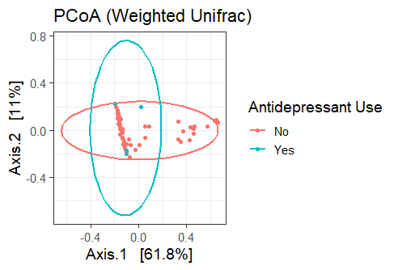
Figure S1. Gut microbial composition does not differ based on antidepressant use. Weighted Unifrac distances were evaluated between samples of both groups with and without antidepressant use. Weighted Unifrac PCoA plot accounts for 72.8 percent variance. Turquoise represents subjects with antidepressant use (“Yes”) and orange represents subjects without antidepressant use (“No”). Sample size is 59 for those without antidepressant use and 5 for those with antidepressant use
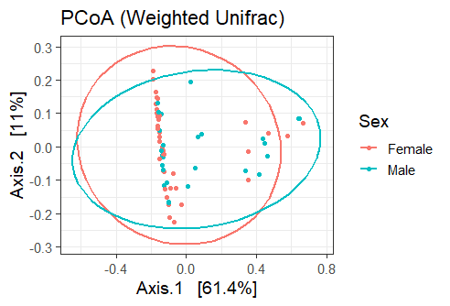
Figure S2. Sex is not associated with a change in gut microbial composition: Weighted Unifrac distances were evaluated between samples of the ‘Male’ and ‘Female’ sexes. Weighted Unifrac PCoA plot accounts for 72.4 percent variance. Turquoise represents male subjects and orange represents female subjects. Sample size is 38 for the female group and 27 for the male group
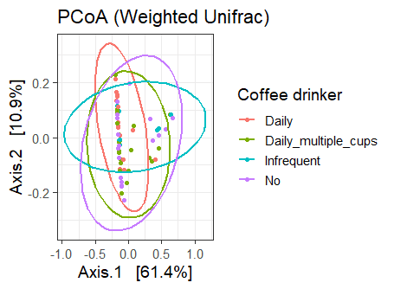
Figure S3. Coffee consumption is not correlated with differences in gut microbiota composition. Weighted Unifrac distances were evaluated between samples of the ‘Daily multiple cups’, ‘Daily’, ‘Infrequent’, and ‘No’ groups. Weighted Unifrac PCoA plot accounts for 72.3 percent variance. Orange represents subjects who drink one cup of coffee per day. Green represents subjects who drink multiple cups per day. Turquoise represents subjects who drink coffee infrequently. Purple represents subjects who do not drink coffee. Sample size is 16 for ‘Daily’ group, 21 for ‘Daily multiple cups’ group, 8 for ‘Infrequent’ group, and 18 for ‘No’ group.

