Supplemental Material
Mark Pitblado, Sara Kowalski, Elizabeth Vaz, Alannah Wilson

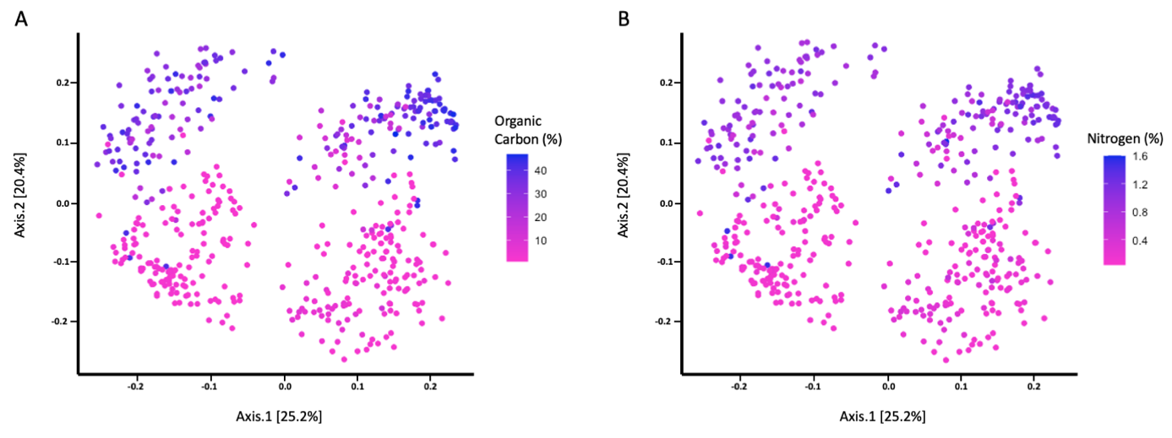
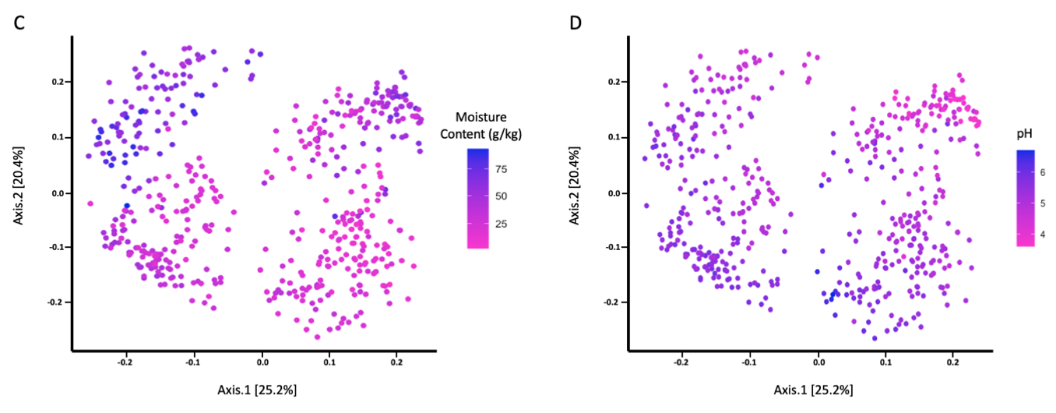
Figure S1. Soil abiotic factors show minimal influence on bacterial communities when grouped by sample. PCoA plot of weighted UniFrac distances for soil samples coloured for (A) organic carbon content, (B) nitrogen content, (C) soil moisture content, and (D) pH level. Axes represent variance explained.

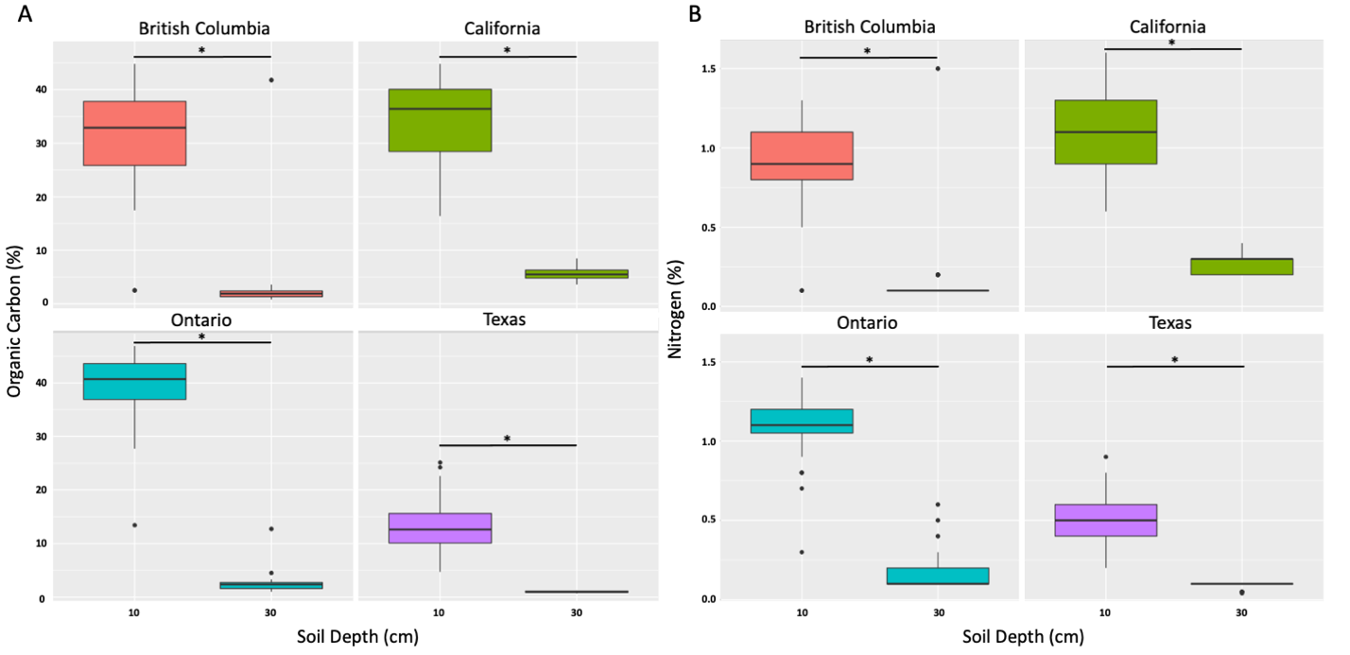
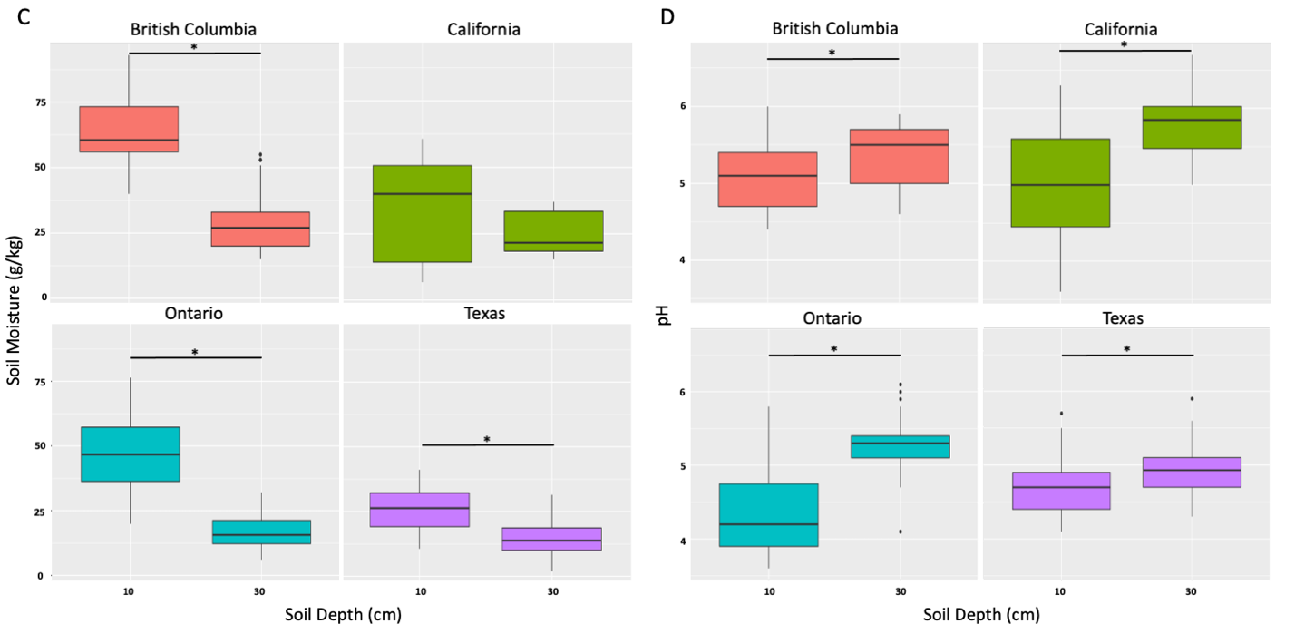
Figure S2. Soil depth impacts the availability of soil abiotic factors. Box-and-whisker-plot displaying the association of soil depth with (A) organic carbon content, (B) nitrogen content, (C) soil moisture content, and (D) pH level. Boxes represent the interquartile range (IQR) where the median is denoted by the center line and the ends of the box specify the upper (75th) and lower (25th) quartiles. Vertical extending lines indicate the minimum and maximum values. (A-D) Line and star denote a statistically significant difference between the group means; statistical significance was calculated by Wilcoxon sign rank test, *p<0.05.

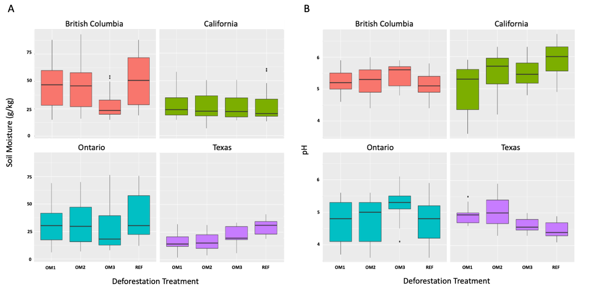
Figure S3. Organic matter removal shows no substantial impact on pH and soil moisture levels. Box-and-whisker-plot displaying the association of deforestation treatment with (A) soil moisture content and (B) pH level. Deforestation treatments included removal of tree branches (OM1), removal of tree trunks and branches (OM2), or removal of whole trees and the entire topsoil layer (OM3). Reference samples were taken from nearby unharvested plots. Boxes represent the interquartile range (IQR) where the median is denoted by the center line and the ends of the box specify the upper (75th) and lower (25th) quartiles. Vertical extending lines indicate the minimum and maximum values. OM = organic matter; REF = reference.

