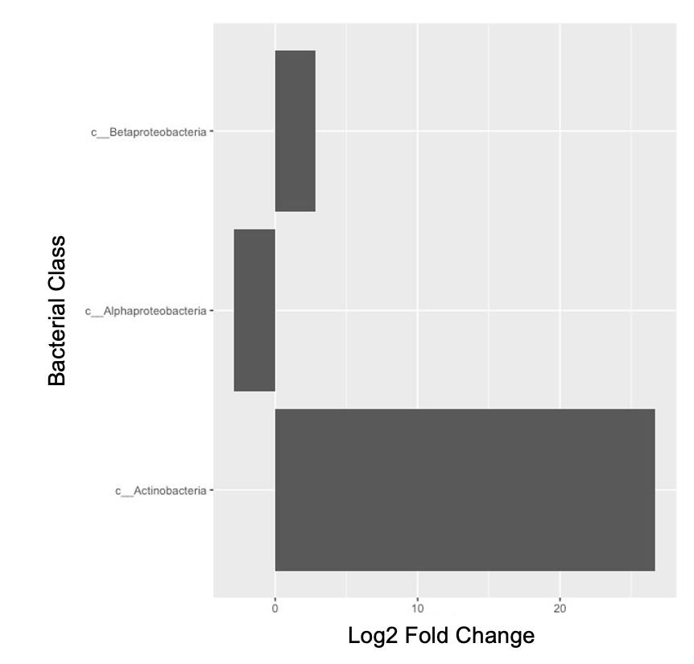
Figure S1. Actinobacteria is the bacterial class that changes the most following varying OM removal treatments. Changes in bacterial class are denoted by a log2 fold change plot.

Correlation_Analysis_R
### Correlation Analysis
# Team 4 - Seohee An, Priya Gill, Brandon Park, Chelsea Williams

# Loading packages
library(tidyverse)
library(vegan)
library(phyloseq)
library(DESeq2)
library(ggplot2)

# importing all data files
biom_file <- import_biom("table-with-taxonomy.biom")
metadata <- import_qiime_sample_data("soil_metadata.txt")
tree <- read_tree_greengenes("tree-soil.nwk")

### Alpha diversity functions
# Shannon's diversity
shannons = function(x){
present = x[x>0]
p = present/sum(present)
-sum(p*log(p))
}

# Pielou's evennenss function
evenness = function(x){
present = x[x>0]
p = present/sum(present)
-sum(p*log(p))/log(sum(x>0))
}

# Richness function
richness = function(x){
return(sum(x>0))
}

### Load data
biom = import_biom("table-with-taxonomy.biom")
taxa_table = otu_table(biom_file)
taxonomy = tax_table(biom_file)
metadata = read.table("soil_metadata.txt",sep="\t",header=T,row.names = 1)

# Select only samples with metadata
microbial_samples = colnames(taxa_table)
metadata_samples = rownames(metadata)
which_metadata = c()
for (i in 1:dim(taxa_table)[2]){
which_metadata = c(which_metadata,which(metadata_samples == microbial_samples[i]))
}
metadata = metadata[which_metadata,]

### Calculate alpha diversity
metadata$richness = apply(taxa_table,2,richness)
metadata$shannons = apply(taxa_table,2,shannons)
metadata$evenness = apply(taxa_table,2,evenness)

### Correlation plots of Shannon's vs metadata variables
# pH
ggplot(metadata,aes(x=pH,y=shannons)) +
geom_point() +
labs(x = "pH", y = "Shannon's Diversity") +
geom_smooth(method="lm",formula=y~x) +
theme_bw(base_size = 15)
# Correlation
cor.test(metadata$pH,metadata$shannons)
# Regression
ph_shannons_lm = lm(shannons ~ pH, data = metadata)
summary(ph_shannons_lm)

# Total Nitrogen
ggplot(metadata,aes(x=Total.Nitrogen,y=shannons)) +
geom_point() +
labs(x = "Total Nitrogen", y = "Shannon's Diversity") +
geom_smooth(method="lm",formula=y~x) +
theme_bw(base_size = 15)
# Correlation
cor.test(metadata$Total.Nitrogen,metadata$shannons)
# Regression
nitrogen_shannons_lm = lm(shannons ~ Total.Nitrogen, data = metadata)
summary(nitrogen_shannons_lm)

# Total Carbon
ggplot(metadata,aes(x=Total.Carbon,y=shannons)) +
geom_point() +
labs(x = "Total Carbon", y = "Shannon's Diversity") +
geom_smooth(method="lm",formula=y~x) +
theme_bw(base_size = 15)
# Correlation
cor.test(metadata$Total.Carbon,metadata$shannons)
# Regression
carbon_shannons_lm = lm(shannons ~ Total.Carbon, data = metadata)
summary(carbon_shannons_lm)

# Moisture Content
ggplot(metadata,aes(x=Moisture.Content,y=shannons)) +
geom_point() +
labs(x = "Moisture Content", y = "Shannon's Diversity") +
geom_smooth(method="lm",formula=y~x) +
theme_bw(base_size = 15)
# Correlation
cor.test(metadata$Moisture.Content,metadata$shannons)
# Regression
moisture_shannons_lm = lm(shannons ~ Moisture.Content, data = metadata)
summary(moisture_shannons_lm)

### Correlation plots of Shannon's Diversity vs metadata variables by LTSP
# pH
ggplot(metadata,aes(x=pH,y=shannons)) +
facet_grid(~LTSP.Treatment) +
geom_point() +
labs(x = "pH", y = "Shannon's Diversity") +
geom_smooth(method="lm",formula=y~x) +
theme_bw(base_size = 15)

ggplot(metadata,aes(x=pH,y=shannons,group=LTSP.Treatment,color=LTSP.Treatment)) +
geom_point() +
labs(x = "pH", y = "Shannon's Diversity") +
geom_smooth(method="lm",formula=y~x) +
theme_bw(base_size = 15)

for (g in unique(metadata$LTSP.Treatment)){
print(paste("LTSP Treatment =",g))
temp_metadata = filter(metadata,LTSP.Treatment==g)
# Correlation
temp_cor = cor.test(temp_metadata$pH,temp_metadata$shannons)
print(paste("Correlation =",temp_cor$estimate,
"p value =",temp_cor$p.value))
# Regression
om_ph_shannons_lm = lm(shannons ~ pH, data = temp_metadata)
print(paste("Regression slope =",summary(om_ph_shannons_lm)$coefficients[2,1],
"p value =",summary(om_ph_shannons_lm)$coefficients[2,4]))
}

# Total Nitrogen
ggplot(metadata,aes(x=Total.Nitrogen,y=shannons)) +
facet_grid(~LTSP.Treatment) +
geom_point() +
labs(x = "Total Nitrogen", y = "Shannon's Diversity") +
geom_smooth(method="lm",formula=y~x) +
theme_bw(base_size = 15)

ggplot(metadata,aes(x=Total.Nitrogen,y=shannons,group=LTSP.Treatment,color=LTSP.Treatment)) +
geom_point() +
labs(x = "Total Nitrogen", y = "Shannon's Diversity") +
geom_smooth(method="lm",formula=y~x) +
theme_bw(base_size = 15)

for (g in unique(metadata$LTSP.Treatment)){
print(paste("LTSP Treatment =",g))
temp_metadata = filter(metadata,LTSP.Treatment==g)
# Correlation
temp_cor = cor.test(temp_metadata$Total.Nitrogen,temp_metadata$shannons)
print(paste("Correlation =",temp_cor$estimate,
"p value =",temp_cor$p.value))
# Regression
om_nitrogen_shannons_lm = lm(shannons ~ Total.Nitrogen, data = temp_metadata)
print(paste("Regression slope =",summary(om_nitrogen_shannons_lm)$coefficients[2,1],
"p value =",summary(om_nitrogen_shannons_lm)$coefficients[2,4]))
}

# Total Carbon
ggplot(metadata,aes(x=Total.Carbon,y=shannons)) +
facet_grid(~LTSP.Treatment) +
geom_point() +
labs(x = "Total Carbon", y = "Shannon's Diversity") +
geom_smooth(method="lm",formula=y~x) +
theme_bw(base_size = 15)

ggplot(metadata,aes(x=Total.Carbon,y=shannons,group=LTSP.Treatment,color=LTSP.Treatment)) +
geom_point() +
labs(x = "Total Carbon", y = "Shannon's Diversity") +
geom_smooth(method="lm",formula=y~x) +
theme_bw(base_size = 15)

for (g in unique(metadata$LTSP.Treatment)){
print(paste("LTSP Treatment =",g))
temp_metadata = filter(metadata,LTSP.Treatment==g)
# Correlation
temp_cor = cor.test(temp_metadata$Total.Carbon,temp_metadata$shannons)
print(paste("Correlation =",temp_cor$estimate,
"p value =",temp_cor$p.value))
# Regression
om_carbon_shannons_lm = lm(shannons ~ Total.Carbon, data = temp_metadata)
print(paste("Regression slope =",summary(om_carbon_shannons_lm)$coefficients[2,1],
"p value =",summary(om_carbon_shannons_lm)$coefficients[2,4]))
}

# Moisture Content
ggplot(metadata,aes(x=Moisture.Content,y=shannons)) +
facet_grid(~LTSP.Treatment) +
geom_point() +
labs(x = "Moisture Content", y = "Shannon's Diversity") +
geom_smooth(method="lm",formula=y~x) +
theme_bw(base_size = 15)

ggplot(metadata,aes(x=Moisture.Content,y=shannons,group=LTSP.Treatment,color=LTSP.Treatment)) +
geom_point() +
labs(x = "Moisture Content", y = "Shannon's Diversity") +
geom_smooth(method="lm",formula=y~x) +
theme_bw(base_size = 15)

for (g in unique(metadata$LTSP.Treatment)){
print(paste("LTSP Treatment =",g))
temp_metadata = filter(metadata,LTSP.Treatment==g)
# Correlation
temp_cor = cor.test(temp_metadata$Moisture.Content,temp_metadata$shannons)
print(paste("Correlation =",temp_cor$estimate,
"p value =",temp_cor$p.value))
# Regression
om_moisture_shannons_lm = lm(shannons ~ Moisture.Content, data = temp_metadata)
print(paste("Regression slope =",summary(om_moisture_shannons_lm)$coefficients[2,1],
"p value =",summary(om_moisture_shannons_lm)$coefficients[2,4]))
}

Differential_Abundance_Analysis_R
### Differential Abundance Analysis
# Team 4 - Seohee An, Priya Gill, Brandon Park, Chelsea Williams

# Load CRAN packages
library(tidyverse)
library(vegan)

# Load Bioconductor packages
library(phyloseq)
library(DESeq2)

# Calculate relative abundance
calculate_RA <- function(x) x/sum(x)

# Helper functions
gm_mean <- function(x, na.rm = TRUE) {
exp(sum(log(x[x > 0]), na.rm = na.rm) / length(x))
}

# Export biom file and tree from QIIME2 and provide original metadata file
biom_file <- import_biom("table-with-taxonomy.biom")
metadata <- import_qiime_sample_data("soil_metadata.txt")
tree <- read_tree_greengenes("tree-soil.nwk")

# Combine all information into a single phyloseq object
physeq <- merge_phyloseq(biom_file, metadata, tree)

# Convert taxonomic rank from numbers to proper names
colnames(tax_table(physeq)) <- c("Kingdom", "Phylum", "Class", "Order",
"Family", "Genus", "Species")

# Keep only abundant ASVs
# First determine counts of ASV across all samples
total_counts <- taxa_sums(physeq)

# Calculate relative abundance for each ASV
relative_abundance <- calculate_RA(total_counts)

# Determine which ASVs are more abundant than 0.1%
abundant <- relative_abundance > 0.001
abundant_taxa <- prune_taxa(abundant, physeq)
# Check the resulting new phyloseq object with much fewer taxa
abundant_taxa

# Phyloseq object is called "Class"
class <- tax_glom(abundant_taxa, taxrank = "Class", NArm = FALSE)
class

# Only keep OM1 samples
OM1class <- subset_samples(class, LTSP.Treatment == "OM1")
OM1class

# Limit to OM1 samples that were filtered
deseq_feature <- phyloseq_to_deseq2(OM1class, ~ LTSP.Treatment)
geo_means <- apply(counts(deseq_feature), 1, gm_mean)
deseq_feature <- estimateSizeFactors(deseq_feature, geoMeans = geo_means)
deseq_feature <- DESeq(deseq_feature, fitType="local")

feature_diff_abund <- results(deseq_feature)

# Define cutoff for the adjusted p-value
alpha <- 0.05
# Reformat information as data frame including feature as variable
significant_feature <- as_tibble(feature_diff_abund, rownames = "feature")
# Keep only significant results and sort by adjusted p-value
significant_feature <- filter(significant_feature, padj < alpha)
significant_feature <- arrange(significant_feature, padj)

# Get the taxonomic information as a data frame
taxa_df <- as_tibble(as.data.frame(tax_table(physeq)), rownames = "feature")

# Combine the significant features with taxonomic classification
significant_feature <- inner_join(significant_feature, taxa_df)

# There 14 features that are different at FDR-corrected p < 0.05!
dim(significant_feature)

# Plot differential abundance
significant_feature %>%
ggplot(aes(x = log2FoldChange, y = Class)) +
geom_col() +
xlab("Log2 Fold Change") +
# Label for y-axis
ylab("Class") +
theme_bw(base_size = 16)

# Convert to relative abundance and define taxrank as Class
physeq_RA <- transform_sample_counts(physeq, calculate_RA)
species_RA <- tax_glom(physeq_RA, taxrank = "Class", NArm = FALSE)

# Graph actinobacteria and filter for that class with subset_taxa
actinobacteria <- subset_taxa(species_RA, Class == "c__Actinobacteria")

# Plot data by changing the table from wide to long format
actinobacteria_melt <- psmelt(actinobacteria)

# Plot with ggplot function
# Define what dataset to plot and what variable on x-axis and y-axis
ggplot(actinobacteria_melt, aes(x = as.factor(LTSP.Treatment), y = Abundance)) +
# Visualize data as Boxplot
geom_boxplot(aes(fill = as.factor(LTSP.Treatment))) +
# Label for x-axis
xlab("LTSP Treatment") +
# Label for y-axis
ylab("Relative Abundance") +
# Plot title
ggtitle("The Relative Abundance of Actinobacteria") +
# colors for the different groups
scale_fill_manual(values=c("gray42", "gray42", "gray42", "gray42")) +
guides(fill = FALSE) +
# Set a standard theme for plot
theme_bw(base_size = 16)

Beta_Diversity_Analysis_R
### Beta Diversity Analysis
# Team 4 - Seohee An, Priya Gill, Brandon Park, Chelsea Williams

# Loading packages
library(tidyverse)
library(vegan)
library(phyloseq)
library(DESeq2)

# Helper functions
gm_mean <- function(x, na.rm = TRUE) {
exp(sum(log(x[x > 0]), na.rm = na.rm) / length(x))
}

# Importing all data files
biom_file <- import_biom("table-with-taxonomy.biom")
metadata <- import_qiime_sample_data("soil_metadata.txt")
tree <- read_tree_greengenes("tree-soil.nwk")

# Combine all objects into phyloseq object
physeq <- merge_phyloseq(biom_file, metadata, tree)
# Overview of phyloseq object
physeq

# Use sample_data() to look at metadata of phyloseq object
# Look only at first 6 lines of table with head()
head(sample_data(physeq))

# Set set of random numbers
set.seed(600)

# taxonomic rank names
rank_names(physeq)
# Rename column names for taxonomic ranks
colnames(tax_table(physeq)) <- c("Kingdom", "Phylum", "Class",
"Order", "Family", "Genus",
"Species")
rank_names(physeq)

# Filter data based on metadata category with ==
OM1 <- subset_samples(physeq, LTSP.Treatment == "OM1")
OM1

# Filter out data based on metadata category with !=
no_OM1 <- subset_samples(physeq, LTSP.Treatment != "OM1")
no_OM1

# format data as table with as.data.frame()
as.data.frame(sample_names(OM1))
# Show read count for each sample using sample_sums()
as.data.frame(sample_sums(OM1))

# Exclude samples with less than 7000 reads
OM1_7000 <- prune_samples(sample_sums(OM1) >= 7000, OM1)
OM1_7000

# Beta diversity PCoA plot
# Diversity requires rarefied taxa tables
physeq_rar <- rarefy_even_depth(physeq, sample.size = 4800)

# Convert to RA (relative abundance)
physeq_rar_RA <- transform_sample_counts(physeq_rar, function(x) x/sum(x))

# Define ordinate() and set method = PCoA and use weighted unifrac metric
ord <- ordinate(physeq_rar_RA, method = "PCoA",
distance = "wunifrac")

# Plot data
plot_ordination(physeq_rar_RA,
ord,
type = "sample",
color = "LTSP.Treatment",
title = "PCoA (Weighted Unifrac)") +
# Adding text to plot
annotate(geom = "text",
label = ".",
x = - 0.025,
y = 0.025,
size = 4) +
# Manually adjust colours for points
scale_colour_manual(values = c("red", "orange",
"forestgreen", "blue"),
labels = c("OM1", "OM2", "OM3", "REF")) +
stat_ellipse(type = "norm", size = 1) +
guides(colour = guide_legend("LTSP Treatment")) +
theme_bw(base_size = 14)

