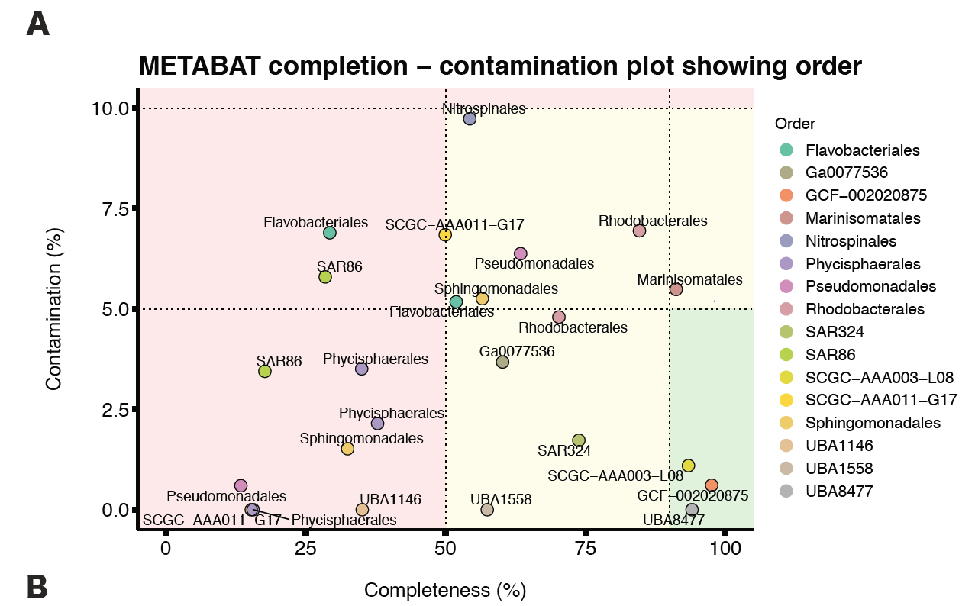

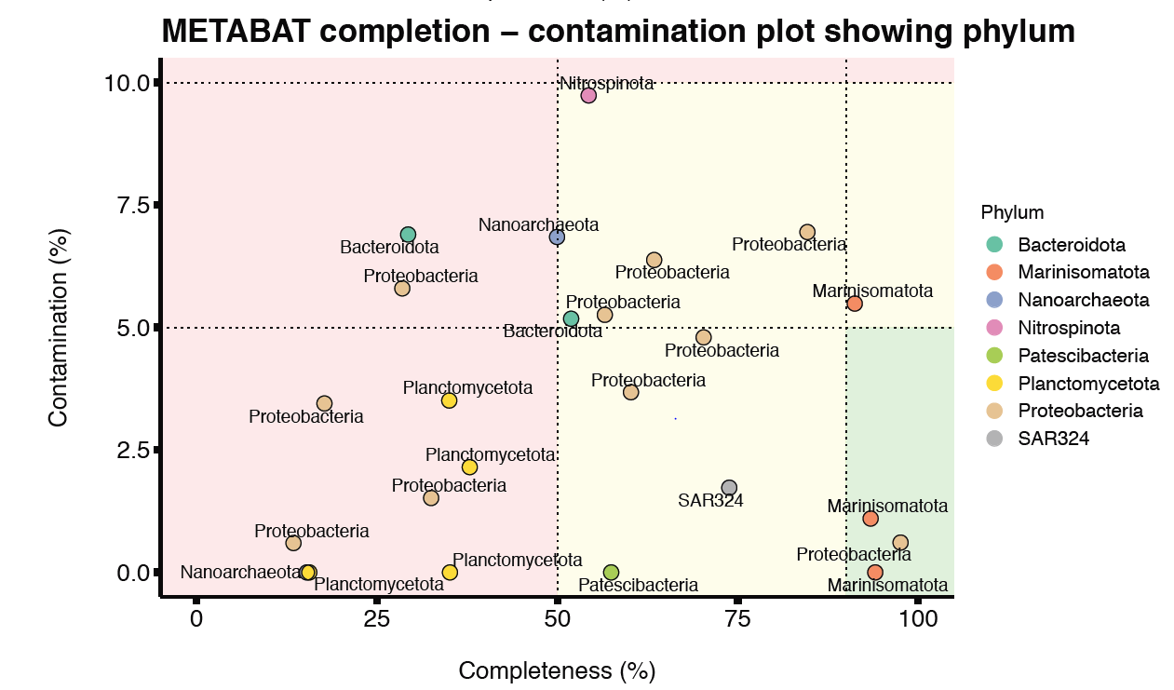

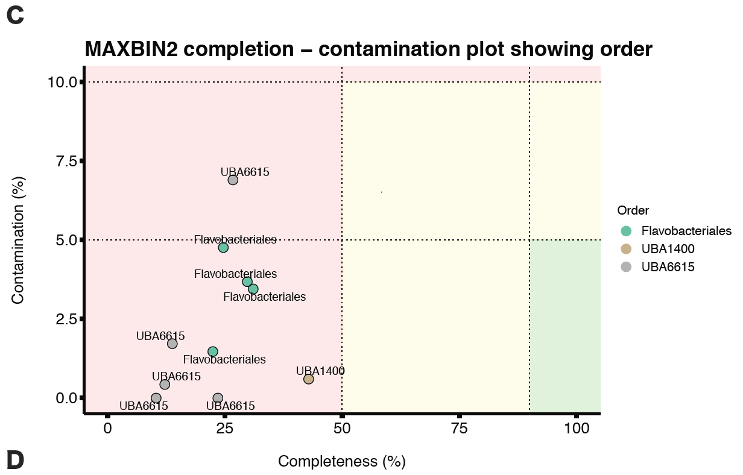

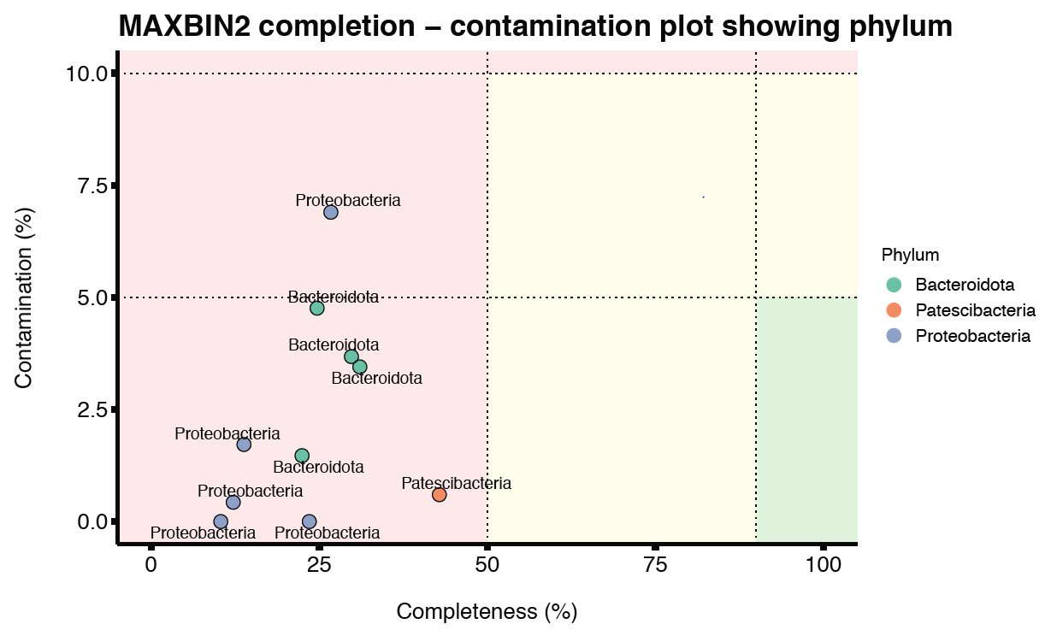

Figure S1 - Completion - contamination plots for MAGs. Panels (A) and (B) contain MAGs generated by the binning algorithms MetaBAT. Panels (C) and (D) indicate the MAGs generated by MaxBin2. CheckM was used to calculate completion and contamination metrics, where parameters were set at a minimum of 50% and maximum of 10% respectively. Green, yellow and red shades contain high, medium and low-quality MAGs, respectively. Figures are further organized based on the taxonomic annotations based on Gtdb-Tk results. Panels (A) and (C) show the order and panels (B) and (D) show the phylum. Only MAGs with Gtdb-Tk taxonomic annotations are shown.

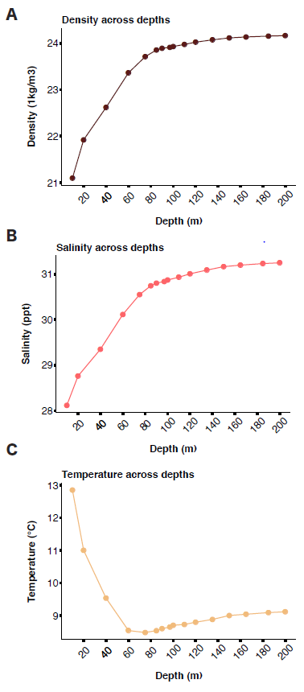
Figure S2 - Water column conditions across different depths. Density, salinity and temperature measurements taken from depths 10 m to 200 m are given in panels (A), (B) and (C), respectively. The data was obtained from Saanich_ Data.csv, provided by the teaching team of MICB 405. Both density and salinity measurements are higher at greater depths compared to temperature, which decreases with increasing depth.

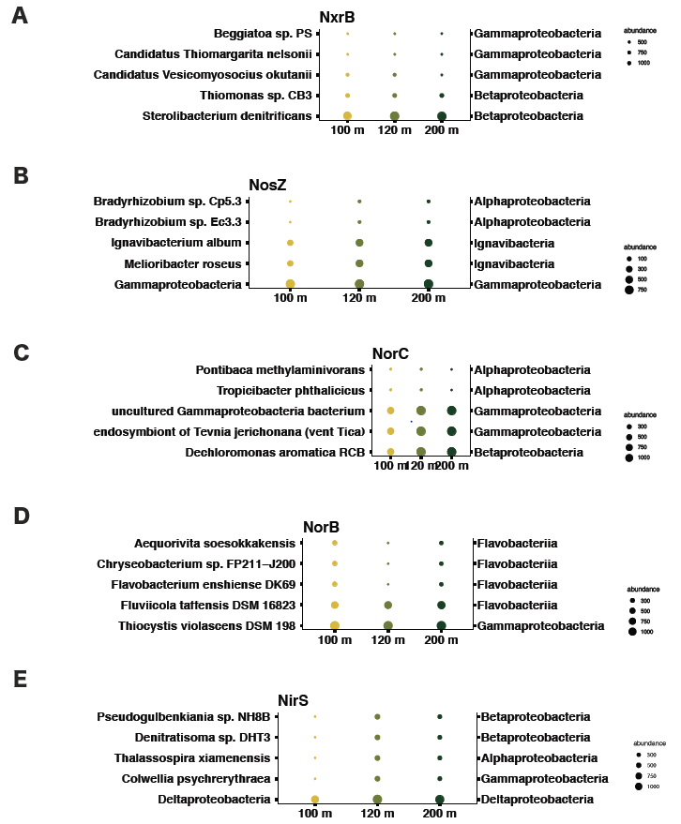

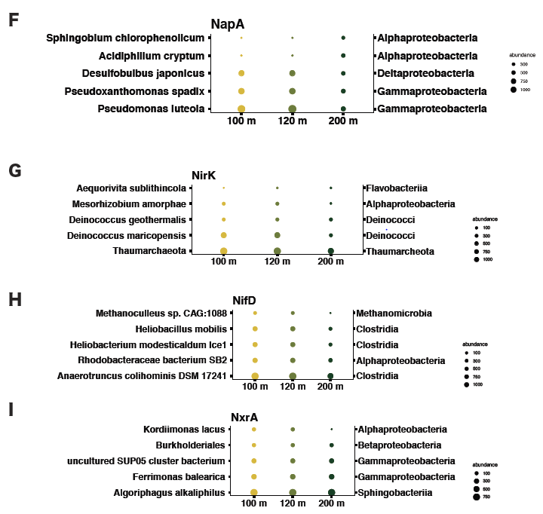

Figure S3 - Nitrogen cycle gene abundances compared across species and classes measured at different depths according to TREESAPP results. Species containing the highest magnitude of the respective gene is indicated by a large circle, while lower gene quantities are indicated by a smaller circle, as shown in the figure legends. Primary x axis indicates the species and the secondary x axis indicates phylum each species belongs to.

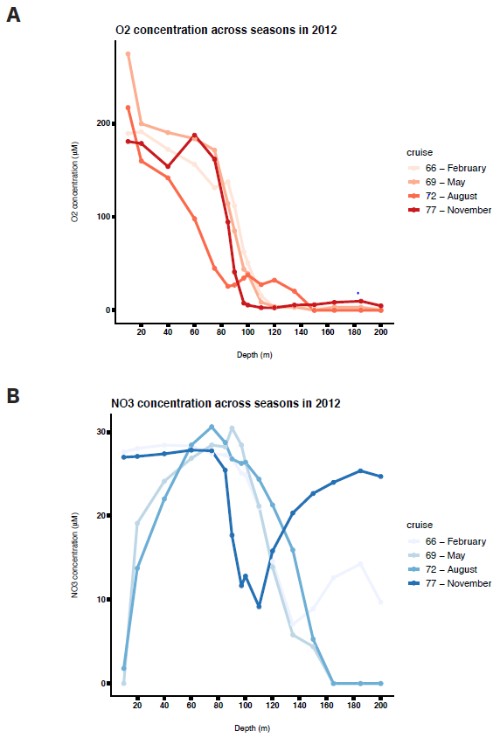

Figure S4 - Abundances (µM) of O2 and NO - are visualized in different depths (m) during the year 2012 across seasons in panels (A) and (B), respectively. Plots were generated using data from Saanich_Data.csv. O concentrations are consistently lower at higher depths across all seasons. NO - concentrations do not indicate a similar trend, as they vary during different seasons.

Nitrate reductase (NapA/ NarG) NO + 2H+ + 2e -> NO + H O

Nitrite Reductase (NirS/NirK) NO + 2H+ + e -> NO + H O

Nitric oxide reductase (NorB/NorC) 2NO + 2H+ + 2e -> N O + H O

Nitrous oxide reductase (NosZ) N O + 2H+ + 2e -> N + H O

Sumed Denitrification redox: NO + 12H+ + 10e -> N + 6H O

Nitrogen fixation (NifD)
N + 8H+ + 8e -> 2 NH + H

Nitration (NxrA/NxrB)
NO + H O -> NO + 2H+ + 2e

Figure S5 - Complete redox reactions each nitrogen cycle gene of interest is involved with.

