Age, water source, and sex do not significantly affect the microbiome of the Hadza people of Tanzania

Ananya Saraph, Maxim Daspe, Mona Golmohammadzadeh, Alina Chalanuchpong
Department of Microbiology and Immunology, University of British Columbia, Canada

SUPPLEMENTARY MATERIAL

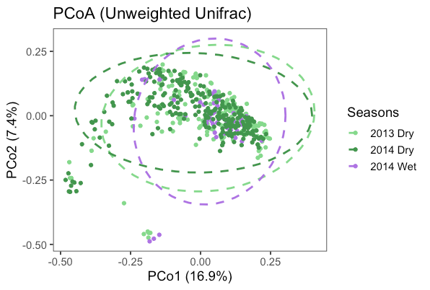
Figure S1: Unweighted UniFrac analysis of Hadza gut microbial community composition does not show a significant difference across seasons. Individual gut microbiome compositions in the 2013 Dry (light green, N = 133), 2014 Wet (purple, N = 46), and 2014 Dry (light green, N = 63) sub-seasons were analyzed using QIIME2 and plotted on an unweighted UniFrac PCoA plot in R. Samples collected in each sub-season are similar to one another. Percent variance explained on axis 1 = 16.9%, axis 2 = 7.4%.
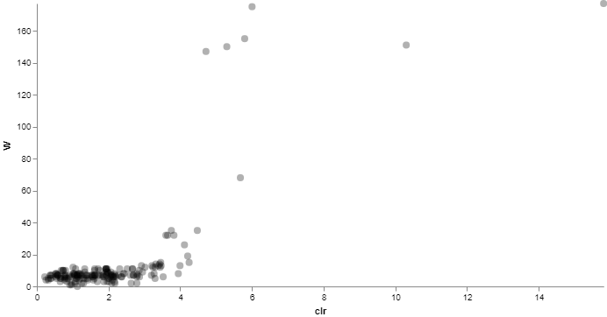
Figure S2: There are no differentially abundant ASVs identified in fecal samples from different bush camps at the family level. Differential abundance testing of fecal samples from different bush camps at the family level was performed in QIIME2 using ANCOM. Two ASVs with high W statistics and clr mean differences were observed, which were identified as k__Bacteria;p__Cyanobacteria;c__4C0d-2;o__YS2;f__ (clr = 15.8, W = 177) and k__Bacteria;p__Proteobacteria;c__Deltaproteobacteria;o__GMD14H09;f__
(clr = 10.3, W = 151). N = 544.

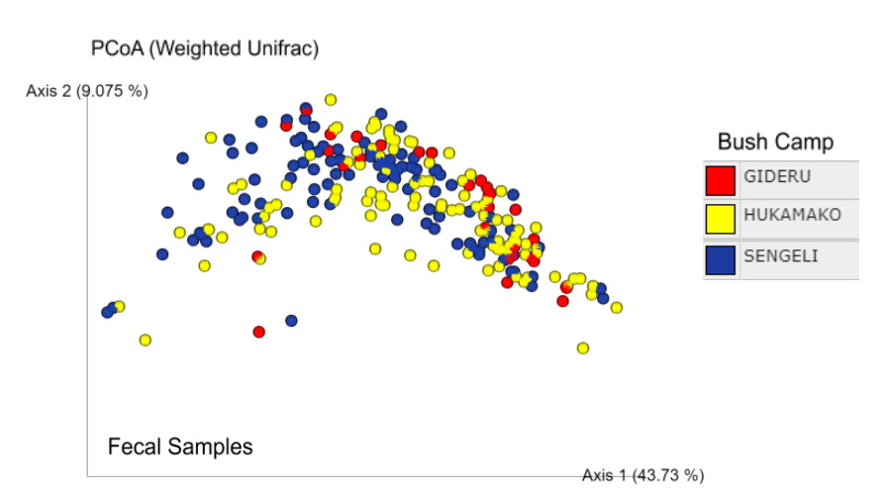
Figure S3: Gideru, Hukamako, and Sengeli bush camps display similar gut microbiomes when analyzed using weighted UniFrac analysis. Using QIIME2, human fecal samples were visualized based on weighted UniFrac analysis on a PCoA plot. All samples from bush camps except for Gideru (red spheres), Hukamako (yellow spheres), and Sengeli (blue spheres) were removed from the analysis, as these 3 camps displayed similar gut microbiomes. Percent variance explained on axis 1: 43.73%. Percent variance explained on axis 2: 9.075%. Gideru: N=30. Hukamako: N=104. Sengeli: N=103.

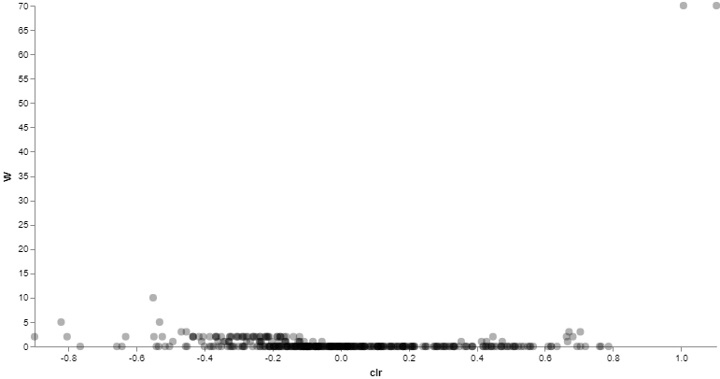
Figure S4: A lack of differentially abundant ASVs are found in the right hand microbiomes of males and females. Using QIIME2, differential abundance testing between males and females was performed with ANCOM at the genus level. Most genera of bacteria display low clr mean difference and W statistics, with only 2 genera having both a high W statistic and high clr mean differences. These organisms are k__Bacteria;p__Proteobacteria;c__Gammaproteobacteria;o__Pseudomonadales;f__Moraxellaceae;g__Psychrobacter (clr=1.104, W=70) and k__Bacteria;p__Acidobacteria;c__[Chloracidobacteria];o__RB41;f__Ellin6075;g__ (clr=1.007, W=70). N=390.

