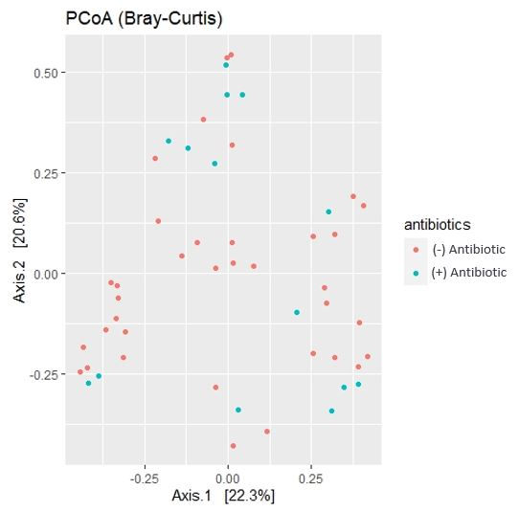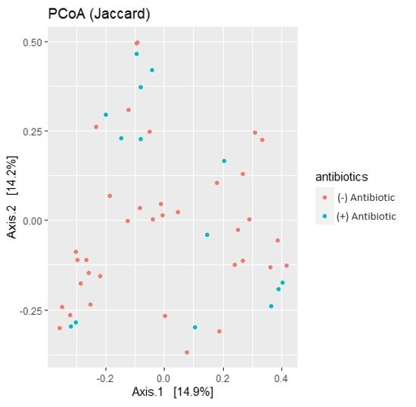

**Figure 1. No apparent differences in microbial composition between antibiotic-treated and non-treated dogs indicated by low beta diversity in Bray-Curtis, Jaccard metrics.** Beta diversity between antibiotic-treated (blue) and non-antibiotic-treated (red) dogs was low in the Bray-Curtis (panel A, left) and Jaccard (panel B, right) metrics. Samples from both treatment groups show a high degree of clustering with no clear distinction suggesting no significant differences in microbial composition.

**A**

**B**

**A**

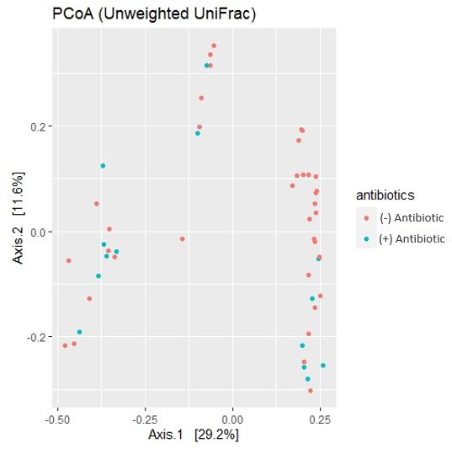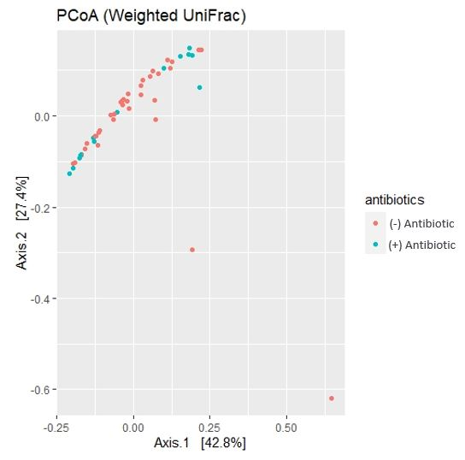

**B**

**Figure 2. No apparent differences in microbial composition between antibiotic-treated and non-treated dogs indicated by low beta diversity in Weighted, Unweighted UniFrac metrics.** Beta diversity between antibiotic-treated (blue) and non-antibiotic-treated (red) dogs was low in the Weighted (panel A, left) and Unweighted (panel B, right) UniFrac metrics. Samples from both treatment groups show a high degree of clustering with no clear distinction suggesting no significant differences in microbial composition.

**A**

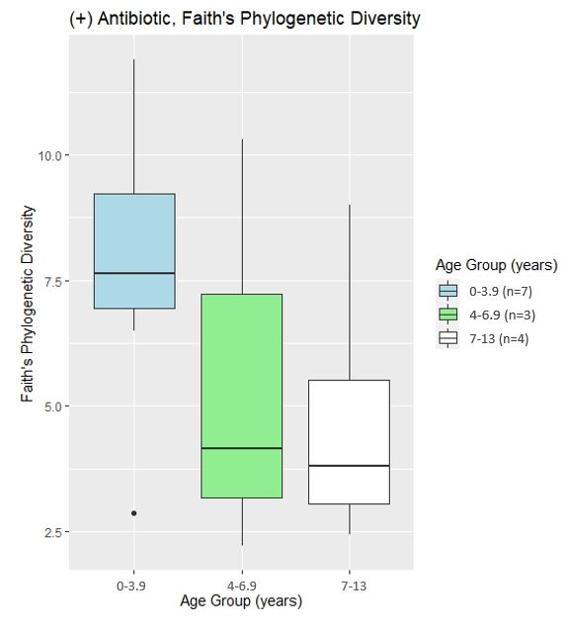

**Figure 3. Faith’s phylogenetic diversity appears to be higher in dogs ages 0-3.9 compared to ages 7-13 in only the antibiotic-treated group.** Faith’s phylogenetic diversity (vertical axis) comparisons between age groups (horizontal axis) in antibiotic-treated dogs. The youngest group appears to have a higher diversity than the oldest group, though this is not statistically significant (p-value = 0.186, Kruskal-Wallis pairwise test, α = 0.05). The legend on the right shows sample sizes of each age group.

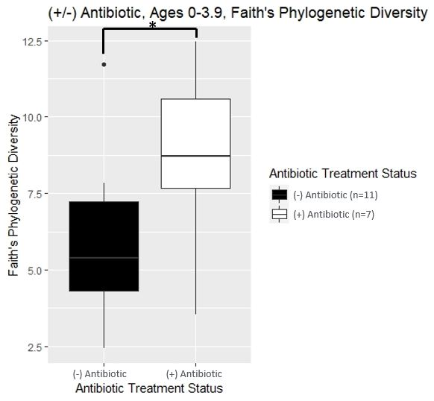

**Figure 4. Dogs of ages 0-3.9 showed higher Faith’s phylogenetic diversity in the antibiotic-treated group compared to the non-treated group.** Faith’s phylogenetic diversity (vertical axis) comparisons between non-antibiotic-treated and antibiotic-treated dogs ages 0-3.9 (horizontal axis) showed a higher diversity in (+) antibiotic-treated dogs with statistical significance (denoted by *, p-value = 0.042, Kruskal-Wallis pairwise test, α = 0.05). The legend on the right shows sample sizes of each antibiotic treatment group.

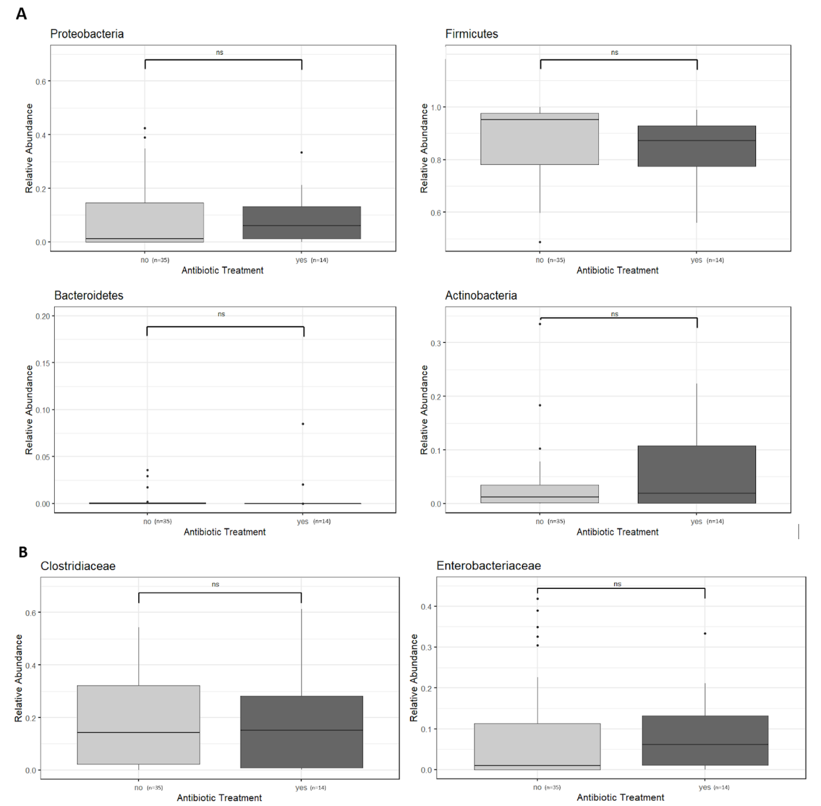

**B**

**A**

**Figure 5. No significant differences in abundance of IBD-associated bacterial communities between IBD dogs on antibiotic treatment versus not on treatment.** Relative abundance of IBD-associated bacterial phyla and families in dogs with IBD. Samples are grouped on the horizontal axis by antibiotic treatment group and relative abundance is shown on the vertical axis as proportional presence out of 1 (total isolated species). (A) Samples from both treatment groups showed a high degree of overlap for abundance of the Proteobacteria, Firmicutes, Bacteroidetes, and Actinobacteria phyla, with no statistically significant differences as determined by Kruskal-Wallis pairwise testing (α = 0.05).  (B)Samples from both treatment groups showed a high degree of overlap for the Clostridiaceae and Enterobacteriaceae families, with no statistically significant differences as determined by Kruskal-Wallis pairwise testing (α = 0.05).

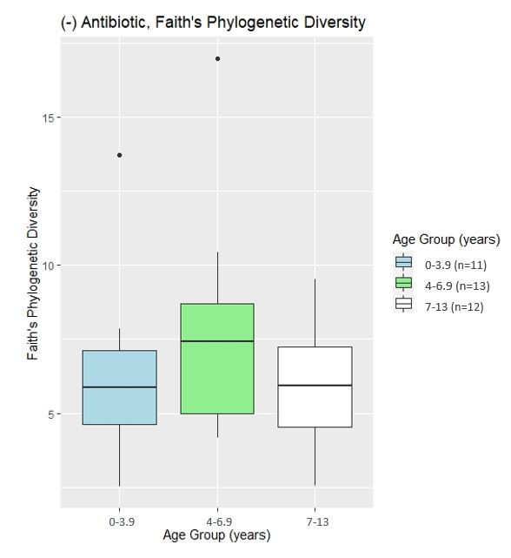

**Supplemental Figure 1. No significant difference in Faith’s phylogenetic diversity between different age groups in non-antibiotic treated dogs.** Alpha diversity comparisons with the Faith’s phylogenetic metric (vertical axis) did not show any differences between age groups (horizontal axis) in dogs that were not treated with antibiotics. The legend on the right shows sample sizes of each age group.

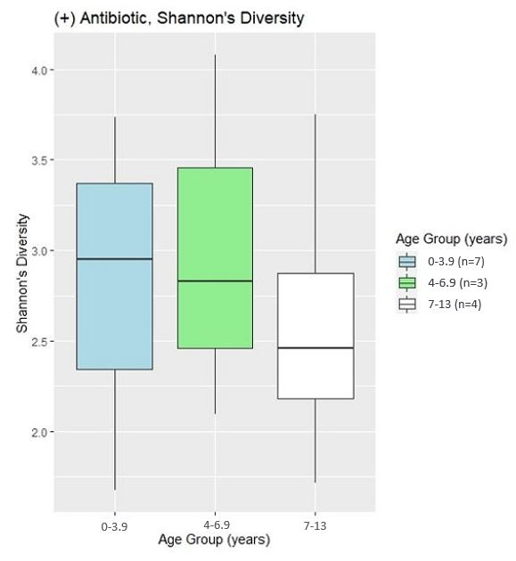

**Supplemental Figure 2. No significant difference in Shannon’s diversity between the different age groups in both dogs treated and not treated with antibiotics.** Alpha diversity comparisons with Shannon's metric (vertical axis) did not show any differences between age groups (horizontal axis) in either antibiotic-treated (panel A, left) or non-treated (panel B, right) dogs. The legend on the right shows sample sizes of each age group.

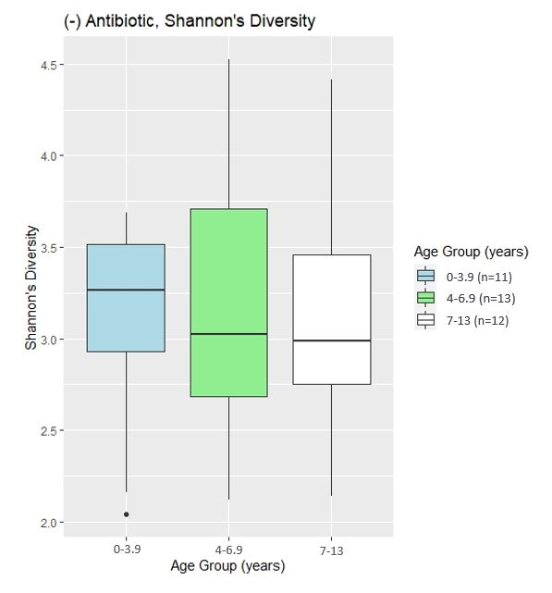

**B**

**A**

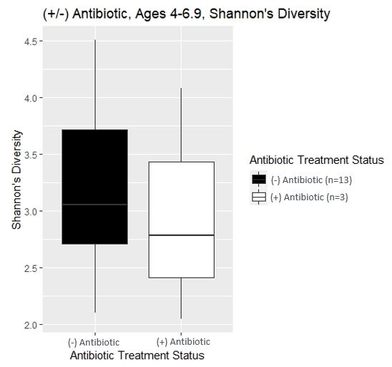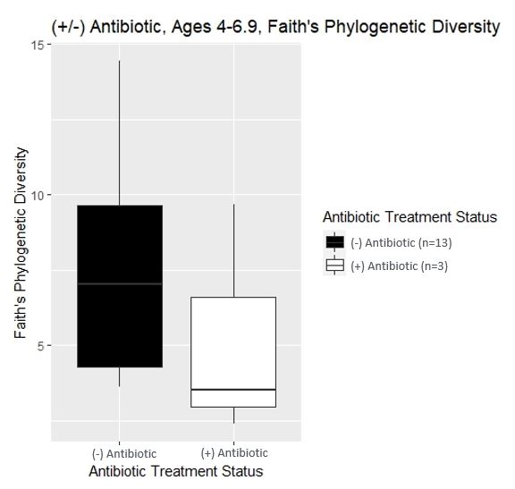

**Supplemental Figure 3. No significant differences in Faith’s phylogenetic and Shannon’s diversity between antibiotic treated and non-treated dogs ages 4-6.9.** Comparison of alpha diversity in the Faith’s (panel A, left) and Shannon’s (panel B, right) metrics between antibiotic treated and non-treated dogs ages 4-6.9 showed no significant differences. The legend on the right shows sample sizes, the vertical axes show alpha diversity and the horizontal axes show antibiotic treatment status.

**B**

**A**

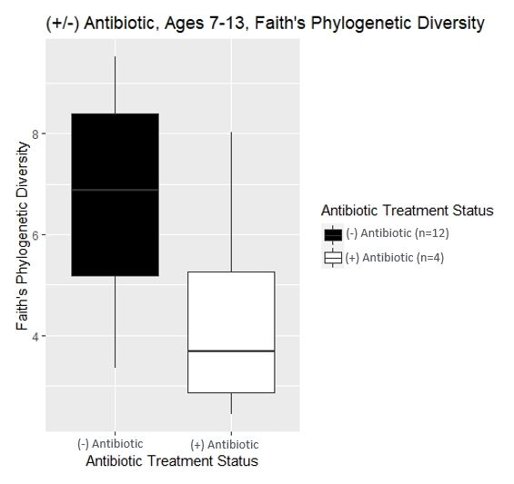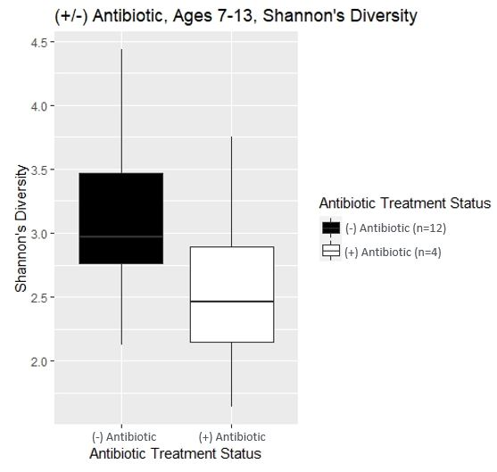

**Supplemental Figure 4. No significant differences in Faith’s phylogenetic and Shannon’s diversity between antibiotic treated and non-treated dogs ages 7-13.** Comparison of alpha diversity in the Faith’s (panel A, left) and Shannon’s (panel B, right) metrics between antibiotic treated and non-treated dogs ages 7-13 showed no significant differences. The legend on the right shows sample sizes, the vertical axes show alpha diversity and the horizontal axes show antibiotic treatment status.

**B**

**A**

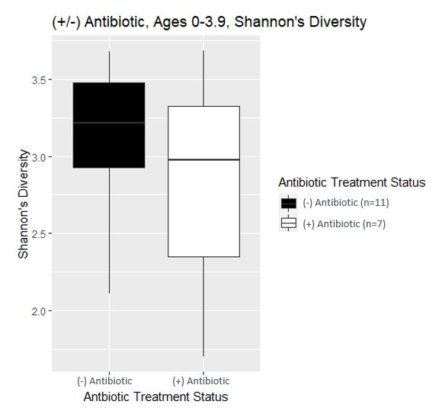

**Supplemental Figure 5. Dogs of ages 0-3.9 showed no difference in Shannon’s diversity between the antibiotic-treated group and the non-treated group.** Shannon’s diversity (vertical axis) comparisons between non-antibiotic-treated and antibiotic-treated dogs ages 0-3.9 (horizontal axis) showed no difference in diversity. The legend on the right shows sample sizes of each antibiotic treatment group.