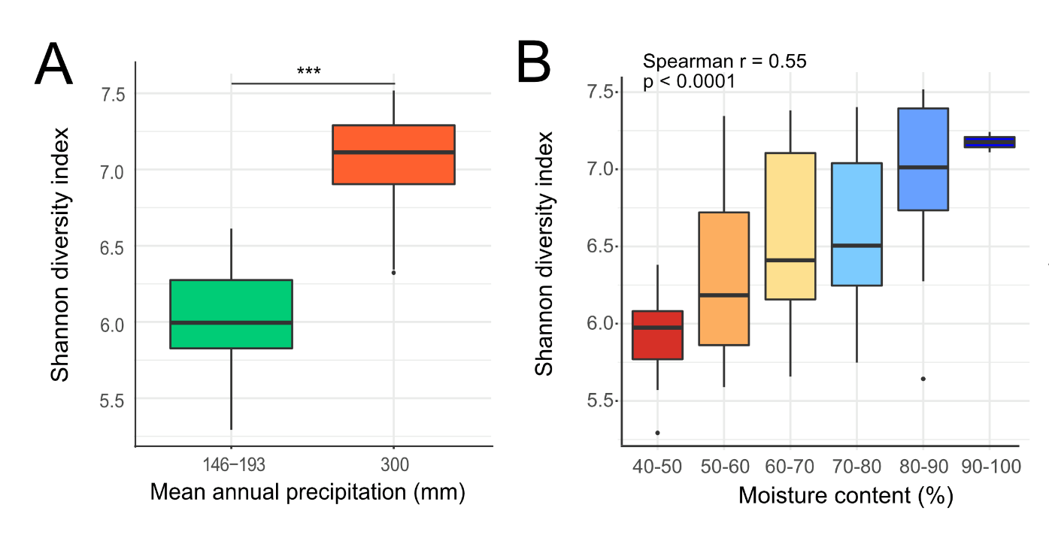
Supplementary Figure 1. Mean annual precipitation and soil moisture content positively correlated with sample Shannon diversity. (A) Shannon diversity index boxplot for low (146-193 mm) and high (300 mm) levels of mean annual precipitation (N_{146-193 mm} = 52, N_{300 mm} = 42). (B) Boxplot showing Shannon diversity index for each soil moisture content group (N_{40-50%}= 13 , N_{50-60%} = 30, N_{60-70%} = 32 , N_{70-80%} = 10, N_{80-90%} = 16 , N_{90-100%} = 3). (***) = statistical significance (p < 0.0001).

Supplementary Figure 2. PCA analysis of weighted UniFrac distance showed clustering of samples into two distinct mean annual precipitation groups. The two groups were low (146-193 mm) and high (300 mm) mean annual precipitation (N_{146-193 mm} = 52, N_{300 mm} = 42).

Supplementary Figure 3. Bradyrhizobium, Rhodoplanes, and Methylocystaceae were the most abundant taxa in both the SBS_{BC} and IDF_{BC} ecozones. The taxonomy bar plot shows the three taxa (dark grey, brown, yellow) present at the highest relative frequency in both ecozones. Less abundant bacterial families are all collectively represented in light grey.

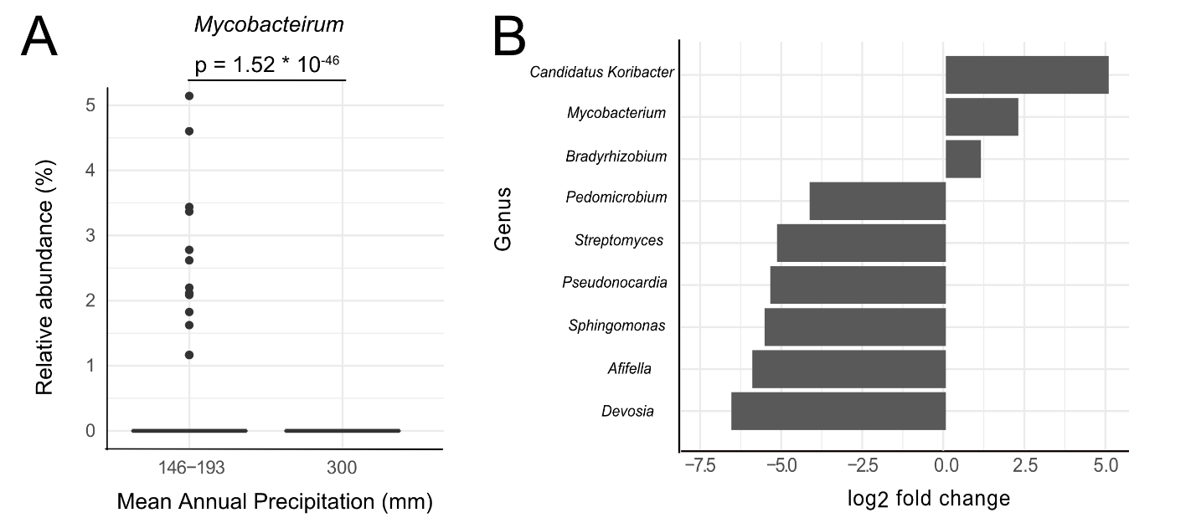

Supplementary Figure 4. Mycobacterium and Bradyrhizobium were more abundant in sites with low mean annual precipitation and low soil moisture content. (A) Relative abundance of Mycobacterium for low (146-193 mm) and high (300 mm) levels of mean annual precipitation (N_{146-193 mm} = 52, N_{300 mm} = 42). (B) Barplot of abundance log2 fold change for genera that show significant differential abundance between the low (40-50%) and high (70-100%) soil moisture content groups (N_{Low} = 13, N_{High} = 29).

Supplementary Table 1. Unweighted UniFrac distance pairwise PERMANOVA results for mean annual precipitation.
Group 1 | Group 2 | Sample Size | Permutations | pseudo-F | p-value | q-value
146-193 | 300 | 94 | 999 | 11.5 | 0.001 | 0.001

Supplementary Table 2. Weighted UniFrac distance pairwise PERMANOVA results for mean annual precipitation.
Group 1 | Group 2 | Sample Size | Permutations | pseudo-F | p-value | q-value
146-193 | 300 | 94 | 999 | 36.9 | 0.001 | 0.001

Supplementary Table 3. Weighted UniFrac distance pairwise PERMANOVA results for soil moisture content.
Group 1 | Group 2 | Sample Size | Permutations | pseudo-F | p-value | q-value
40-50% | 50-60% | 38 | 999 | 3.95 | 0.009 | 0.033
 | 60-70% | 41 | 999 | 4.96 | 0.004 | 0.030
 | 70-80% | 20 | 999 | 3.66 | 0.011 | 0.033
 | 80-90% | 29 | 999 | 13.4 | 0.001 | 0.015
 | 90-100% | 14 | 999 | 12.2 | 0.013 | 0.033
50-60% | 60-70% | 55 | 999 | 0.58 | 0.76 | 0.76
 | 70-80% | 34 | 999 | 1.23 | 0.26 | 0.32
 | 80-90% | 43 | 999 | 3.29 | 0.018 | 0.039
 | 90-100% | 28 | 999 | 2.33 | 0.044 | 0.073
60-70% | 70-80% | 37 | 999 | 1.37 | 0.20 | 0.27
 | 80-90% | 46 | 999 | 3.44 | 0.008 | 0.033
 | 90-100% | 31 | 999 | 2.47 | 0.042 | 0.073
70-80% | 80-90% | 25 | 999 | 2.11 | 0.081 | 0.12
 | 90-100% | 10 | 999 | 1.52 | 0.34 | 0.36
80-90% | 90-100% | 19 | 999 | 1.5 | 0.28 | 0.32

