Identifying breed, dietary, and reproductive factors affecting the gut microbiome of dogs with inflammatory bowel disease

Joshua Calalang, Honor Cheung, Kristi Lichimo, Bonny So
Department of Microbiology and Immunology, University of British Columbia, Vancouver, British Columbia, Canada

SUPPLEMENTAL MATERIALS
Supplemental Table 1. Overview of total sample sizes
Factors of interest | Total samples before filtering and rarefaction (n) | Total samples after filtering and rarefaction (n)
Dog breeds | 191 | 148
Protein source | 92 | 75
Percent crude protein | 89 | 73
Neuter status | 188 | 146

Supplemental Table 2. Healthy and IBD samples for at-risk and not-at-risk breed groups
Risk group | Healthy samples (n) | IBD samples (n)
At-risk breeds | 5 | 15
Not-at-risk breeds | 79 | 49

Supplemental Table 3. Healthy and IBD samples for chicken, fish, hydrolyzed and lamb as protein sources
Protein Source | Healthy samples (n) | IBD samples (n) | Total samples used for analysis (n)
Chicken | 28 | 17 | 45
Fish | 3 | 7 | 10
Hydrolyzed | 1 | 9 | 10
Lamb | 7 | 3 | 10

Supplemental Table 4. Healthy and IBD samples for amount of crude protein in diet
Crude protein (%) | Healthy samples (n) | IBD samples (n) | Total samples used for analysis (n)
14-20 | 3 | 11 | 14
21-25 | 25 | 15 | 40
25-35 | 10 | 9 | 19

Supplemental Table 5. Healthy and IBD samples according to sex and neuter status
Sex | Neuter Status | Healthy samples (n) | IBD samples (n)
Male | Yes | 24 | 11
 | No | 14 | 26
Female | Yes | 31 | 12
 | No | 15 | 13

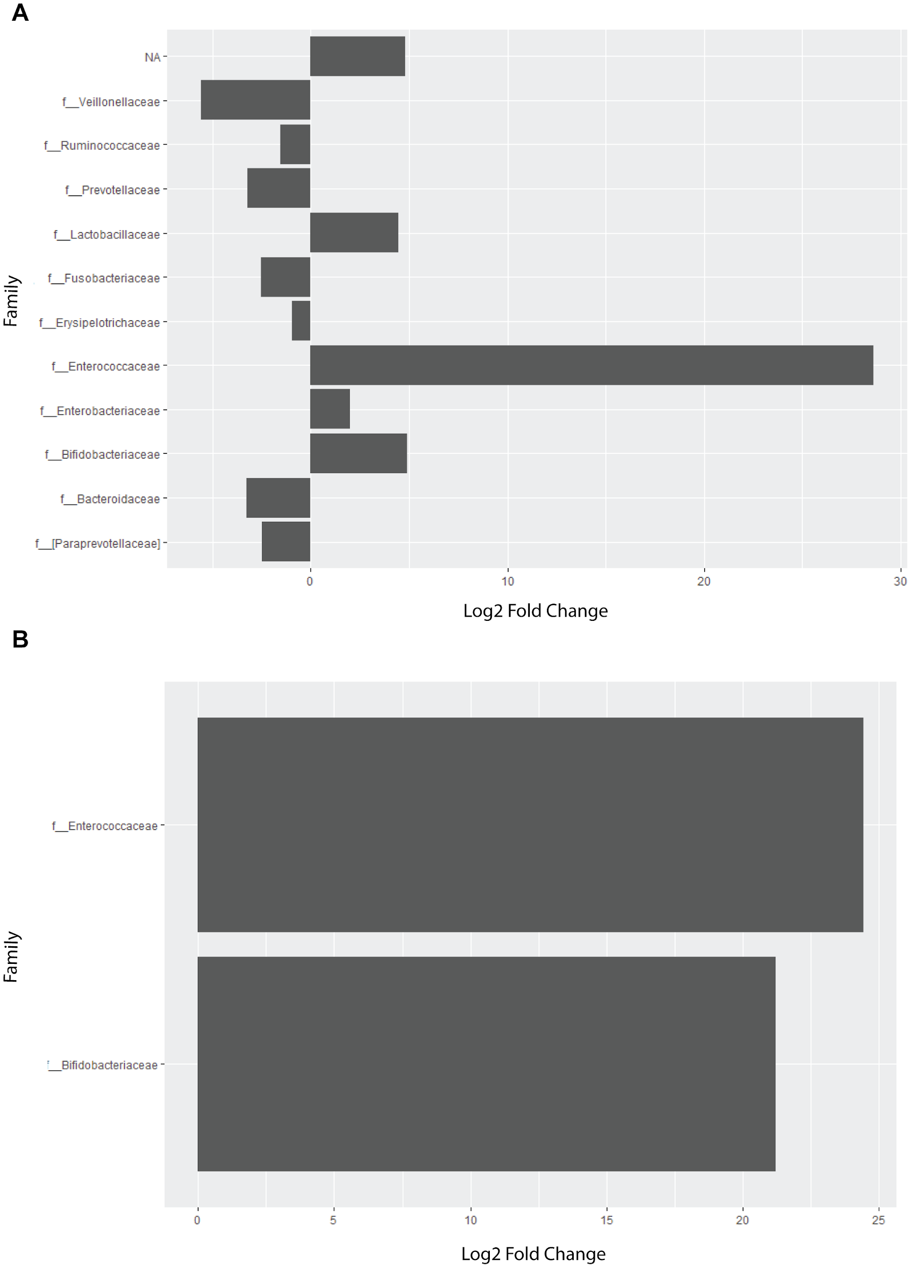
Supplemental Figure 1. The family Enterococcaceae is relatively more abundant in dogs with IBD. A differential abundance analysis at the family level for (A) non-at-risk and (B) at-risk IBD dogs identified a relatively higher abundance of Enterococcaceae in both at-risk and non-at-risk IBD dogs. In (A), the bars on the left represent families that are more relatively abundant in healthy dogs, and the bars on the right represent families that are more relatively abundant in IBD dogs.

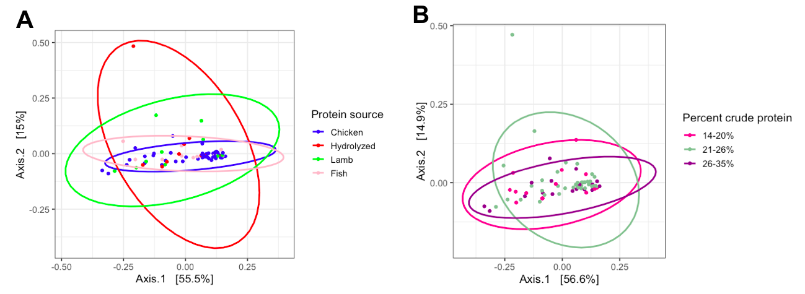
Supplemental Figure 2. Beta diversity did not differ between protein sources (A) and percent crude protein (B) in terms of weighted UniFrac distances. Principal coordinates analysis (PCoA) showed similar clustering patterns between diets with respect to abundance and phylogenetic distances. Ellipses are colour-coded according to the legend and indicate patterns of clustering. Percentage variance = 70.5% (A) and 71.5% (B).
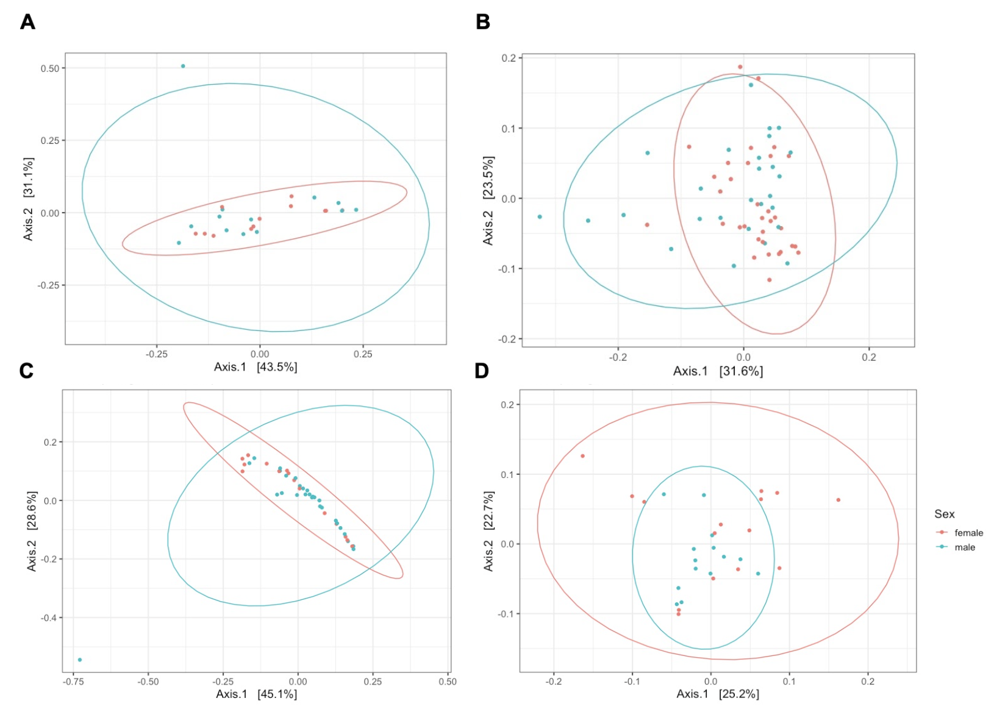
Supplemental Figure 3: Beta diversity in terms of weighted UniFrac distances did not differ between male and females in all neutering status and disease status combinations. (A) Neutered + IBD, (B) Neutered + Healthy, (C) Intact + IBD, (D) Intact + healthy. There was no difference in the gut microbial composition between males (blue) and females (red) in A, B, C, and D, as seen by the lack of significant clustering patterns. Percentage variance = 74.6% (A), 55.1% (B), 73.7% (C), 47.9% (D).

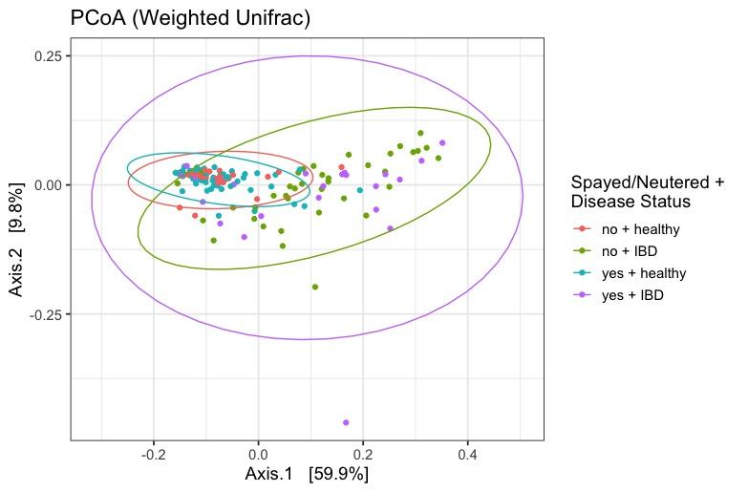
Supplemental figure 5: Beta diversity in terms of weighted UniFrac distances among all neuter and disease status combinations showed a distinction between healthy and IBD dogs. Principal coordinates analysis (PCoA) plot showed clustering patterns based on disease status, indicating that there is a difference between healthy and IBD with respect to their gut microbial composition. Percentage variance = 69.7%.

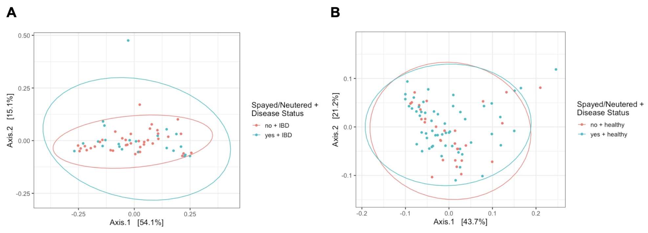
Supplemental Figure 6: Beta diversity between intact and neutered dogs did not differ among healthy and IBD dogs. Principal coordinates analysis (PCoA) in terms of weighted UniFrac distances showed that there were no differences in the gut microbial communities of intact and neutered dogs that had IBD (A) or were healthy (B). Percentage variance = 69.2% (A), 64.9% (B).

