**Supplemental Figure 1. Boxplots showing Alpha diversity between human fecal and honey samples.** Alpha diversity compares the mean diversity between groups. Difference in alpha diversity between honey and Hadza human fecal samples was confirmed by Kruskal-Wallis pairwise test (α = 0.05, asterisk indicates q < 0.05) in both assessed metric: (A) Shannon’s diversity and (B) Faith’s phylogenetic diversity. The box represents the interquartile range (IQR) and the middle line represents the median. Upper and lower whiskers go to the highest or lowest measurement, or to the IQR multiplied by 1.5, whichever is higher or lower, respectively.

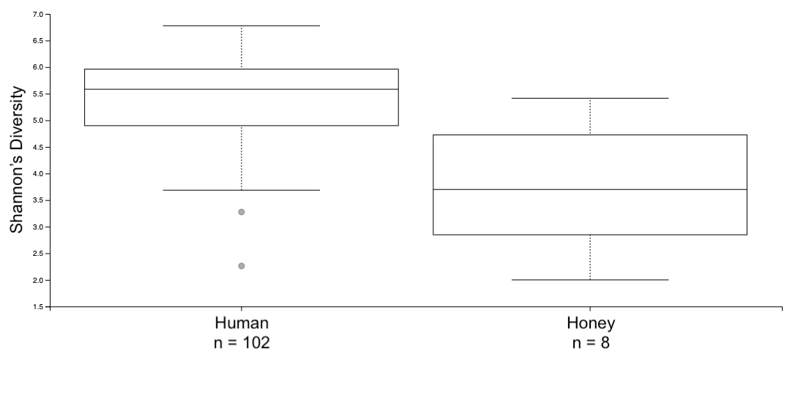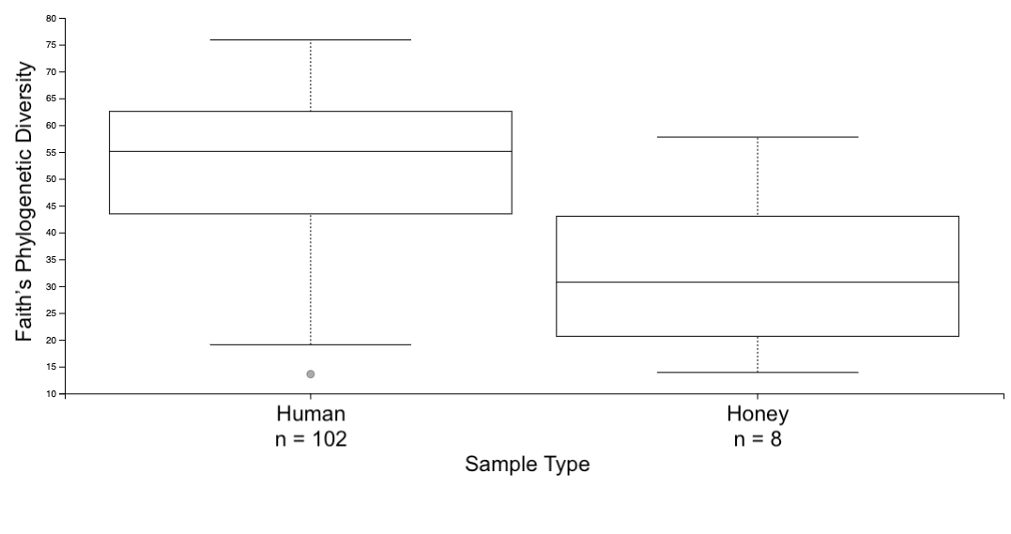

q = 0.002

q = 0.0004

B

A

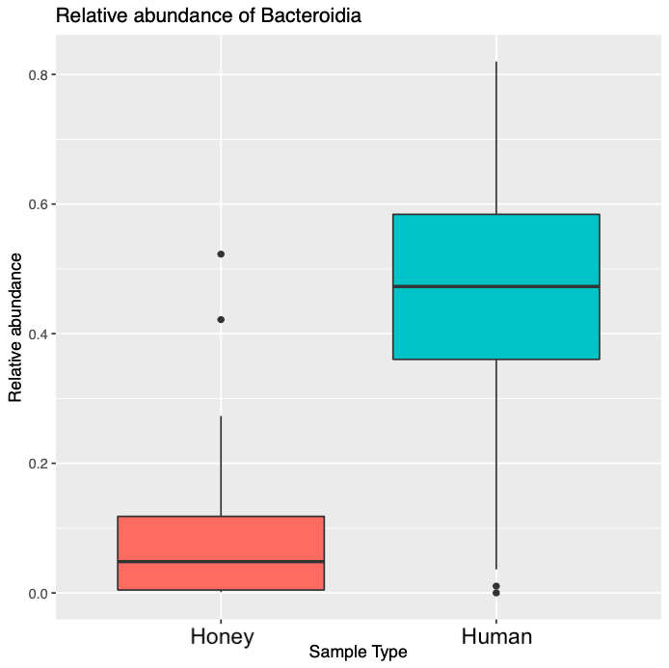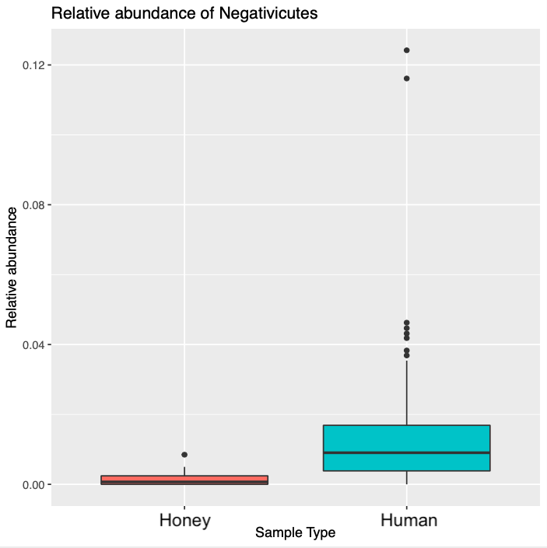

*

*

A

B

**Supplementary Figure 2. Boxplots showing the relative abundances of Bacteroidia and Negativicutes between honey and Hadza fecal samples.** Differential abundance analysis determines the bacterial Classes that differ significantly in relative abundance between honey samples and Hadza human fecal samples. All bacterial Classes not mentioned do not differ significantly between groups in their relative abundance. Differential abundance analysis identified a relatively higher abundance of (A) Bacteroidia and (B) Negativicutes in human samples. Differences are confirmed by differential abundance analysis with DESeq2 (α = 0.05, asterisk indicates q < 0.05). The box represents the interquartile range (IQR) and the middle line represents the median. Upper and lower whiskers go to the highest or lowest measurement, or to the IQR multiplied by 1.5, whichever is higher or lower, respectively.

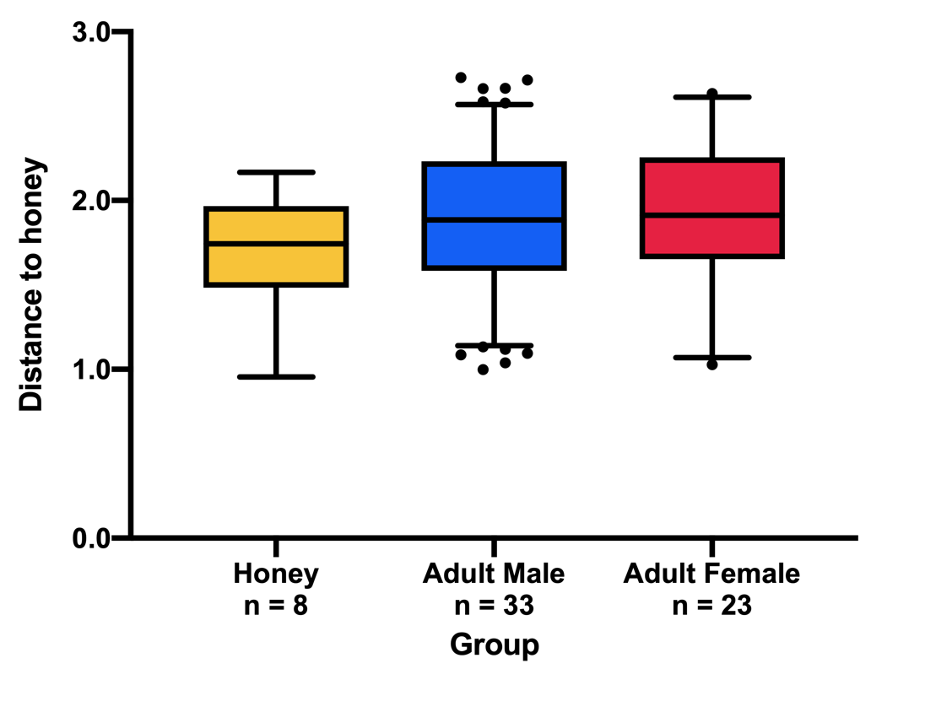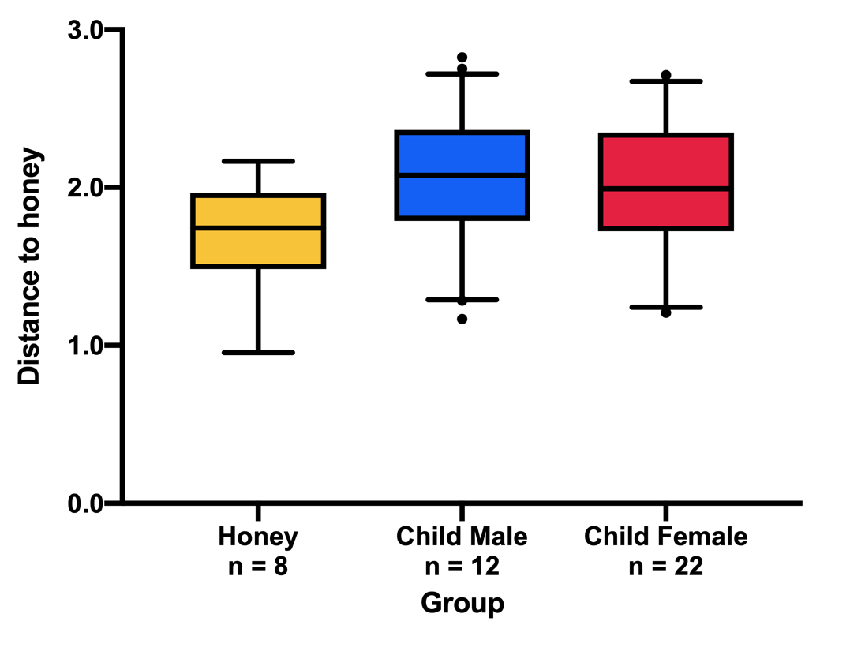

q = 0.01

q = 0.01

q = 0.1

q = 0.01

q = 0.01

q = 0.1

B

A

**Supplemental Figure 3. Boxplots showing Alpha diversity between male and female fecal samples.** Alpha diversity compares the mean diversity between groups. Difference in alpha diversity between male and female fecal samples was confirmed by Kruskal-Wallis pairwise test (α = 0.05) in both assessed metrics. (A) Shannon’s diversity and (B) Faith’s phylogenetic diversity. The box represents the interquartile range (IQR) and the middle line represents the median. Upper and lower whiskers go to the highest or lowest measurement, or to the IQR multiplied by 1.5, whichever is higher or lower, respectively.

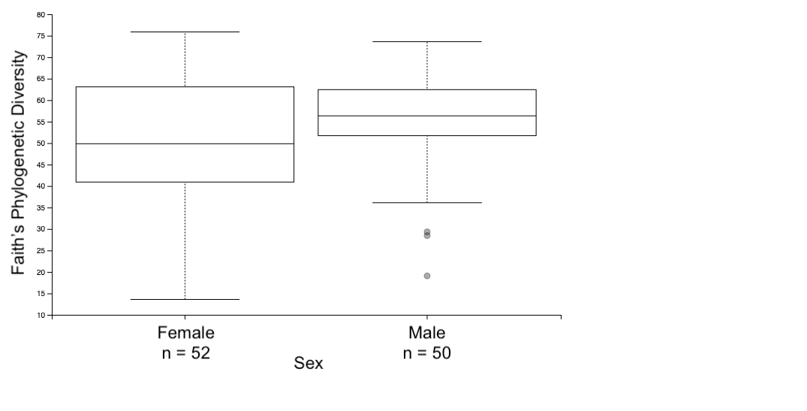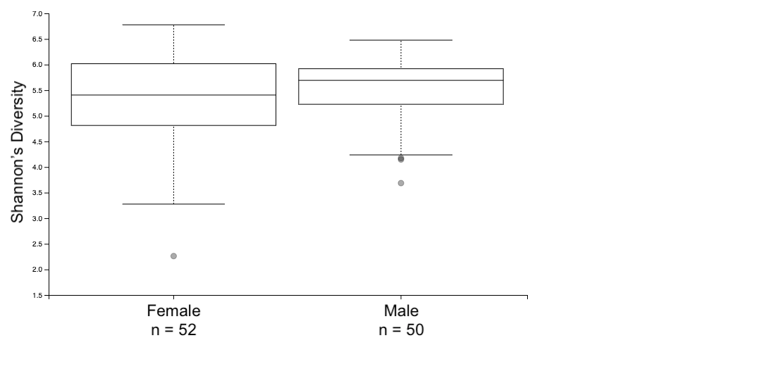

q = 0.5

q = 0.2

B

A

**Supplemental Figure 4. Differences between honey and Hadza fecal microbial communities do not differ between sexes, within adult and child life stage groups.** Weighted UniFrac Beta diversity, which considers both phylogenetic distance and abundance when plotting compositional differences between 16S microbiome of samples. Beta diversity between honey and both male and female Hadza fecal samples showed no difference between sexes with regards to distance to honey, within (A) Hadza adult and (B) Hadza child fecal samples, confirmed by Pairwise PERMANOVA testing. The box represents the interquartile range, and the middle line represents the median. Whiskers represent 95% confidence intervals.

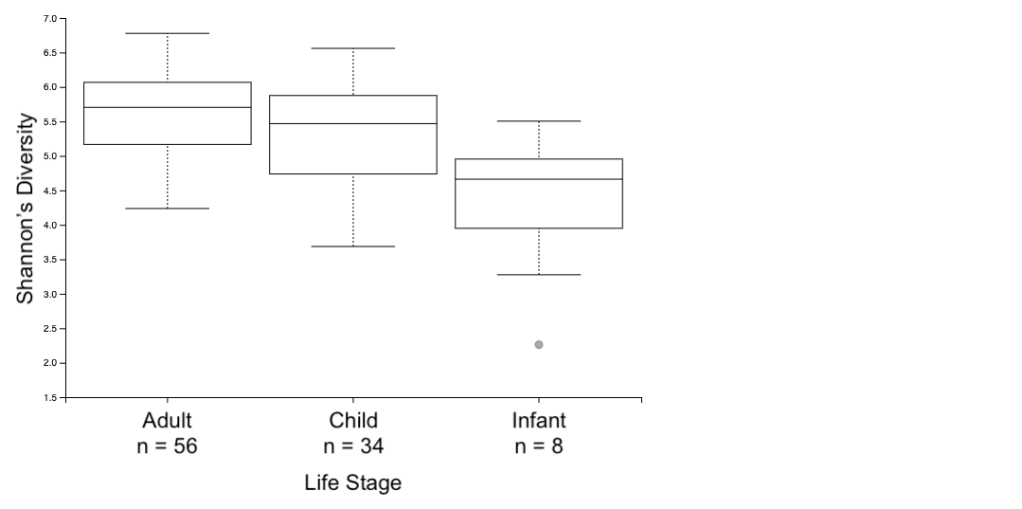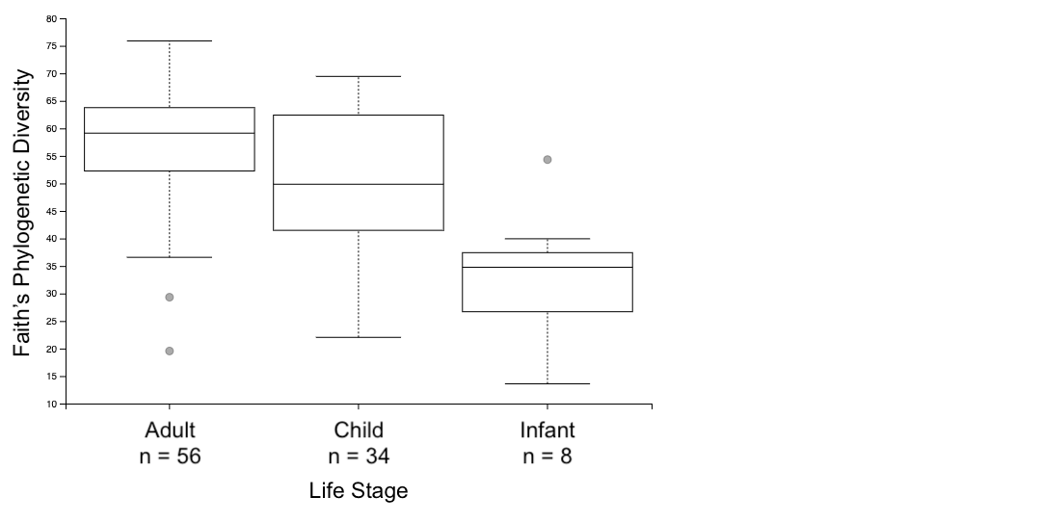

q = 0.08

q = 0.0001

q = 0.002

q = 0.1

A

B

q = 0.01

q = 0.003

**Supplementary Figure 5. Boxplots showing Alpha diversity between infants, adults and children.** Alpha diversity compares the mean diversity between groups. Difference in alpha diversity between adult, children and infants confirmed by Kruskal-Wallis pairwise test (α = 0.05, asterisk) in both assessed metrics: (A) Shannon’s diversity and (B) Faith’s phylogenetic diversity. The box represents the interquartile range (IQR) and the middle line represents the median. Upper and lower whiskers go to the highest or lowest measurement, or to the IQR multiplied by 1.5, whichever is higher or lower, respectively.

**Supplementary Figure 6. Boxplot showing the relative abundance of Spirochaetia between child and child Hadza fecal samples.** Differential abundance analysis determines the bacterial Classes that differ significantly in relative abundance between Hadza child and Hadza infant fecal samples. All bacterial Classes not mentioned do not differ significantly between groups in their relative abundance. Differential abundance analysis identified a relatively higher abundance of Spirochaetiain children. Differences are confirmed by differential abundance analysis with DESeq2 (α = 0.05, asterisk indicates q < 0.05). The box represents the interquartile range (IQR) and the middle line represents the median. Upper and lower whiskers go to the highest or lowest measurement, or to the IQR multiplied by 1.5, whichever is higher or lower, respectively.

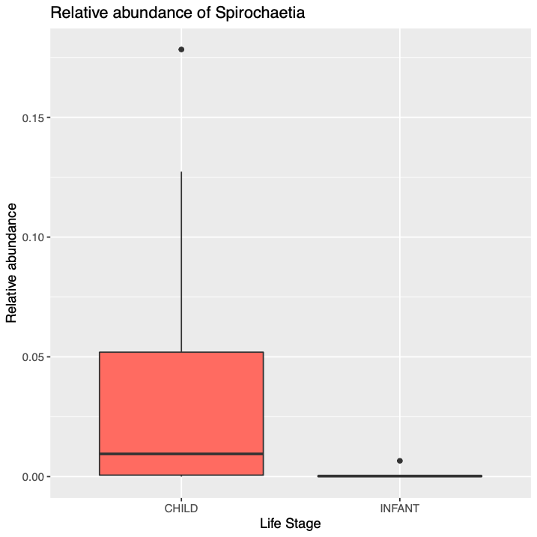

*

B

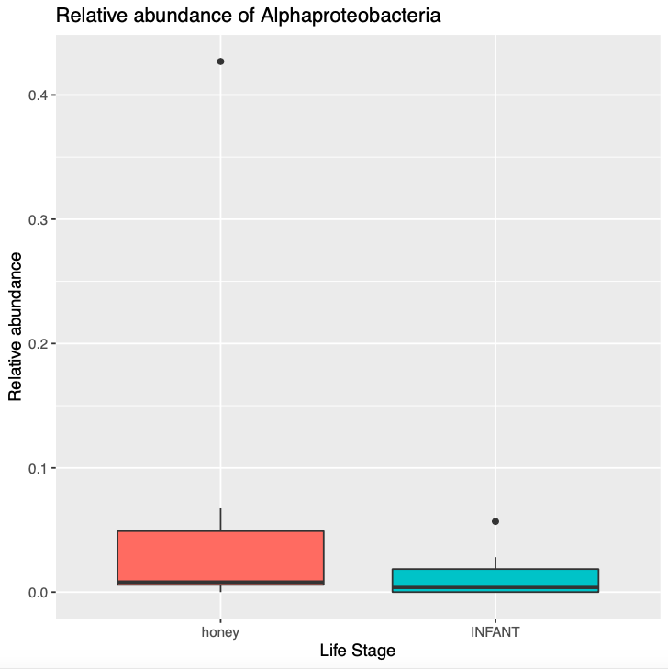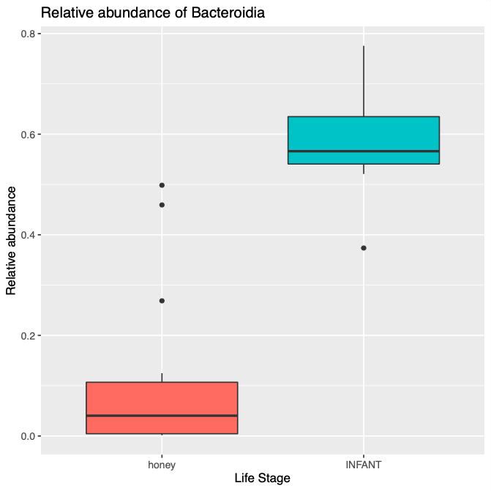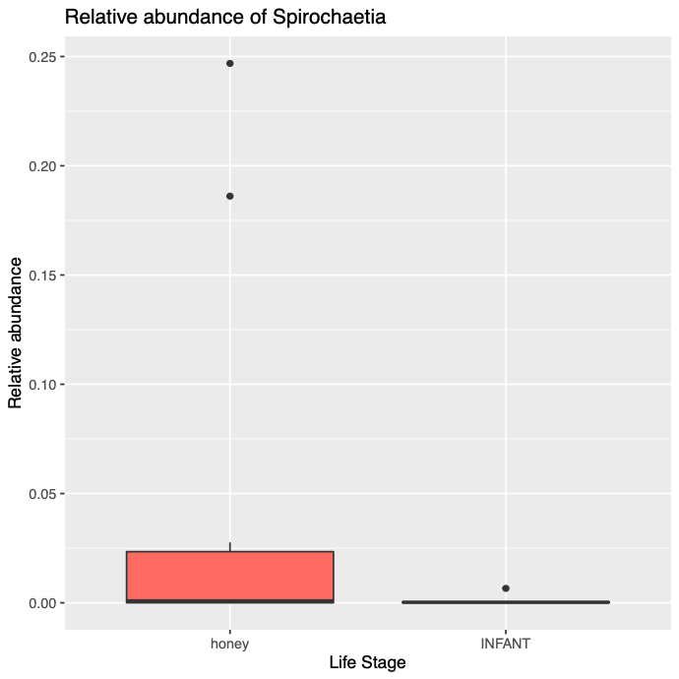

*

*

*

HONEY INFANT

Life Stage

HONEY INFANT

Life Stage

HONEY INFANT

Life Stage

A

C

**Supplementary Figure 7. Boxplot showing the relative abundance of Alphaproteobacteria, Spirochaetia and Bacteroidia between honey samples and infant fecal samples.** Differential abundance analysis determines the bacterial Classes that differ significantly in relative abundance between honey samples and Hadza infant fecal samples. All bacterial Classes not mentioned do not differ significantly between groups in their relative abundance. Differential abundance analysis identified a relatively higher abundance of (A) Alphaproteobacteria, (B) Spirochaetia in honey samples, and of (C) Bacteroidia in infant samples. Differences are confirmed by differential abundance analysis with DESeq2 (α = 0.05, asterisk indicates q < 0.05). The box represents the interquartile range (IQR) and the middle line represents the median. Upper and lower whiskers go to the highest or lowest measurement, or to the IQR multiplied by 1.5, whichever is higher or lower, respectively.

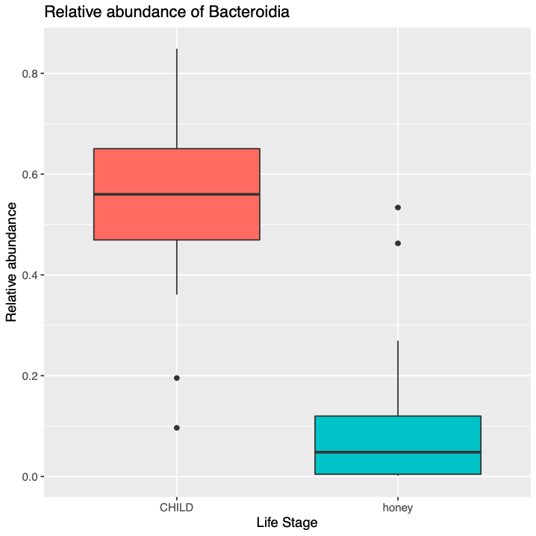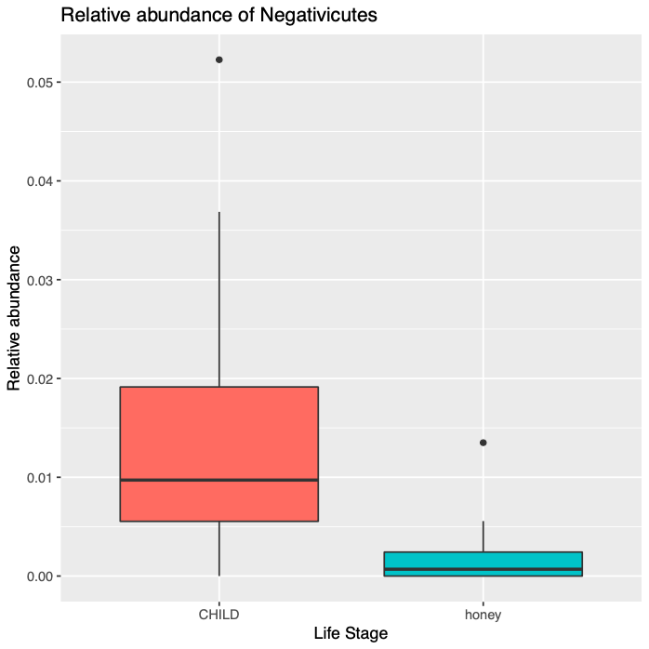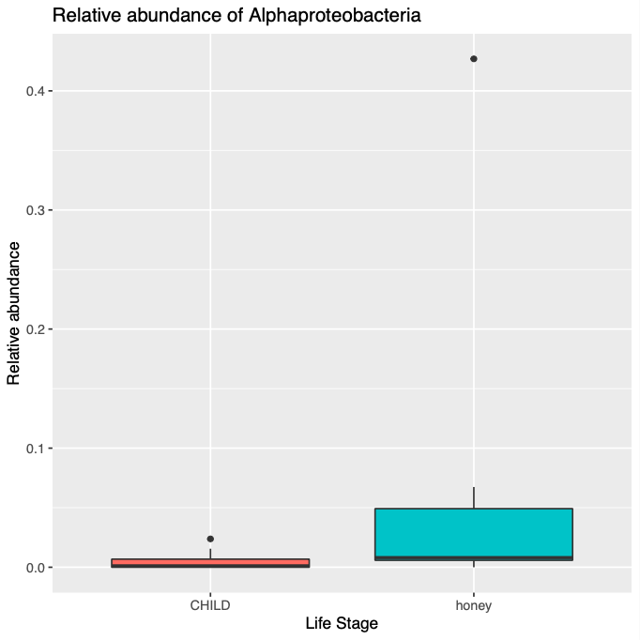

*

CHILD HONEY

Life Stage

CHILD HONEY

Life Stage

*

CHILD HONEY

Life Stage

*

B

A

C

**Supplementary Figure 8. Boxplots showing the relative abundance of Bacteroidia, Negativicutes and Alphaproteobacteria between honey samples and child fecal samples.** Differential abundance analysis determines the bacterial Classes that differ significantly in relative abundance between honey samples and Hadza child fecal samples. All bacterial Classes not mentioned do not differ significantly between groups in their relative abundance. Differential abundance analysis identified a relatively higher abundance of (A) Bacteroidia, (B) Negativicutes in child samples, and of (C) Alphaproteobacteria in honey samples. Significant differences are determined by Differences are confirmed by differential abundance analysis with DESeq2 (α = 0.05, asterisk indicates q < 0.05). The box represents the interquartile range (IQR) and the middle line represents the median. Upper and lower whiskers go to the highest or lowest measurement, or to the IQR multiplied by 1.5, whichever is higher or lower, respectively.

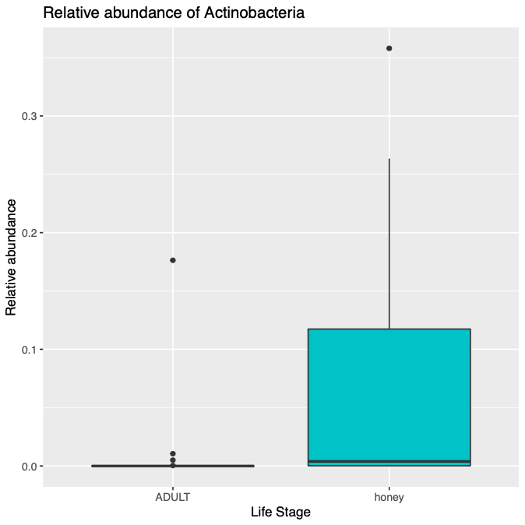

ADULT HONEY

Life Stage

*

**Supplementary Figure 9. Boxplot showing the relative abundance of Actinobacteria between honey samples and adult fecal samples.** Differential abundance analysis determines the bacterial Classes that differ significantly in relative abundance between honey samples and Hadza adult fecal samples. All bacterial Classes not mentioned do not differ significantly between groups in their relative abundance. Differential abundance analysis identified a relatively higher abundance of Actinobacteria honey samples. Significant differences are determined by ANOVA testing (α = 0.05, asterisk indicates q < 0.05). The box represents the interquartile range (IQR) and the middle line represents the median. Upper and lower whiskers go to the highest or lowest measurement, or to the IQR multiplied by 1.5, whichever is higher or lower, respectively.

|  |  |
| --- | --- |
| Jaccard Distance | q = 0.001 |
| Bray-Curtis Distance | q = 0.001 |
| Weighted UniFrac Distance | q = 0.001 |
| Unweighted UniFrac Distance | q = 0.001 |

**Supplemental Table 1. PERMANOVA analyses between honey and Hadza fecal samples**. Each of the four Beta diversity metrics assessed show significant differences in microbial community composition between honey and Hadza fecal samples. PERMANOVA q-values are shown for each metric assessed.