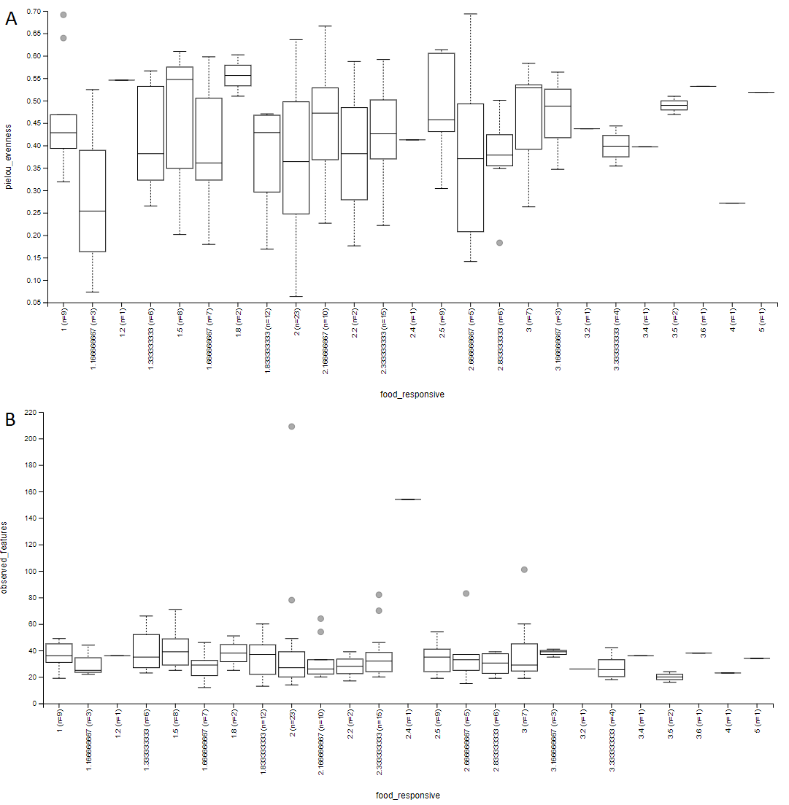

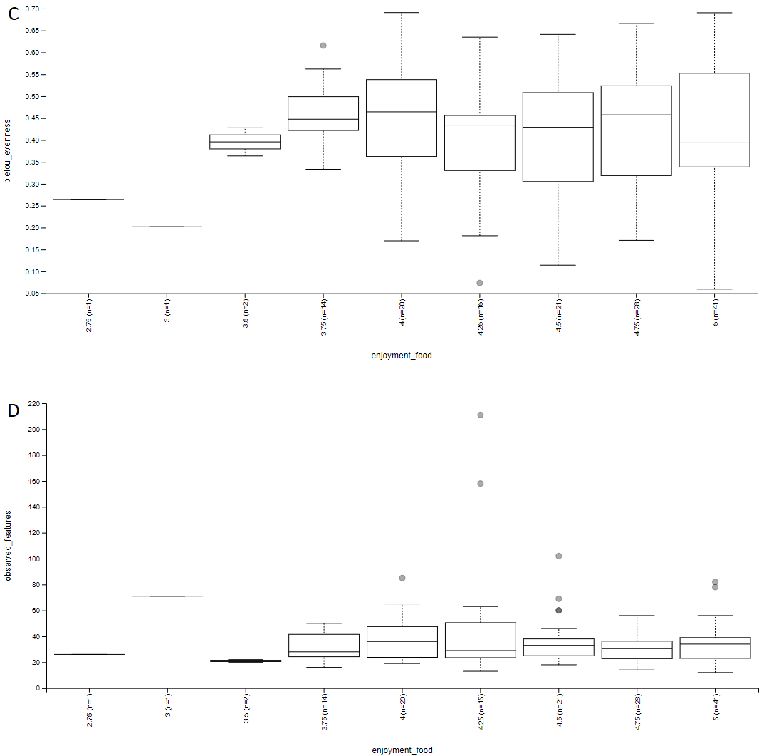
Supplemental Figure 1. Box plots show no significant differences in alpha diversity in infant gut microbiomes based on food enjoyment/responsiveness. Pielou’s evenness and observed features metrics are shown for (A, B) food responsiveness and (C, D) enjoyment, respectively. A 1-5 Likert scale was used for both responsiveness and enjoyment. p > 0.05 for all alpha diversity metrics (Kruskal-Wallis pairwise test).

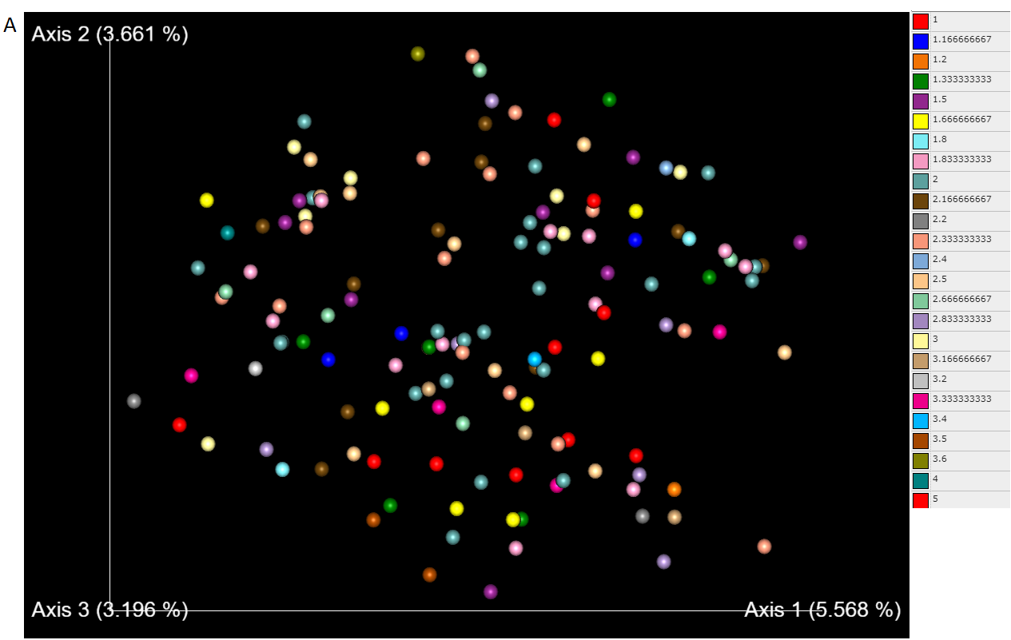

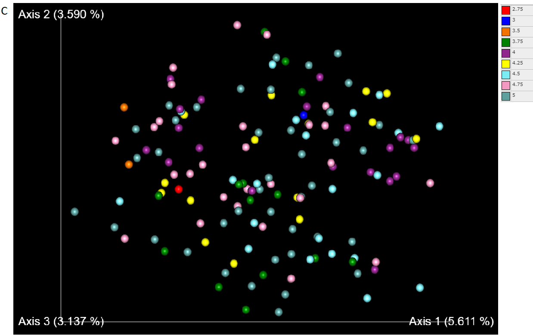
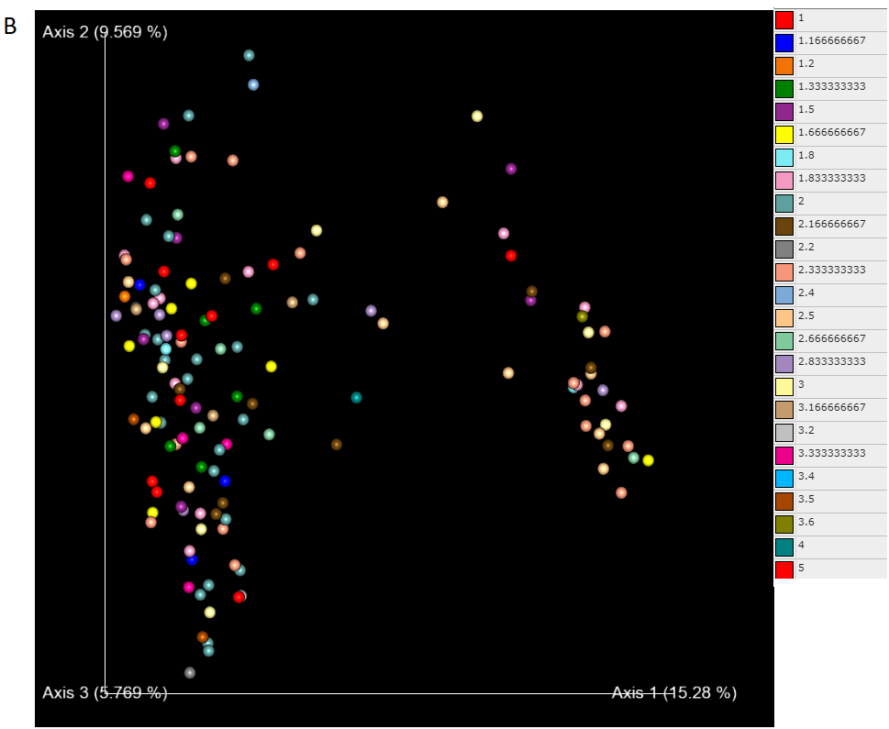

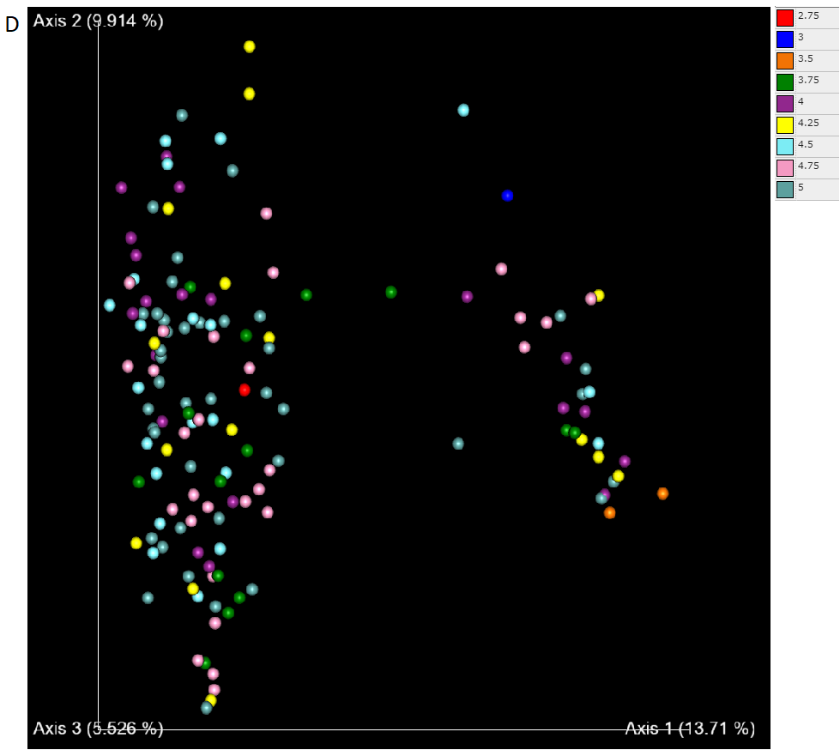
Supplementary Figure 2. PCoA plots show no distinct microbial communities in infant gut microbiome based on food enjoyment/responsiveness. Jaccard’s and unweighted Unifrac distance are shown for (A, B) food responsiveness and (C, D) enjoyment, respectively. A 1-5 Likert scale was used for both responsiveness and enjoyment.

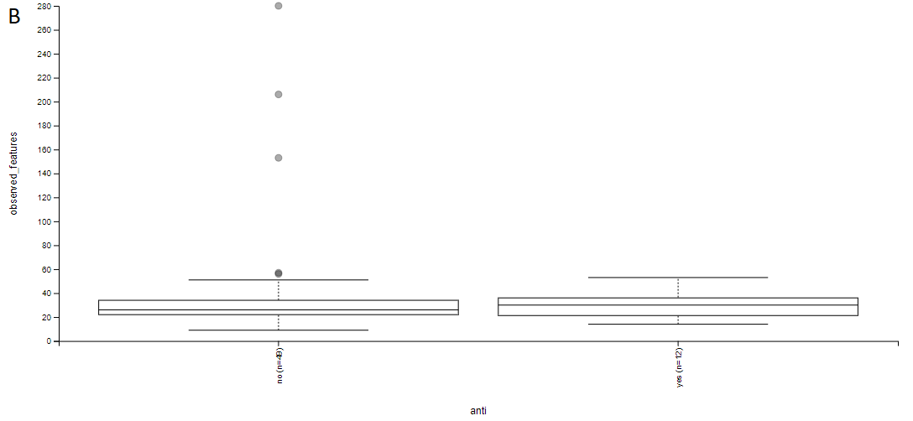
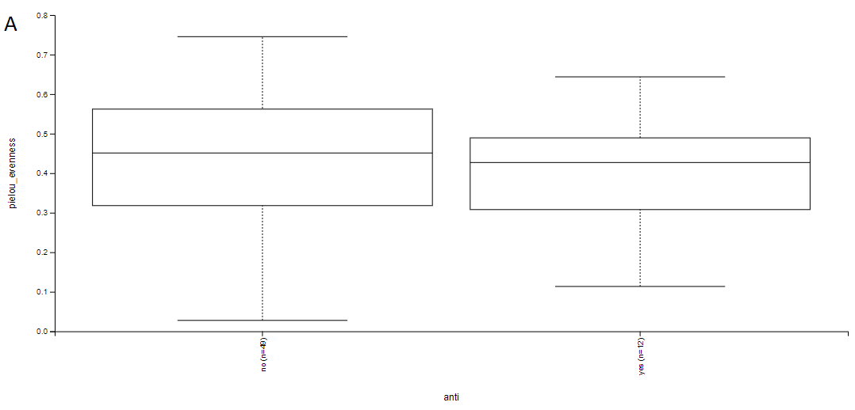
Supplemental Figure 3. Box plots show no significant differences in alpha diversity for infant gut microbiomes based on antibiotic use. (A) Pielou’s evenness and (B) observed features metrics are shown. N = 49 for no antibiotics and N = 12 for antibiotics used. p = 0.676 for A, p = 0.771 for B (Kruskal-Wallis pairwise test).
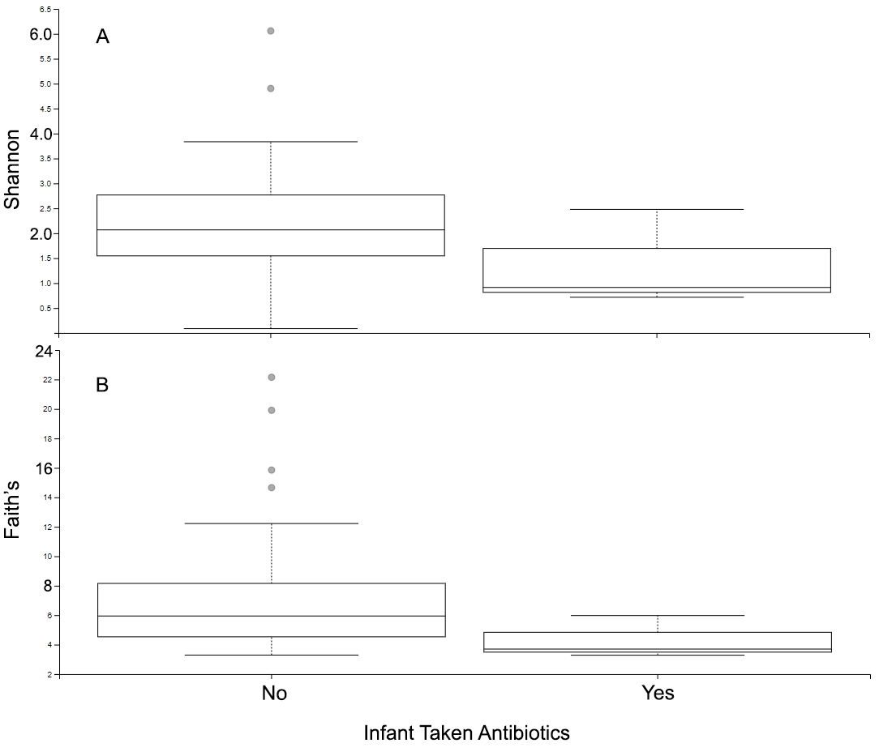
Supplemental Figure 4. Boxplots showing no significant difference in alpha diversity for infant gut microbiomes based on antibiotic use. (A) Shannon’s and (B) Faith’s phylogenetic diversity metrics are shown for food enjoyment. p = 0.430 for A, p = 0.929 for B (Kruskal-Wallis pairwise test).
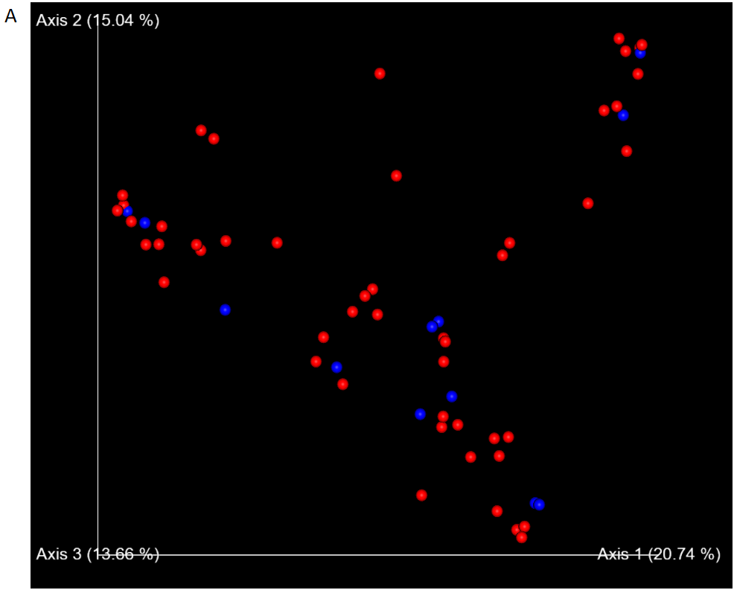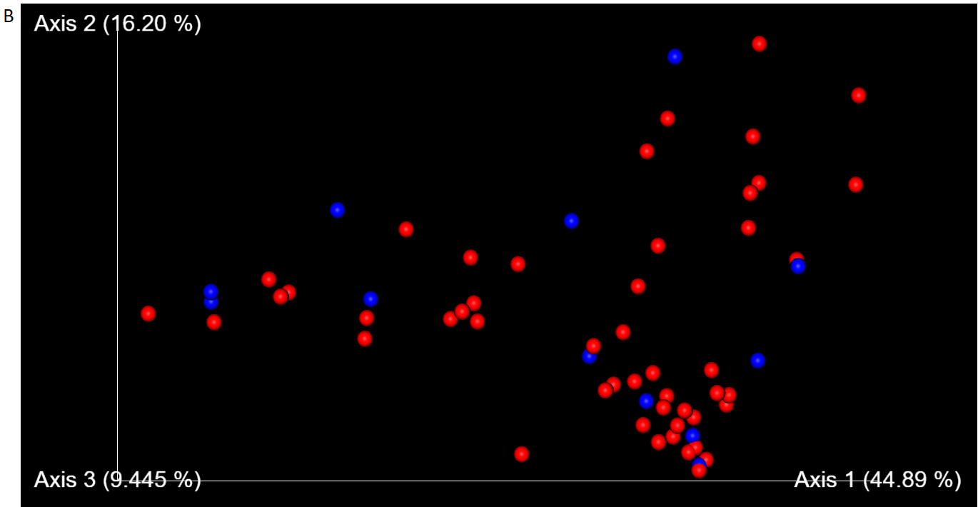

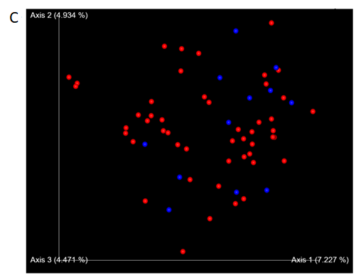
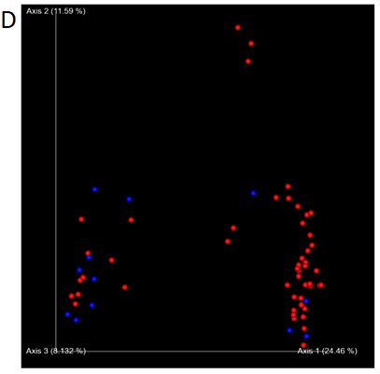
Supplemental Figure 5. PCoA plots showing that there are no distinct microbial communities in infant gut microbiomes based on antibiotic use. (A) Bray-Curtis, (B) weighted UniFrac, (C) Jaccard’s and (D) unweighted UniFrac distances are shown between infants who used antibiotics (blue) and did not use antibiotics (red). N = 49 for no antibiotics and N = 12 for antibiotics used.
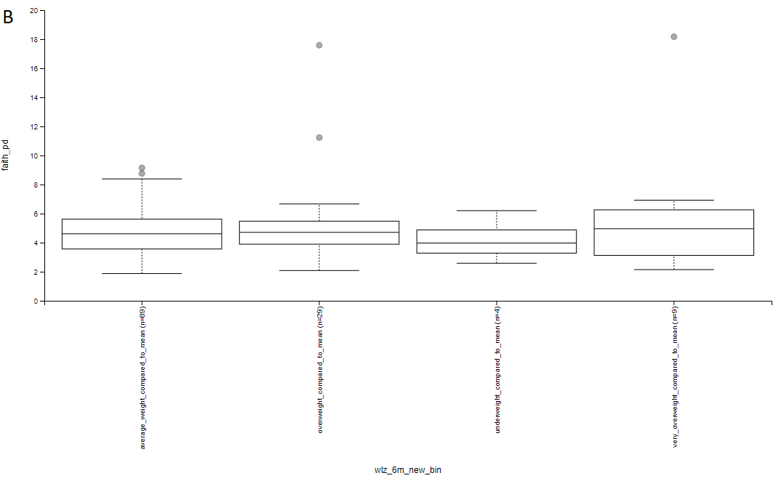
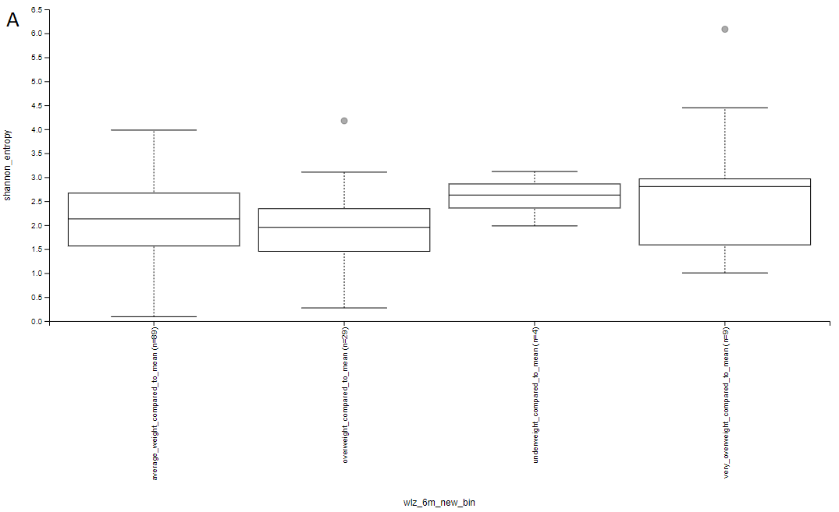
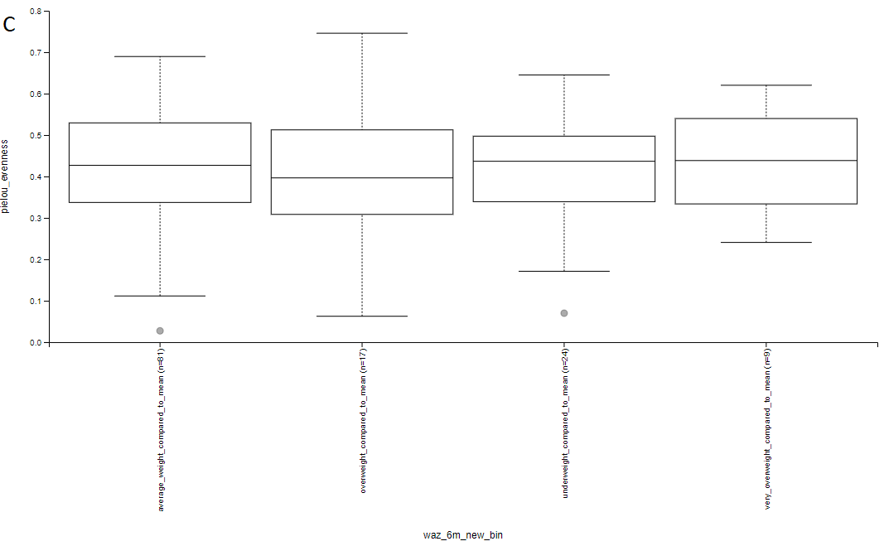

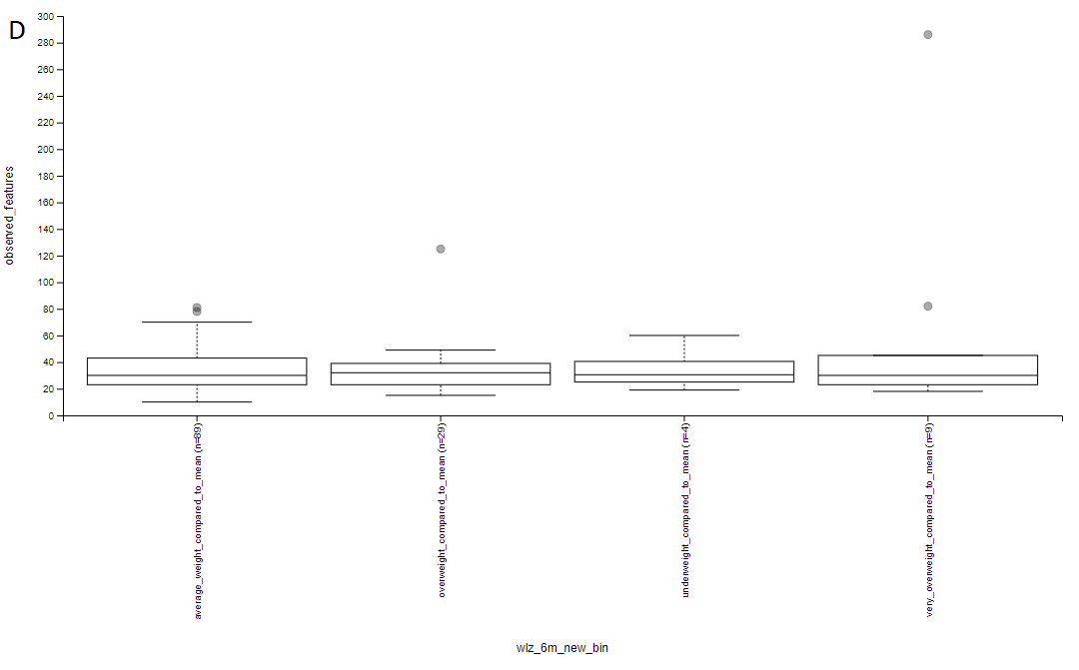
Supplemental Figure 6. Boxplots show no significant differences in alpha diversity for infant gut microbiomes based on weight compared to mean weight-to-length at 6 months. (A) Shannon’s, (B) Faith’s, (C) Pielou’s evenness and (D) observed features distances are shown between infants who are underweight, average weight, overweight and very overweight. There are no significant differences among all the groups as p > 0.05.

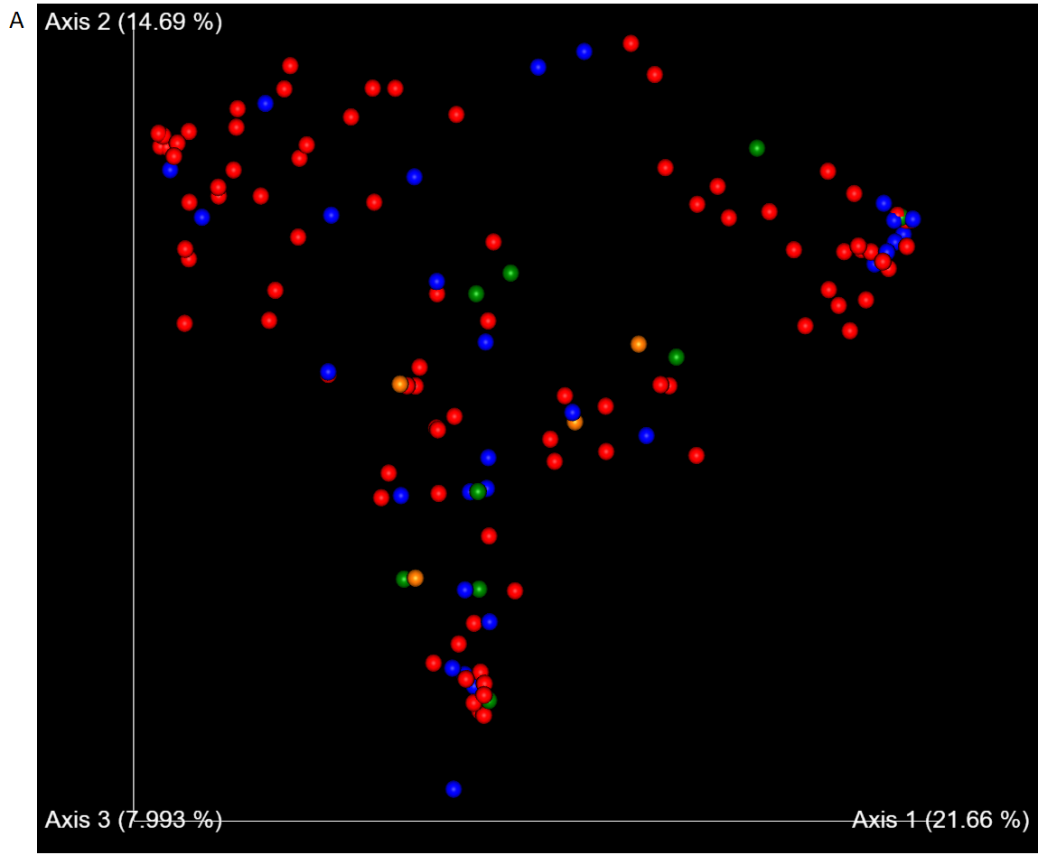
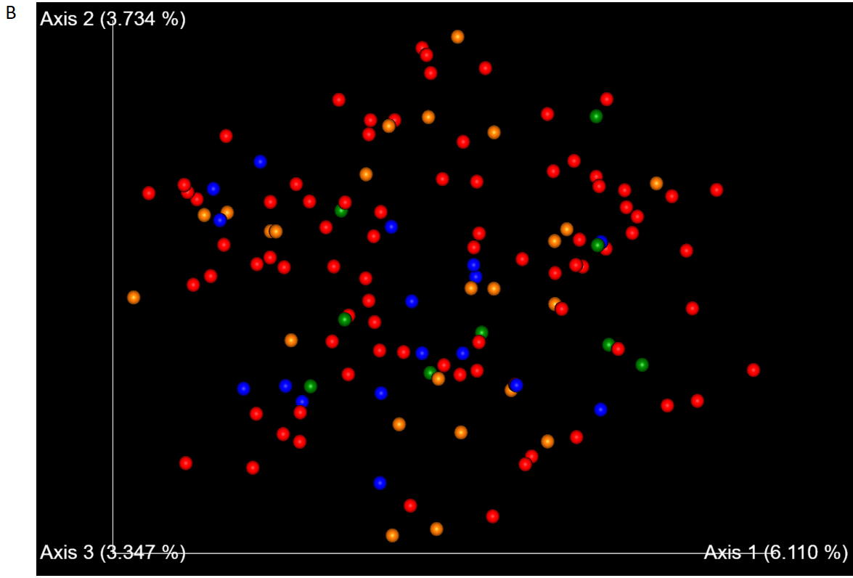

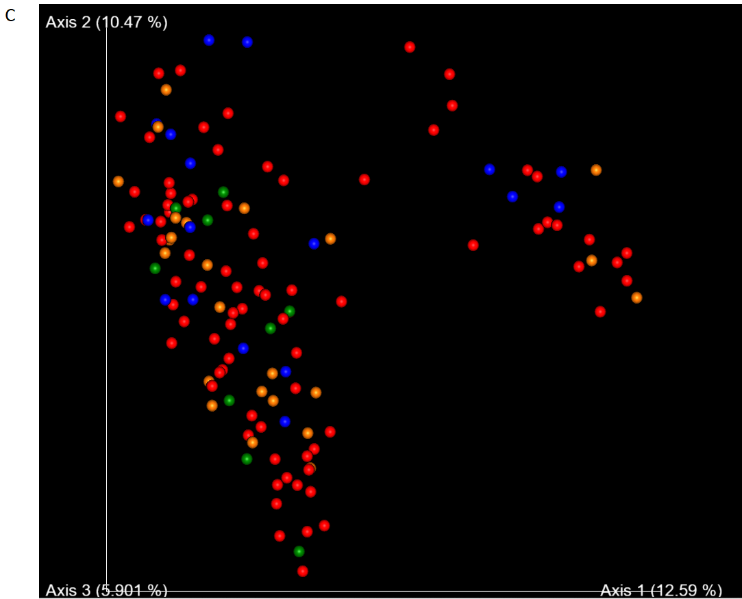
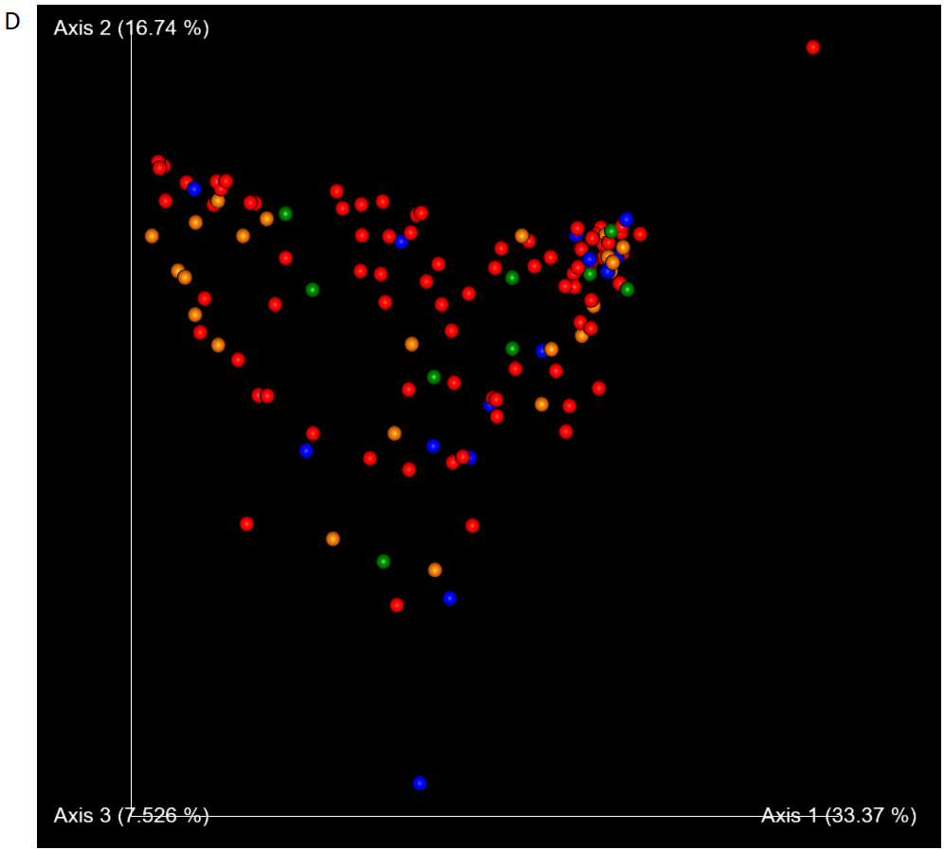
Supplemental Figure 7. PCoA plots show no distinct microbial communities in infant gut microbiomes based on weight compared to mean weight-to-length at 6 months. (A) Bray-Curtis, (B) Jaccard’s, (C) unweighted UniFrac and (D) weighted UniFrac distances are shown between infants who are underweight (orange), average weight (red), overweight (blue) and very overweight (green).

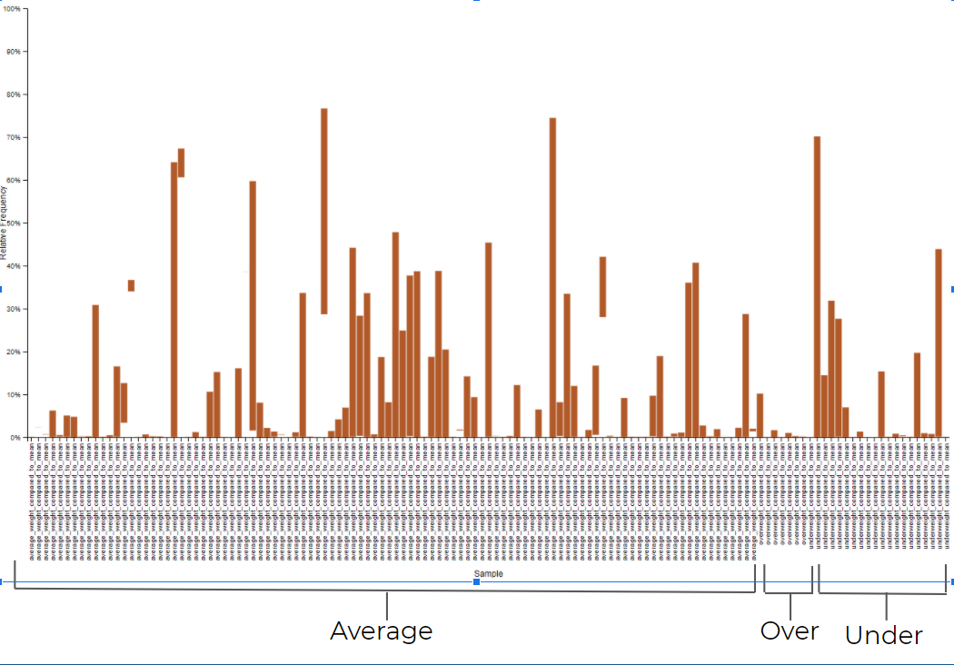
Supplemental Figure 8: Taxonomic bar graph showing relative frequency of Bacteroidetes phyla present in infants sorted by weight for lengths at 6 months. Taxonomic level 2 (phyla) was used.
Table S1. Kruskal-Wallis analysis of food responsiveness on microbial composition. There is no significant difference between infant gut microbial communities and infants who responded to food differently.

Shannon Diversity | 0.774
Observed Features | 0.859
Faith’s Phylogenetic Diversity | 0.417
Pielou’s Evenness | 0.755

Table S2. Kruskal-Wallis analysis of food enjoyment on microbial composition. There is no significant difference between infant gut microbial communities and infants who enjoyed food differently.

Shannon Diversity | 0.834
Observed Features | 0.452
Faith’s Phylogenetic Diversity | 0.670
Pielou’s Evenness | 0.760

Table S3. Kruskal-Wallis analysis for infants with and without antibiotic usage. There is no significant difference between infant gut microbial communities with and without antibiotic usage.
Shannon Diversity | p = 0.430
Observed Features | p = 0.771
Faith’s Phylogenetic Diversity | p = 0.929
Pielou’s Evenness | p = 0.676

Table S4. Kruskal-Wallis analysis for obese, healthy weight and underweight infants. There is no significant difference in infant gut microbial diversity between the three groups for all alpha diversity metrics

Shannon Diversity | p = 0.430
Observed Features | p = 0.771
Faith’s Phylogenetic Diversity | p = 0.929
Pielou’s Evenness | p = 0.676

Table S5. PERMANOVA analysis for infants and food responsiveness. There is no significant difference between infant gut microbial communities and infants who responded to food differently.

Bray-Curtis | p = 0.987
Weighted UniFrac | p = 0.996
Jaccard | p = 0.461
Unweighted UniFrac | p = 0.381

Table S6. PERMANOVA analysis for infants and food enjoyment. There is no significant difference between infant gut microbial communities and infants who enjoyed food differently.

Bray-Curtis | p = 0.075
Weighted UniFrac | p = 0.091
Jaccard | p = 0.582
Unweighted UniFrac | p = 0.351

Table S7. PERMANOVA analysis for infants with and without antibiotic usage. There is no significant difference between infant gut microbial communities with and without antibiotic usage.
Bray-Curtis | p = 0.913
Weighted UniFrac | p = 0.428
Jaccard | p = 0.711
Unweighted UniFrac | p = 0.188

