Supplementary
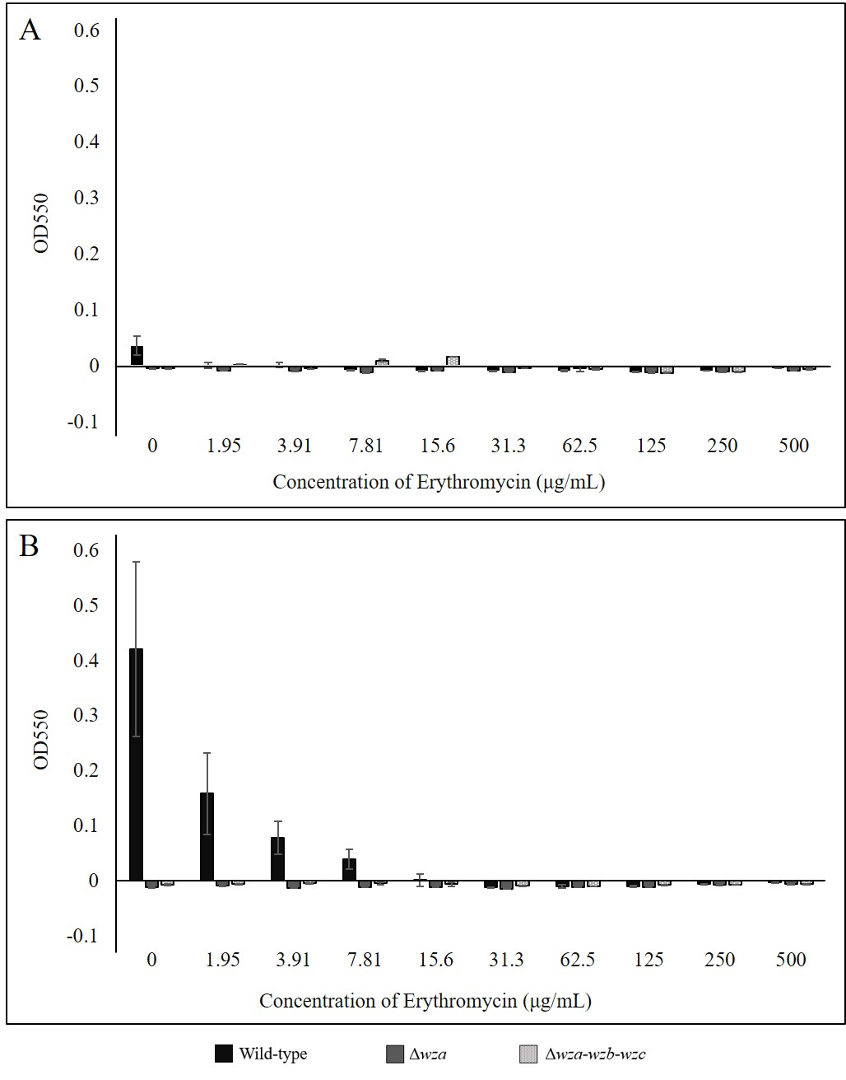
Supplementary Figure 1. E. coli K30 biofilm production is not correlated with erythromycin resistance in wild-type, Δwza, and Δwza-wzb-wzc strains at 72 hours. Biofilm production was quantified at OD₅₅₀ using a 96-well plate crystal violet staining assay after 72 hours of incubation at 37°C. Crystal violet was dissolved with 30% glacial acetic acid for 15 minutes, then transferred to a new 96-well plate for optical density reading at OD₅₅₀. OD₅₅₀ pure LB control was subtracted from all samples while plotting. Panels (A) and (B) represent one biological replicate each (n = 2). Error bars represent standard deviation for 2 technical replicates for each strain at each concentration.

