SUPPLEMENTAL

TITLE: Cell elongation by depletion of FtsZ in Escherichia coli strain DH5ɑ increases adsorption of T4 bacteriophage

Table S1. Summary of antisense RNA and empty vector plasmid construct features.
Plasmid | Features | Antibiotic Resistance Gene | Obtained from:
DEAN-pZ | ftsZ antisense RNA | Chloramphenicol | Dr. Liam Good, University of London
DEAN-pHN678 | Empty Vector | Chloramphenicol | Dr. Liam Good, University of London

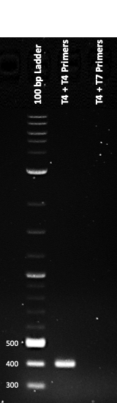
Figure S1. Confirmation of T4 bacteriophage via PCR and gel electrophoresis. gp23 was amplified via PCR and run on a 1% agarose gel. Lane 2 represents T4 bacteriophage lysate amplified with T4 bacteriophage primers, with an anticipated band size of 398 base pairs. Lane 3 represents T4 bacteriophage lysate amplified with T7 bacteriophage primers.

Titer of T4 bacteriophage stock. The concentration of T4 bacteriophage stock was determined through a double overlay plaque assay. Dilutions of bacteriophage were mixed with E. coli DH5a, plated, and incubated at 37 ºC overnight. A phage titer of 9.00 x 10⁷ pfu/mL was determined.

PCR amplification of gp23 confirmed T4 bacteriophage identity. The identity of the T4 bacteriophage stock was determined through PCR amplification of gp23. gp23 encodes the major T4 bacteriophage capsid protein with a 398 base pair expected band size. Amplification of gp23 is observed without any presence of T7 bacteriophage contamination, confirming the T4 bacteriophage identity and purity (Fig S1. lanes 2-3).

