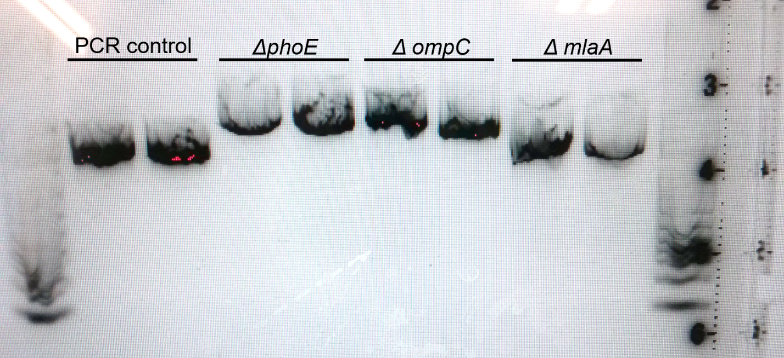
Figure S1. Genotypes of E. coli ​BW25113 ΔompC​, ΔphoE​, and Δmla strains were confirmed through PCR and gel electrophoresis analysis. ​PCR amplification of phoE​, ompC​, and mlaA genes were visualized on a 1.5% low melting point agarose gel. As a PCR control, ompC was amplified in the wild type strain using an alternative primer set obtained from Boen et al. (10). Expected product sizes were 1165 (PCR control), 1671 bp (ΔompC), 1850 bp (ΔphoE​), and 1400 bp (ΔmlaA​).

