APPENDIX (Supplemental Material)
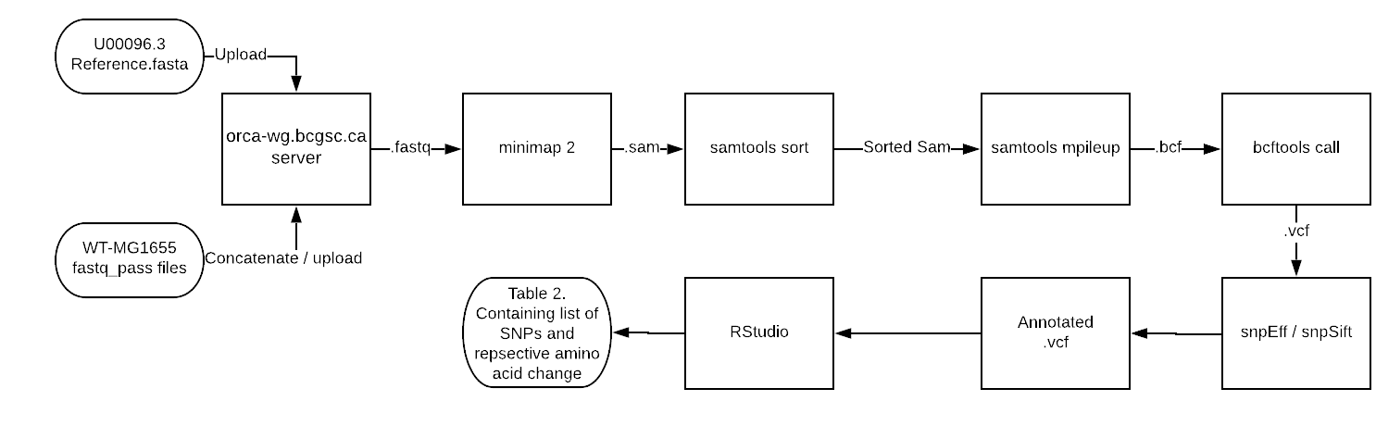
FIG. A1. Flowchart detailing variant calling procedure. Passed fastq files from 2 sequencing runs of the same WT strain were uploaded onto orca.wg.bcgsc.ca server and were concatenated. Minimap2 (10) was used to align the sequences and were sorted with samtools (11, 12). This was then followed by variant calling with samtools mpileup and converted to a vcf file with bcftools mpileup. Snpeff (13) and snpSift (14) were used to annotate the vcf file and Rstudio was used to organize the data.

Table A1. Raw OD₆₀₀ data and visual observations for sucralose MIC assay. Negative control is TSB only. MIC assay was incubated overnight at 37°C for 16 hours at 200 rpm. OD₆₀₀ for 125 mM sucralose was performed on a sample diluted 1/10 in TSB.
[Sucralose] (mM) | 0 (Negative control) | 125 (1/10 dilution) | 150 | 175
Observation | No turbidity | Turbid | No turbidity | No turbidity
OD₆₀₀ | 0.130 | 0.250 | 0.208 | 0.129

Table A2. Raw nanodrop absorbance and Qubit data of various gDNA preparations. Starred method involved taking the eluent of a previous gDNA preparation (where [gDNA] = 155.1 ng/µL) and performing the purification again starting from addition of RNase A and Genomic Lysis/Binding Buffer, according to manufacturer’s protocol
Sample | gDNA Preparation Method | Nanodrop [gDNA] (ng/μL) | A₂₆₀/A₂₈₀ | A₂₆₀/A₂₃₀ | Qubit [gDNA] (ng/μL) | Sequenced?
WT-MG1655 | PureLink | 48.7 | 1.99 | 1.51 | 19.2 | Yes
 | PureLink | 57.9 | 2.03 | 1.25 | 20.4 | No
 | PureLink | 155.1 | 1.50 | 0.38 | N/A | N/A
 | PureLink x2* | 28.0 | 1.79 | 1.20 | 17.6 | Yes
HS-MG1655-1b | BioBasic | 963.9 | 2.12 | 2.03 | 14.6 | N/A

