Supplemental 2A. Active pore available for sequencing for Run 1. This graph shows the number of pores available on ONT MinION sequencer throughout the sequencing run for the first run. Run time was 16 hours.
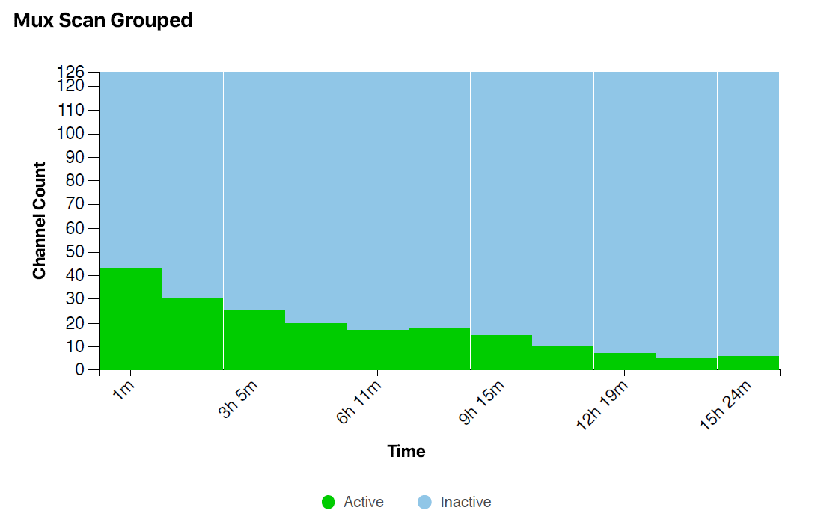

Supplemental 2B. Active pore available for sequencing for Run 2. This graph shows the number of pores available on ONT MinION sequencer throughout the sequencing run for the second run. Run time was 24 hours.
