SUPPLEMENTARY

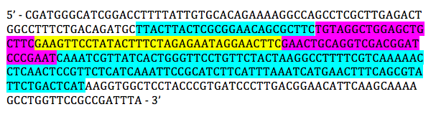
Figure S1. The Sanger sequence of the PCR product from ∆rpoS strain confirms kanamycin cassette removal. The parts of the nucleotide sequence highlighted in blue are regions that matched up with the WT rpoS gene. The sequence highlighted in yellow is the FRT (FLP recognition target) sequence and the purple regions are the flanking region of FRT. Together with the flanking region, the FRT creates a scar sequence. Based on the sequence alignment, the kanamycin cassette was confirmed to be removed, leaving a non-functional rpoS gene.

Table S1. The T7 phage stock concentration is determined using double agar overlay and plaque count.
Dilution Plated | Replicate | Volume of Dilution Plated | Plaque count | Number of plaque/mL diluted T7 solution | Average Number of T7 phage/mL stock solution
10⁻⁶ | 1 | 0.1 mL | TNTC | N/A | → $(1.0 ×10^{10})+(1.3 ×10^{10})+(1.3 ×10^{10})+(1.0 ×10^{12}) =1.036×10^{12}$  → $(1.036×10^{12})/4 = 2.59×10^{11}$plaque/mL
 | 2 |  | TNTC | N/A
 | 3 |  | TNTC | N/A
10⁻⁸ | 1 |  | 10 | 1.0 x 10¹⁰
 | 2 |  | 13 | 1.3 x 10¹⁰
 | 3 |  | 13 | 1.3 x 10¹⁰
10⁻¹⁰ | 1 |  | 1 | 1.0 x 10¹²
 | 2 |  | 0 | 0
 | 3 |  | 0 | 0
10⁻¹² | 1 |  | 0 | 0
 | 2 |  | 0 | 0
 | 3 |  | 0 | 0

Table S2. The dilution scheme for various different T7 phage concentration used for each treatment in the lysis curve assay
[T7 phage]$(T7 phage/mL)$ | $$3.6×10^{7}$$ | $$7.2×10^{7}$$ | $$2.16×10^{8}$$ | $$4.32×10^{8}$$
Amount of diluted T7 phage solution (µL) | 10 | 20 | 100 | 200
Amount of LB media (µL) | 710 | 700 | 1100 | 1000
** Perform 1:100-fold dilution on the original T7 phage stock solution before proceeding to dilute the T7 phage using this scheme

Table S3. The loading scheme for samples in all treatments onto 96-well plate for the phage lysis curve
 | 1 | 2 | 3 | 4 | 5 | 6 | 7 | 8 | 9 | 10 | 11 | 12
A |  |  |  |  | 0.05 | 0.1 | 0.05 | 0.1 | 0.05 | 0.1 | 0.05 | 0.1
B |  |  |  |  | 0.05 | 0.1 | 0.05 | 0.1 | 0.05 | 0.1 | 0.05 | 0.1
C |  |  |  |  | 0.05 | 0.1 | 0.05 | 0.1 | 0.05 | 0.1 | 0.05 | 0.1
D |  |  |  |  | 0.05 | 0.1 | 0.05 | 0.1 | 0.05 | 0.1 | 0.05 | 0.1
E |  |  |  |  | 0.05 | 0.1 | 0.05 | 0.1 | 0.05 | 0.1 | 0.05 | 0.1
F |  |  |  |  | 0.05 | 0.1 | 0.05 | 0.1 | 0.05 | 0.1 | 0.05 | 0.1
G |  |  |  |  | 0.05 | 0.1 | 0.05 | 0.1 | 0.05 | 0.1 | 0.05 | 0.1
H | LB | LB | LB | LB | LB
*** The types of cells loaded into each well is labelled using colours of the well
*** 0.05 and 0.1 is indicating the MOI of the T7 phage to cells in the wells
*** LB means that the well is loaded with sterile LB and is used as blank

Red = WT in exponential phase
Blue = WT in stationary phase
Green = ∆rpoS strain in exponential phase
Yellow = ∆rpoS strain in stationary phase

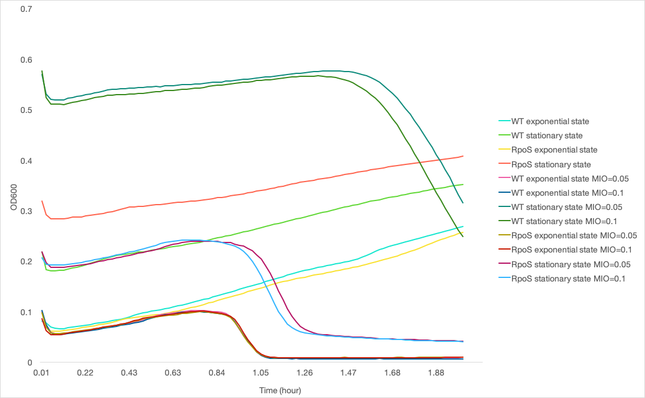
Figure S2. Up-regulation of rpoS in the stationary phase results in delay in T7 phage lysis. The T7 phage lysis growth curve shows that stationary phase cells have delay in T7 phage lysis compared to the cells in exponential phase. The rpoS knockout strain also shows an impairment in delay lysis, which indicate the importance of RpoS in the cells to delay in T7 phage-induced lysis.

