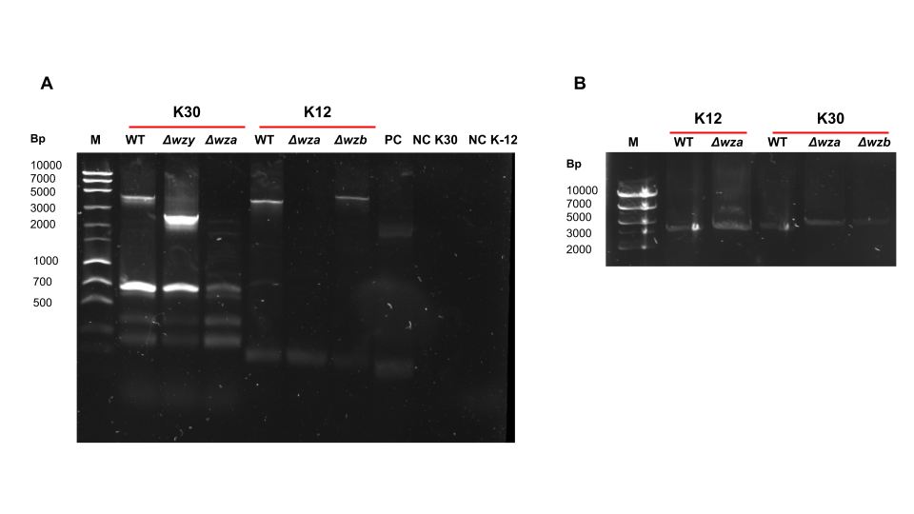
Supplemental Figure 1. Confirmation of genotype via PCR and Gel Electrophoresis
A) Photograph of 1st PCR run. M: MassRuler Express Forward DNA Ladder. WT: K30 E69 (WT) or K-12 BW25113. Δwzy: K30 CWG655. Δwza: K30 CWG281 or K-12 JW2047-1. Δwzb: K30 CWG343 (Δwzb) or K-12 JW2046-1 (Δwzb). PC: pUC-19 as a positive PCR control. NC K30: K30 primers with no template as a negative control. NC K-12: K-12 primers with no template as a negative control. B) Photograph of second PCR run showing bands not seen in the first PCR.

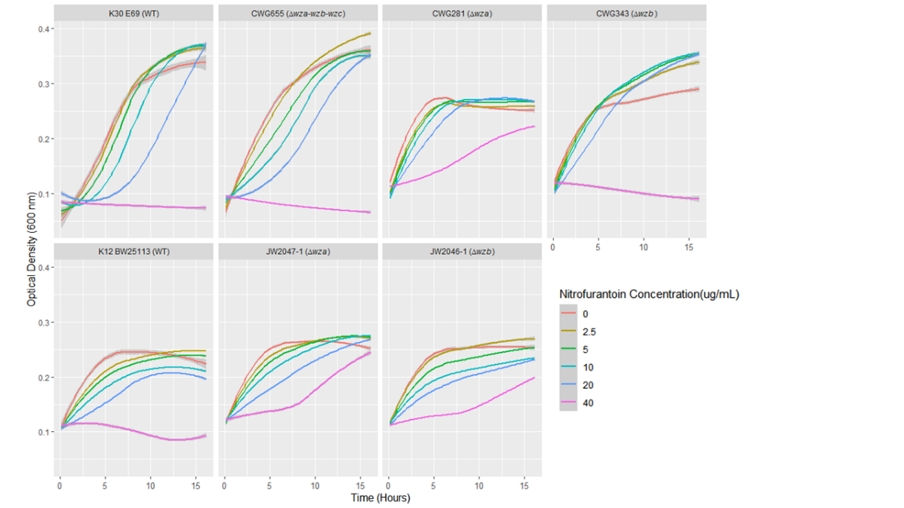
Supplemental Figure 2. Results of growth curve assay run 1

