Disruption of trehalose production in Escherichia coli K-12 does not confer sensitivity to SDS-EDTA-induced outer membrane stress
Mackenzie W. Gutierrez, Laurel M. Neufeld, Xin Wei, and Yi Han Yin
Department of Microbiology and Immunology, University of British Columbia, Vancouver, British Columbia, Canada

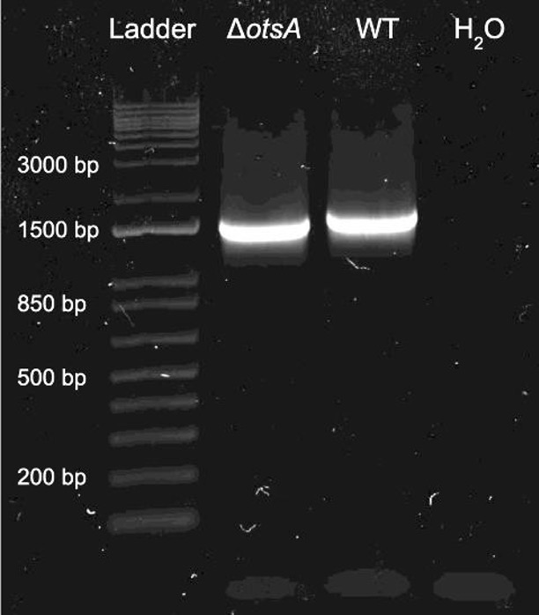
SUPPLEMENTAL MATERIALS

Supplemental Figure 1. otsA amplicon of JW5312-3 displays a reduced molecular weight. Gel electrophoresis of otsA amplicons from JW5312-3 (ΔotsA) and BW25113 (WT). Position relative to the 1kb ladder was used to interpret results.
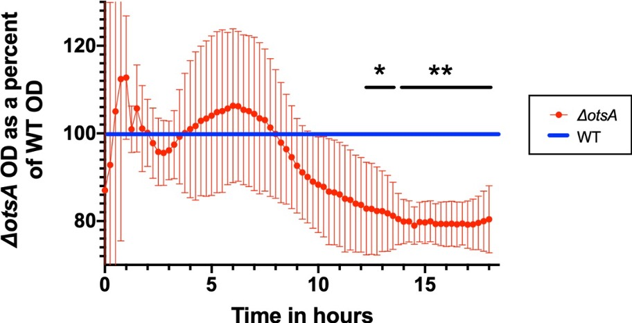
Supplemental Figure 2. Baseline growth dynamics of WT and otsA mutant differ significantly within each replicate. otsA knockout mutant growth curve as a percentage of WT growth curve over 18 hours in LB broth. For each of three biological replicates (each with three technical replicates), the OD₆₀₀ values from the ΔotsA growth curve were divided by the OD₆₀₀ values of the WT growth curve. Statistical analysis was performed with a two-tailed unpaired parametric T test. *, P<0.05; **, P<0.005. Error bars indicate standard deviation between biological replicates.

