Stringent response induced by amino acid starvation not involved in mediating broad spectrum antibiotic resistance in Escherichia coli

Kabir Bhalla, Jason Gravett, Paul Crichton, & Ayse Nisan Erdogan
Department of Microbiology and Immunology, University of British Columbia, Vancouver, British Columbia, Canada

SUPPLEMENTAL MATERIAL
Supplemental Table 1: MIC values of WT E. coli and ΔrelA/ΔspoT mutant in starved and unstarved conditions. The addition of L-valine significantly decreased (> 2-fold change) the ampicillin and streptomycin MIC values of the ΔrelA/ΔspoT mutant. No other significant change was observed.
 | MIC
 | WT |  | ΔrelA/ΔspoT
L-valine | - | + | - | +
Ampicillin  (μg/mL) | 3 | 1.5 | 3 | 0.75
Streptomycin  (μg/mL) | - | - | 28 | 3.5
Polymyxin B  (ng/mL) | 1 | 0.5 | 2 | 2
Tetracycline  (μg/mL) | - | 10 | - | 5
Erythromycin  (μg/mL) | - | - | 600 | 600

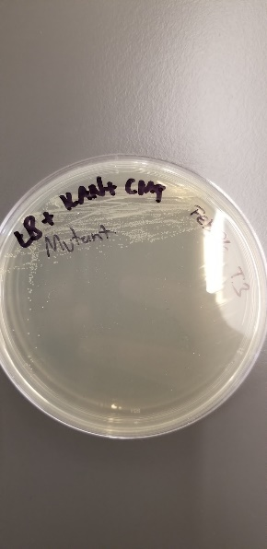
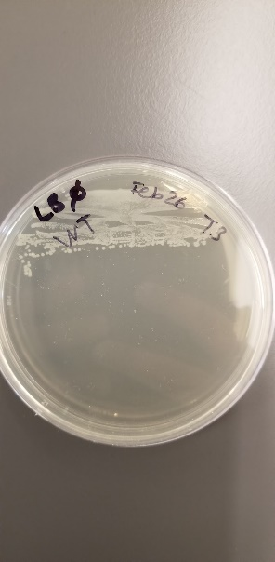
A
B
C
D

Supplemental Figure 1: Kanamycin and chloramphenicol resistance cassettes present in the ΔrelA/ΔspoT mutant but not in WT E. coli. E. coli BW25113 (WT) or E. coli SL11W447-4 (ΔrelA/ΔspoT mutant) were grown on either LB media, with or without the addition of kanamycin (KAN) and chloramphenicol (CAM). Growth of the WT strain was observed on LB (A), but no growth was observed on LB + KAN/CAM (B). The mutant strain grew both in the presence and absence of antibiotics (C,D).
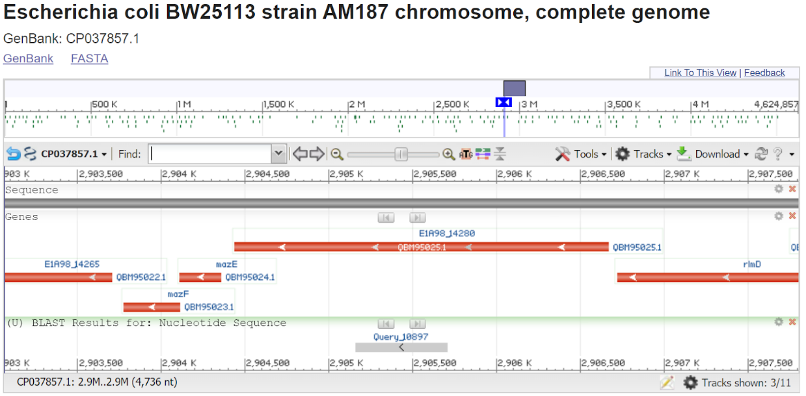
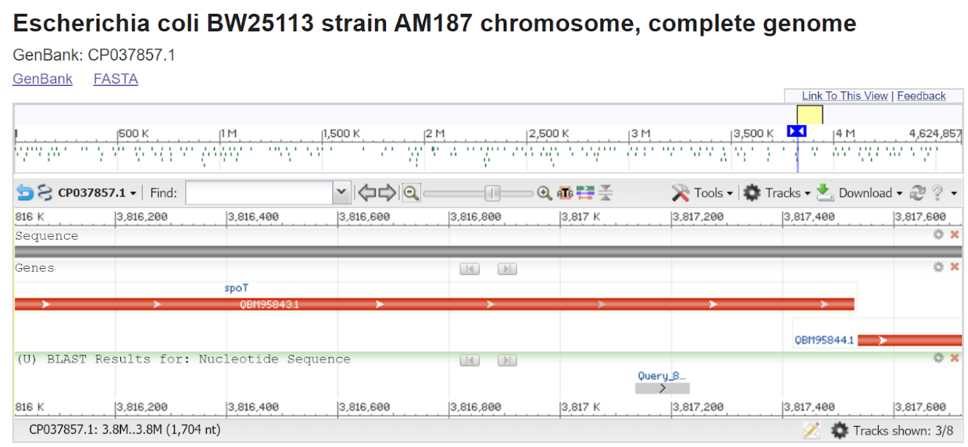
A
WT
ΔrelA/ΔspoT
B
ΔrelA/ΔspoT
WT
C
D
600bp
150bp

Supplemental Figure 2: relA and spoT are present in WT E. coli BW25113 and absent in E. coli SL11W447-4 (ΔrelA/ΔspoT). relA (~600 bp) and spoT (~150 bp) are present in WT, but absent in the ΔrelA/ΔspoT mutant (A, B). Nucleotide blast alignment identified amplified sequences as E1A98_14280 (relA) (C) and spoT (D) genes in the E. coli BW25113 genome.

